Commercial Training 4-28-15
Questions/Comments:

Updates:
We still have 2 comprehensive trials available for qualifying companies
- At least 400 pieces of equipment and at least 1000 gallons of fuel consumed per month and per piece of equipment.

Training/Discussion:
Spring Event Info
- When you log into your GDI back office (corporate site), click the GDI Library tab and then the GDI Documents tab. You will notice a couple of new documents:
  - GDI Custom Pricing Options
    - This is optional and used at your discretion
    - Can be used to start a trial or “1st time customer discount”
  - GDI Reseller Agreement
    - Important Note: 3 or less “non-chain franchise locations”
  - GDI Credit Line Process
    - Available, but encourage them using their own credit (rewards)
    - Minimum order is $2,000 to qualify

Soot and Common Problems:

What is soot and what causes soot:
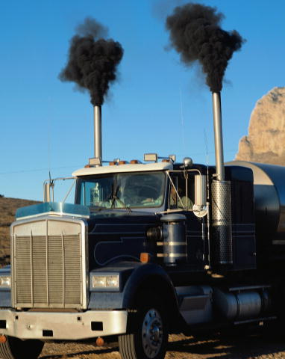
- http://en.wikipedia.org/wiki/Soot “Soot /ˈsʊt/ is impure carbon particles resulting from the incomplete combustion of hydrocarbons.”
- “When fuel is combusted in the engine, some of the diesel fuel cannot completely combine with oxygen and that leaves behind small unburned particles of carbon.”
http://www.vehicleservicepros.com/article/10922127/excessive-soot-levels-in-oil-can-cause-engine-issues
- Most soot is oxidized in the combustion chamber or caught in the SCR (Selective Catalytic Reduction) system, but some gets past the piston rings and into the oil, which creates problems.
        - Improper air/fuel ratio = incomplete combustion
  - Worn piston rings, poorly calibrated engine electrical systems, and malfunctioning fuel injectors are common causes of increased soot.
  - “A large truck will burn 1,786 gallons of fuel every 12,500 miles, at 7 mpg. During this 12,500-mile interval, more than half a pound (8.5oz) of soot will enter the oil.“ http://www.centrifugeprocessing.com/pickup-truck-engineapplications.html
- https://www.youtube.com/watch?v=trrQtgWa-GQ - Video showing engine sludge

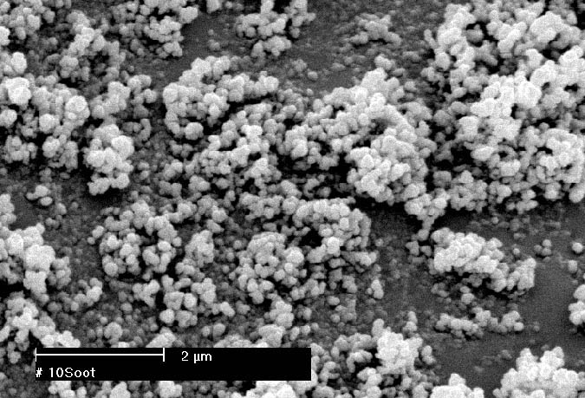
https://courseware.e-education.psu.edu/courses/egee101/L05_petroleum/soot.html

Problems associated with soot:
- Soot particles have a tendency to “join together” which is called agglomeration and leads to formation of “sludge”. This “sludge” is more abrasive as it becomes thicker and causes more damage.
- Engine oils have “dispersant additives” that are designed to prevent that from happening
- As soot increases in an engine…
  - Engine oil soot dispersants become less effective, which leads to decreased engine oil life cycles (more costs).
  - Engine oil become more viscous or “thick” which can cause poor oil flow and damage – especially during start-up.
  - Engines typically begin to consume more oil, which increases operational costs.
  - Soot particles begin to attach themselves to engine surfaces and oil filters, which results in more dirty oil entering the engine.
  - Increases engine wear and premature engine failure.
Proof that Xp3 will help to reduce engine sludge (see oil analysis PDF) “Xp3 Test Results” tab

- http://100ksalesteam.com - Free training resource for Certified GDI Sales Reps to help consistently put those steps together!

