Commercial Training 3-3-15
Questions/Comments:

Updates:
We still have 2 comprehensive trials available for qualifying companies
- At least 400 pieces of equipment and at least 1000 gallons of fuel consumed per month and per piece of equipment.
If you know a company that qualifies please continue to work with them to take advantage of this opportunity.

Training/Discussion:
Selective Catalytic Reduction (SCR) system:
- The SCR system injects a liquid-reductant agent through a special catalyst into the exhaust stream of a diesel engine. The reductant source is usually automotive-grade urea, otherwise known as Diesel Exhaust Fluid (DEF).
  - The DEF sets off a chemical reaction that converts nitrogen oxides into nitrogen, water and tiny amounts of carbon dioxide (CO2), natural components of the air we breathe, which is then expelled through the vehicle tailpipe.
- SCR systems significantly reduce toxic emissions and PM (particulate matter) including:
  - 90% reduction of Nitrogen oxides (NOx)
  - 50-90% reduction in Hydrocarbon (HC) and Carbon monoxide (CO) emissions
    - http://www.epa.gov/otaq/consumer/05-autos.pdf
    - http://cfpub.epa.gov/eroe/index.cfm?fuseaction=detail.viewPDF&ch=46&lShowInd=0&subtop=341&lv=list.listByChapter&r=219652
  - 30-50% reduction in Particulate Matter (PM)
- Addresses Tier 4 emissions standards https://www.cumminspower.com/www/literature/technicalpapers/PT-9010-Tier4EmissionRegImpact.pdf
- Life span of SCR system is up to 20,000 hours and average replacement costs is typically between $10,000 to $20,000
  - https://www.empire-cat.com/uploadedFiles/Empire_Cat/Power_Systems/Emissions_Solutions/Stationary_Portable_Power/SCR%20Frequently%20Asked%20Questions.pdf
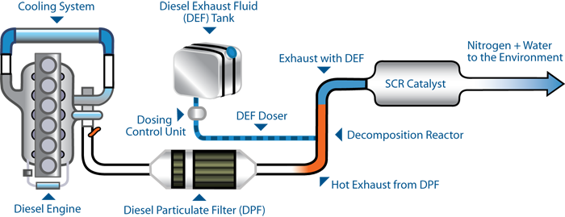
NOx = Nitrigen Oxide
CO = Carbon Monoxide
HC = Hydrocarbon
PM = Particulate Matter
Oxidation Catalyst (DPF Filter – see training on 2-24-15 in training library) - Platinum group metals (PGM) including platinum itself, palladium, and rhodium are commonly used in emission control catalysts. Modern catalytic converters utilize a monolith honeycomb substrate which is coated with the PGM metal compounds and packaged into a stainless steel container. The honeycomb is made either of ceramics or stainless steel foil. Its structure of many small parallel channels presents high catalytic contact area to the exhaust gases. As the hot gases flow through the channels and contact the catalyst, several exhaust pollutants are converted into harmless substances. The following reactions occur in the oxidation catalyst:
http://www.nettinc.com/information/emissions-faq/how-does-an-oxidation-catalyst-work

DEF Fluid – Diesel Exhaust Fluid
- DEF is a non-hazardous solution
- Composed of 32.5% urea and 67.5% de-ionized water.
- DEF is sprayed into the exhaust stream of diesel vehicles to break down dangerous NOx emissions into harmless nitrogen and water.
- This system is called Selective Catalytic Reduction (SCR) and can be found on 2010 and later model year trucks and many diesel pickups and SUVs.
- DEF is not a fuel additive and never comes into contact with diesel. It is stored in a separate tank, typically with a blue filler cap.
- DEF is corrosive for some metals such as carbon steel, aluminum, copper and zinc, and DEF should not be stored in containers made of these materials.
- Wearing protective clothing is not necessary when handling DEF, however, DEF can stain clothes. If you do spill any DEF on your clothing, rinse it off with water.
- DEF has a typical shelf life of two years. However, this can be reduced if the fluid is exposed to direct sunlight or if the temperature of the DEF remains above 86°F (30°C) for sustained periods.
- DEF freezes into a crystalline slush at 12°F (-11°C) and should not be kept at temperatures above 86°F (30°C). If DEF is frozen on your vehicle, for example overnight or over a weekend, you do not need to take any action. Use the vehicle as you normally would. Truck manufacturers use a variety of heating methods to thaw frozen DEF tanks, including in-tank heating elements
- DEF uses automotive-grade urea which has a much higher purity than fertilizer urea. Using a lower-quality fertilizer urea will cause degradation of the Selective Catalytic Reduction (SCR) system, eventually causing the truck to break down.
- When pumping Diesel Exhaust Fluid (DEF) in a closed area it is possible that inhalation of a small quantity of ammonia fumes from DEF might occur. If you do inhale these fumes from DEF, move to an area of fresh air. A physician should be consulted if you experience any continued symptoms, such as irritation to nose or throat. DEF does sometimes have a slight ammonia smell (similar to home cleaning agents), but these are not harmful.

DEF Typical use:
- Diesel Exhaust Fluid (DEF) consumption is measured as a ratio of diesel fuel use, normally termed the "dosing rate" or "treat rate".
- Medium- and heavy-duty vehicles have a dosing rate of 2-3%. This means that if your truck has a fuel efficiency of six miles per gallon and a dosing rate of 3% it will use approximately 1 gallon of DEF every 200 miles. (miles to be traveled/MPG)*(3%) = number of gallons of DEF needed to travel those miles. 200/6 = 33.33*3% = approximately 1 Gallon of DEF
- Feedback from a number of fleets suggests that the dosing rate is slightly lower than originally predicted by manufacturers, at around 2.0-2.5%.

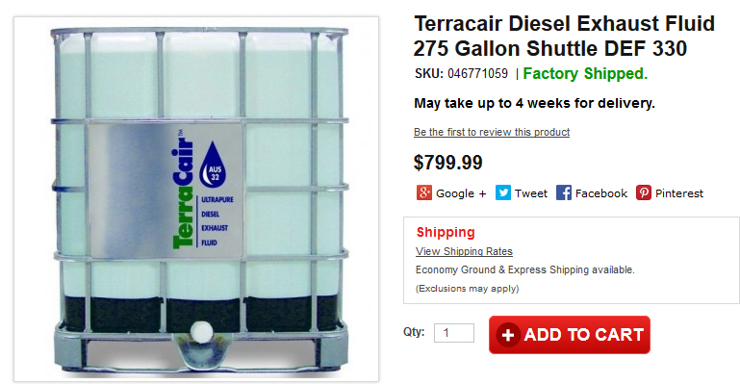

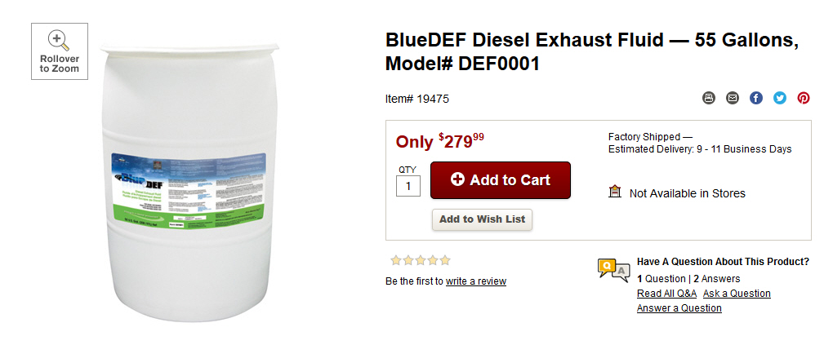
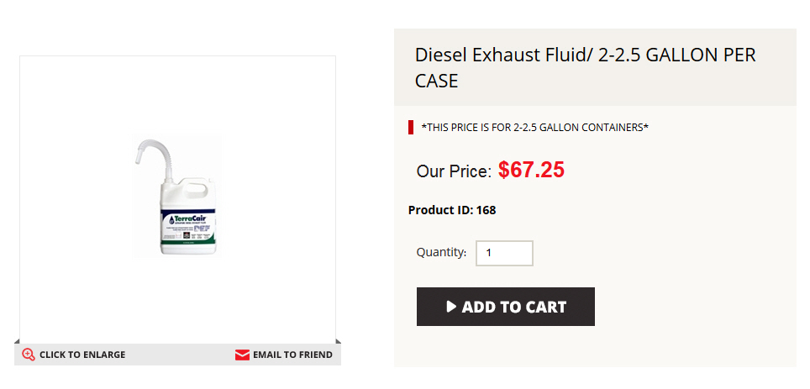

SCR Resources:
http://www.dieselforum.org/about-clean-diesel/what-is-scr-

DEF Resources:
http://www.discoverdef.com/def-overview/faq/#def

Sales Training/Tips:
- I came across a great sales training resource which is a Podcast from Bob Marx
  - http://www.sellmoretalkless.com/podcast/

- http://100ksalesteam.com - Free training resource for Certified GDI Sales Reps to help consistently put those steps together!

