Commercial Training 3-10-15
Questions/Comments:

Updates:
We still have 2 comprehensive trials available for qualifying companies
- At least 400 pieces of equipment and at least 1000 gallons of fuel consumed per month and per piece of equipment.
If you know a company that qualifies please continue to work with them to take advantage of this opportunity.
- Farming – this is the perfect time of year to start those conversations

Training/Discussion:
Exhaust Gas Recirculation (EGR) system: https://www.youtube.com/watch?v=9ifz8YdN2kM
- Here is a great introductory video explaining the EGR system and how it helps reduce NOx (nitrogen oxide) which we have discussed in our previous 2 weeks with the SCR system.
- Quick explanation:
  - Purpose is to reduce NOx which is produced in the combustion process.
  - NOx is produced when the Nitrogen and Oxygen in the air/fuel mixture to combine at high temperatures (above 2500 degrees Fahrenheit).
  - EGR valve is designed to lower combustion temperatures by allowing a measured amount of spent inert (does not burn) exhaust gas to be placed back into the combustion chamber. The inert gas takes up “space” in the combustion chamber, which reduced the amount of air/fuel in the combustion chamber = lower combustion temperatures AND lower NOx emissions.

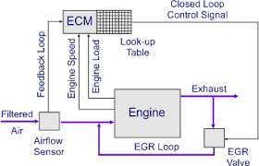
EGR in Diesel Engines: http://en.wikipedia.org/wiki/Exhaust_gas_recirculation
- The initial technology has been around since 1970’s, but has been improved upon since then.
- EPA regulations that went into effect in 2007 required the use of EGR systems to reduce NOx
- There have been less issues with EGR systems since 2010 because of improvements in engine manufacturing and technology that meets the EPA standards.
- The EGR gas is cooled with a “heat exchanger” to allow more of the recirculated gas into the combustion process. Here is a link to learn more about heat exchangers http://en.wikipedia.org/wiki/Heat_exchanger
- As we discussed in our overview, less oxygen in the air/fuel mixture = lower combustion temps and less NOx.

Problems with EGR in diesel engines
- “…Exhaust recirculated back into the cylinder can increase engine wear as carbon particulate wash past the rings and into the oil.^{[6]}
- Adding EGR to diesel decreases the heat ratio of combustion gases in the power stroke, which reduces the amount of power.
- Tend to increase the amount of unburned fuel which means money lost in fuel expenses and increased particulate matter.
- Great article outlining information and changes in EGR systems
http://www.truckinginfo.com/article/story/2014/02/stay-ahead-of-trouble-on-egr-engines.aspx
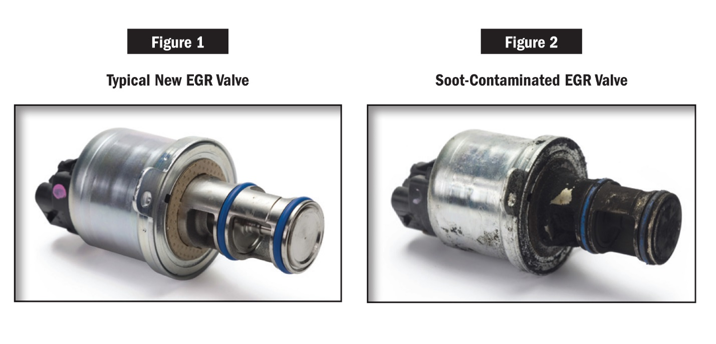
- Another great article about EGR systems and common issues - http://www.truckinginfo.com/article/story/2012/11/maintaining-diesels.aspx

Typical replacement costs for the EGR system typically start around $1,000 (not including lost revenue from down time).
Most important things are to monitor things like coolant levels in used oil analysis.

Create a short list of emissions benefits connected with Xp3

Sales Training/Tips:
- I came across a great sales training resource which is a Podcast from Bob Marx
  - http://www.sellmoretalkless.com/podcast/

- http://100ksalesteam.com - Free training resource for Certified GDI Sales Reps to help consistently put those steps together!

