Commercial Training 2-24-15
Questions/Comments:

Updates:
We still have 2 comprehensive trials available for qualifying companies
- At least 400 pieces of equipment and at least 1000 gallons of fuel consumed per month and per piece of equipment.
If you know a company that qualifies please continue to work with them to take advantage of this opportunity.

Training/Discussion:

Emissions Laws and Tier 4 Compliance Requirements
- Tier 4 standards are designed to reduce Particulate Matter and Nitrogen Oxide (NOx) by 90%.
  - Particulate matter is particle pollution and “…is a mixture of solid particles and liquid droplets. Some particles, such as dust, dirt, soot, or smoke, are large or dark enough to be seen with the naked eye. Others are so small they can only be detected using an electron microscope.” http://www.epa.gov/pm/basic.html
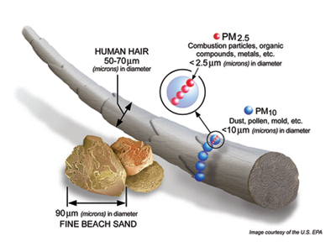
- Nitrogen Oxides are released into the air from motor vehicle exhaust and the burning of coal, oil, diesel, and natural gas (especially from electric power plants.” They also http://toxtown.nlm.nih.gov/text_version/chemicals.php?id=19
- Tier 4 engine standards are to be implemented on all new engines as of January 1, 2011 for machines between 175 and 750 horsepower.
  - Diesel Particulate Filters (DPF) are one of the ways engine manufacturers are reducing emissions.
What Are DPF filters?

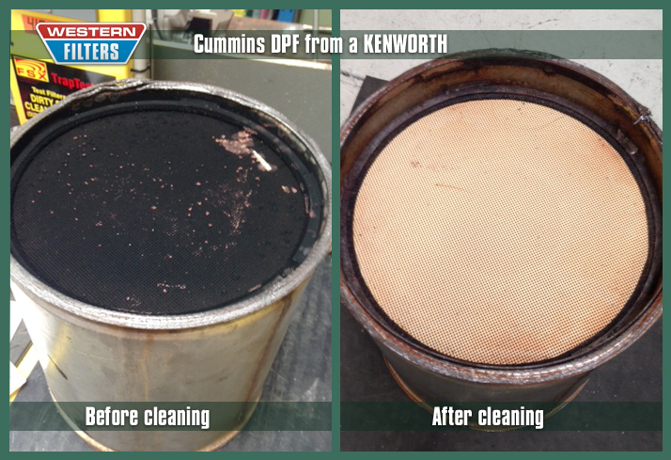
  - Designed to stop individual particles (most are invisible to the human eye) of soot and particulate matter. You’ve seen these particles whenever you’ve witnessed an older or poorly performing engines with large amounts black smoke coming from the exhaust.
  - Why is it important to trap the particulate matter?
    - Certain emissions and particulate matter have been linked to respiratory and lung ailments, certain cancers, heart disease, and environmental damage.
  - Typically capture particle sizes of around 2.5 microns
    - A single human hair is the size of 40 to 120 microns
    - The eye of needle is about 1200 microns
  - Typically can reduce particulate emissions in the range of 80 to 100%
  - The typical DPF is made up of ceramic, cordierite, or a metallic filter
  - The filters collect the particulate matter and eventually need to be “regenerated” to the particulate matter into ash. There are 2 types of “regeneration” :
    - Passive Regeneration – “…when exhaust gas temperatures are high enough to initiate combustion of the accumulate PM – without added fuel, heat, or driver action.”
    - Active Regeneration –Can involve the driver/operator in triggering the regeneration process and/or other “…other sources of fuel or heat are used to raise the temperature sufficiently to combust the accumulated PM.”
  - The filters must also be cleaned regularly, which is typically every 6 to 12 months. There are several factors that influence the frequency of the cleaning cycle including the quality of fuel, type of filters, and operating condition of the engine.
    - We have seen DPF cleaning cycles as often as every 30 days.
    - Costs for cleaning DPF filters is often between $500 to $1000
  - DPF filters typically last around 10,000 hours before they have to be replaced.
  - Cost of DPF systems vary depending on whether they are active or passive regeneration systems “…between $5,000 to $50,000 depending on engine size, filter technology, and installation technology.”
Benefits of Xp3 on DPF filters:
- Xp3 improves combustion which naturally reduces PM
- Less PM hitting the DPF filters means less frequent regeneration and cleaning
- Longer DPF filter life and reduced cost for cleaning DPF filters
  - One company that is the early testing phase with Xp3 has DPF filters cleaned every 4 to 6 weeks (they travel shorter distances) at a cost of around $500 per cleaning. Huge potential savings with Xp3.

Resources for more information on DPF’s
- http://www.epa.gov/cleandiesel/documents/420f10029.pdf
- Great video that explains the DPF filter cleaning process - http://www.youtube.com/watch?v=oi-Ti6Z4_nw
- http://www.epaemissions.com/how-does-dpf-work-in-trucks/
- http://blog.ringpower.com/post/Diesel-Particulate-Filter-%28DPF%29-Cleaning.aspx
- Very in depth article with great pictures - http://energy.gov/sites/prod/files/2014/03/f8/deer12_sappok.pdf
- http://cumminsengines.com/cummins-particulate-filter
- http://www.miltoncat.com/News/Documents/Articles/For%20the%20Trenches%20-%20Tier%204.pdf

Sales Training/Tips:
- I came across a great sales training resource which is a Podcast from Bob Marx
  - http://www.sellmoretalkless.com/podcast/

- http://100ksalesteam.com - Free training resource for Certified GDI Sales Reps to help consistently put those steps together!

