Commercial Training 2-17-15
Questions/Comments:

Updates:
- Comprehensive Trials – Mauricio approved one of the comprehensive trials this afternoon and will be testing
  - MPG and used oil analysis on all 3 Trial and Non-Trial Vehicles.
  - Emissions on 2 Trial and 2 Non-Trial Vehicles
  - Fuel injectors on 2 Trial and Non-Trial Vehicles
- We still have 2 open spots remaining, so if you know a company that qualifies please continue to work with them to take advantage of this opportunity.

Training/Discussion:
- We got some very thorough data back from one of our GDI reps who did a 5 used oil analysis samples from 3-10-14 to 1/8/15 and the results were impressive.
- Here is some key data:
http://www.cashmanequipment.com/bently/publications/appnotes/app31.php
  - We saw a 50% reduction of iron ppm (parts per million)
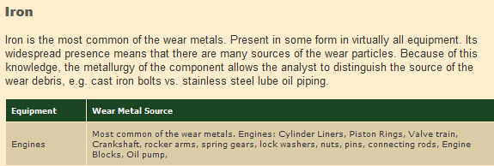
  - We saw a 60% reduction of copper (parts per million)
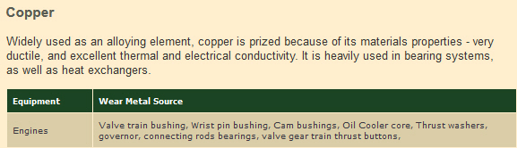
  - We saw a 47% increase miles between oil changes from 3,400 to 5,000 miles
    - Blackstone Lab reported that the oil change intervals could be increased from about 3400 miles to “…easily go 5,000 miles on the next oil, and if things continue to look this great, you might go even longer than that!”
- This data equals more savings over a long term with Xp3. Let’s say that a person changes oil
  - This vehicle averages about 8 oil changes per year and let’s say each one costs $20 = $160.
  - If you cut that in ½ you save about $80 just in oil changes, but many times that in things like:
    - Time without car payments
    - Increased resale value
    - Reduced maintenance costs
- Don’t forget: This data doesn’t even include the MPG savings which easily pays for the product.

What specific questions and/or comments do you have about any of the following things:
- Trial and/or sales process
- Objections
- Marketing to expand your business

- http://100ksalesteam.com - Free training resource for Certified GDI Sales Reps to help consistently put those steps together!

