Commercial Training 12-22-14
Questions/Comments:

Updates:
- Comprehensive Trials – We have 5 good size companies that are being considered for the trial. If you have any companies that qualify (at least 400 pieces of equipment and high monthly fuel consumption (at least 1200 to 1500 gallons of per month) – please work with them quickly if you’d like to have them considered for the trial.
- The phone system is back up and working - call (763) 493-7787. I called late this afternoon and the line is working. They are updating the “voicemail message and options” but the line is working.
- Testimonies – if you are willing to share your personal Xp3 testimony – please email a picture of yourself (or you by the vehicle – no license plates in the pics). I am building a webpage of testimonies Xp3 testimonies for the team to use.
Training/Discussion:
- Managing your customer accounts and helping them place orders that serve them!
- Best price for their needs & order quantities that take into account the “summer” and “winter” blends to avoid confusion.

- Used oil analysis process – sample reports
  - The initial analysis in June showed a developing problem in the engine.
  - The “Post-Trial” report showed that problem continued to worsen
  - Whenever possible, we want to make sure that we inform the owners of any significant issues that we become aware of prior to starting with Xp3.
  - Please make sure to tell the customer to use the same brand and type of oil throughout this process.
  - Depending on the length of the trial and frequency of oil changes, it may be possible to gather more than 2 used oil analysis reports. More analysis serve as “more data points” to compare the results. If you’d like to purchase additional “used oil analysis kits” – please contact me so we can talk with Blackstone Lab about pricing and getting the additional “samples” connected to the proper company account within GDI. These additional samples can be purchased by distributors or the trial company.
  - http://www.bobistheoilguy.com/engine-oil-analysis/
  - http://www.agatlabs.com/Brochures/Tribology%20Brochure%20Print.pdf
  - Ask operators to note on the fuel log the dates and approximate amounts of oil that had to be added between oil analysis.
  - We will make a Trial checklist for the “Trial Companies” to help with the tips for things like oil consumption and using the same type of oil.
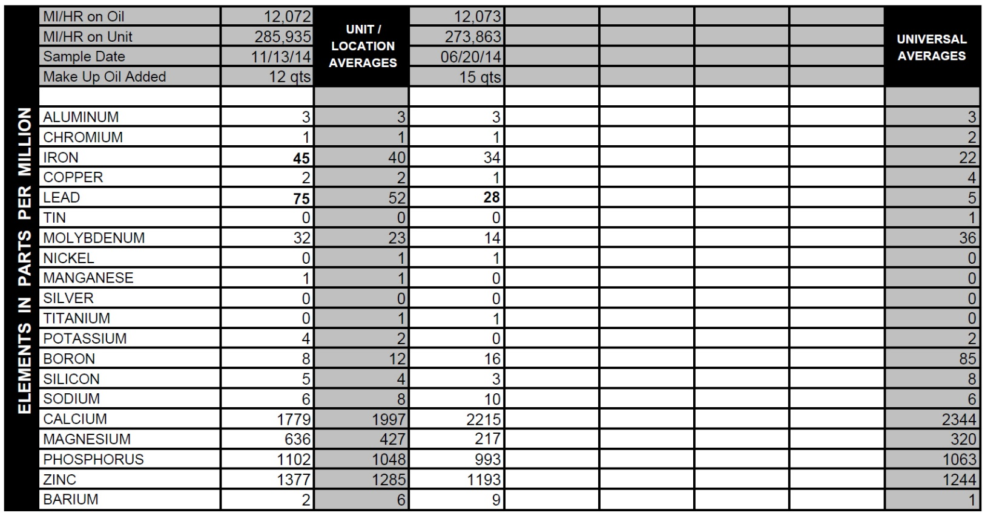

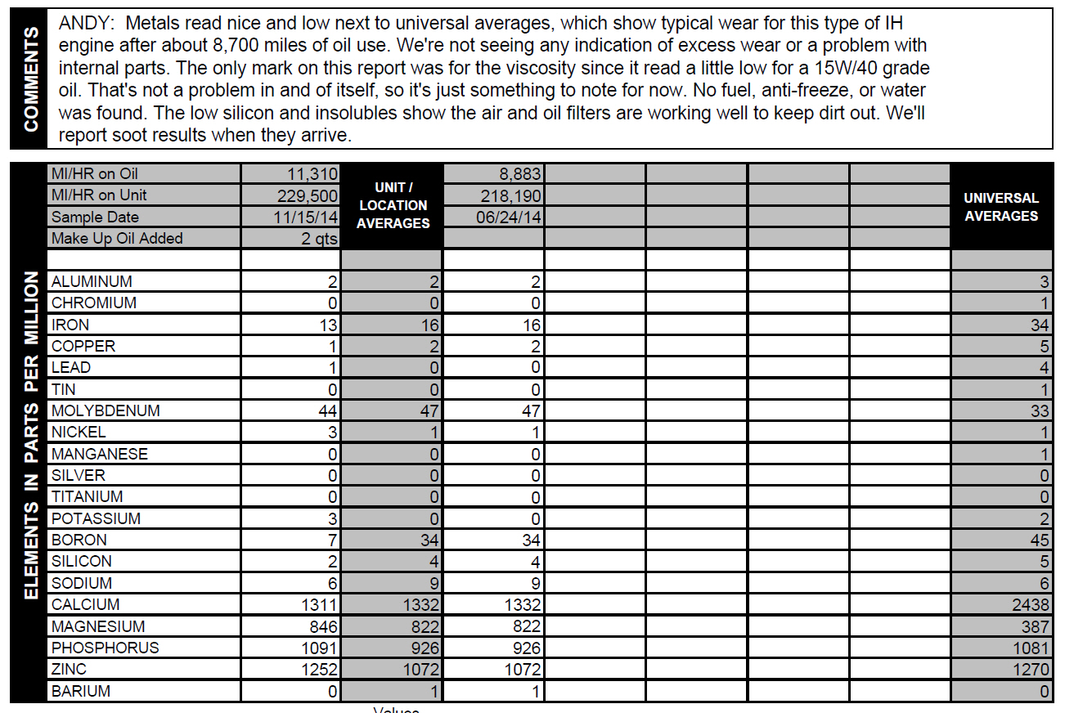

Fuel Logs –
- It is so important that we monitor the fuel logs and get a copy of the “Fuel Logs” before we start using Xp3. We are working on some “apps” that can also be used during the trial, which will allow the operator to email you the data.
- The baseline tanks are very important to the evaluation process. If we see an issue with the “baseline tank” data/tracking, we will be able to communicate with the operators to improve the process.

5 Steps To Make Sure 2015 Is A Year To Remember:
- Ask yourself better questions: What can I do to make inevitable to grow my business by …. (or whatever result you’re looking to accomplish)?
- Analyze your strengths and find ways to use them more often
- (Brian Tracy) Analyze areas where you need to improve and pick 1 area to focus on and improve
- Learn to outsource more often – use resources like Fiverr and Odesk
- Take consistent daily action towards producing those outcomes – How to eat an elephant? This is The Slight Edge!
A great resource for business owners http://www.entrepreneur.com/howto

http://100ksalesteam.com - Free training resource for Certified GDI Sales Reps to help consistently put those steps together!

http://www.entrepreneur.com/article/222521

