Commercial Training 9-20-16
Updates:
There are 3 comprehensive trials available for qualifying companies
- At least 400 pieces of equipment and at least 1000 gallons of fuel consumed per month and per piece of equipment.
- The next GDI 1 day workshop will be Saturday, November 19th from 9am to 4pm at the GDI corporate office in Maple Grove, MN. http://becomeproworkshop.com
Questions, Comments, and Successes:
- T

Fuel and Industry Related Info:
Great supplemental pdf with general information on diesel engines and fuel systems –
- http://seabeemagazine.navylive.dodlive.mil/files/2014/05/14264A-Construction-Mechanic-Basic-Chapters-5-6.pdf
Article talking about the common causes of turbocharger failure –
- http://zhome.com/ZCMnL/PICS/turboChargerBasics/turboChargerBasics.html
  - “Approximately 40% of all turbocharger failures are oil related. Contaminated or dirty oil leads to bearing scratching and scoring, which causes bearing wear and premature bearing failure.”
  - Check out 1:20 into the video showing the turbo function - https://www.youtube.com/watch?v=RVnlRKnMjhk
LinkedIn article talking about prices for truck trailer washing
- https://www.linkedin.com/pulse/its-all-details-pricing-strategies-truck-wash-business-cara-findlay
  - By using Xp3, our customers reduce the amount of soot and emissions, which means that they can reduce the frequency of trailer washings = saving money
  - Average 18 Wheeler Tractor Trailer w/5 axels (truck and trailer) = $50-$75 per wash
Great article talking about DEF fluid costs and purity
- http://www.truckinginfo.com/article/story/2013/06/def-here-to-stay.aspx
  - Example of current DEF prices (Pilot Flying J - $2.79 gallon)
    - https://pilotflyingj.com/fuel-prices
    - Average OTR truck consumes conservatively consumes about 1000 gallons of fuel each week = about 20 to 30 gallons of DEF fluid each week.
    - Take 80 gallons of DEF a month and multiply that by $2.79 = approximately $200 a month on DEF fluid.
      - Imagine if using Xp3 reduced that number by 10% = $20 per month.
        - Let’s say that same truck consumes one case of Xp3 in 5 months = $480 for a case. In this example over a 5 month period, we could help that trucker save approximately $100 on DEF. Another great secondary benefit of using Xp3.
- Great supplemental article about average DEF consumption
  - https://www.linkedin.com/pulse/20140910154005-155323188-how-much-diesel-exhaust-fluid-do-i-need-to-use
  - “Class 8 vehicles (including most tractor trailers) use between 3 and 8 gallons of DEF for every 100 gallons of diesel fuel. Off-road machinery, using a full SCR system, can use 8 to 10 gallons of DEF to every 100 gallons of diesel fuel.”

Supplemental Resources on Locomotives:
Interesting statistics and info about the efficiency of Tier 4 locomotives
- https://www.csx.com/index.cfm/about-us/the-csx-advantage/fuel-efficiency/?mobileFormat=true
PDF from April 2016 talking about the steps that locomotive fleets are taking to reduce greenhouse gases.
- https://www.aar.org/BackgroundPapers/Railroads%20and%20Greenhouse%20Gas%20Emissions.pdf
  - Great supplemental site – Association of American Railroads - https://www.aar.org/
  - Union Pacific company info (including 8500 locomotives) - http://www.up.com/aboutup/corporate_info/uprrover/index.htm
    - Video talking about diesel locomotives consuming about 2 gallons of fuel per hour at idle and up to 100 gallons an hour at highest gear - https://www.youtube.com/watch?v=nYX1qc5A-aw

Sales Training:
More insights from the book, High Probability Selling, by Jacques Worth and Nicholas E. Reuben:
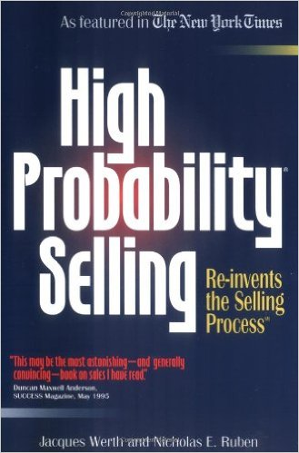

The idea is to place ourselves in a high percentage situation where we have the competitive edge. Match your strengths to the prospects who want your strengths the most.
Price, Quality, Service
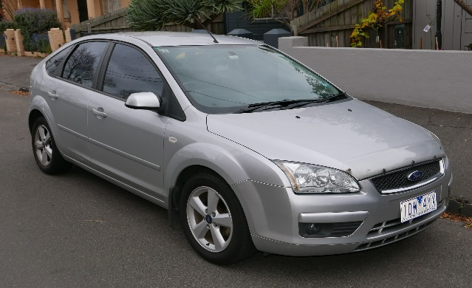
  - Xp3 is a multi-functional fuel technology (multi-functional problem solver). We offer the premier fuel enhancer technology, so why would we try to compete with them on price?
    - Our clients should not expect to have the lowest price (compared to other fuel additives)

Pg. 79
- What if someone is really interested in our product?
  - There is no commitment in interest – it is usually a cover for someone who doesn’t want to buy.
Pg. 80
- What if the prospect says, “Send me some information?”
  - “Usually when people say that to me it is a polite way of saying “Get lost”. If you want me to “Get Lost” just say so – it’s ok. I don’t send out information unless someone wants what I’m selling, needs the information, and there’s a strong likelihood that we’ll do business together once your conditions of satisfaction are met.”
Pg. 89
- “A hammer is effective whether you understand why it works or you don’t.”
  - When people want to understand every detail about Xp3.
Pg. 105
- This situation (and statement) requires posture – What to do when you are talking with one person and there are other decision makers involved (assuming you found this out before doing any presentation) –
  - You say something like, “Bob, besides yourself is there anyone else who would be involved in a decision to partner with another company?”
  - Bob replies, “Yes, my business partner Beth would also be involved.”
  - You say something like, “Great, I’m available Thursday afternoon this week or Tuesday morning next week. Which of those options would work for the three of us to meet?”
  - Bob replies, “I can meet with you and I’ll meet with Beth.”
  - You reply, “Bob, because I respect your time and want to partner with you to (insert the problem Bob wants to solve), it’s imperative that I meet with both of you at the same time. I’ve got my calendar open, when would be the next time that works for both of you?”
In high probability selling, we’re not willing to continue the sales process if Bob is unwilling to set up a time for all three of you to meet because we cannot have people selling Xp3 for us (that’s not their job or expertise).

