Commercial Training 9-19-17
Updates:
There are 3 comprehensive trials available for qualifying companies
- At least 400 pieces of equipment and at least 1000 gallons of fuel consumed per month and per piece of equipment.
The next 1-day workshop located at the Maple Grove corporate office will be
- Saturday November 18th, 2017 from 9am to 5pm
  - New GDI Reps and Certified GDI reps need to register by visiting http://becomeproworkshop.com
    - New GDI reps are required to have completed the online training before attending a workshop.
  - We invite all currently certified GDI reps to attend - there is a $25 fee for currently certified reps, which covers lunch, printed materials, and a new GDI thumb drive with current GDI documents.
    - Currently Certified Reps can purchase their $25 ticket by logging into your back office and clicking “Shop Now” > Then select your catalog > then select “Xp3” > and you’ll find Item #9700 available for purchase.
Questions, Comments, and Successes:
- Questions for Xp Lab and/or GDI -
- Marketing and Qualifying Potential Clients –
- Xp3 Questions -
- Sales Questions or Experiences You’d Like to Review –
Fuel and Industry News:
Excellent article on diesel gelling
- http://www.mycleandiesel.com/pages/SoftContaminants.aspx
  - “In the past, cold flow improvers worked very well, but in recent years their effectiveness has been reduced. ULSD is not as responsive to the benefits of cold flow improvers as higher sulfur fuel.”
  - With fuel filter filtration going down to 2 microns, they are more susceptible to catch wax crystals quicker and plug filters
  - Biodiesel can be very problematic for cold weather environments
    - “Once solid glycerin forms, in many cases it will not melt when fuel is warmed and must be physically removed through tank cleaning and/or filtration.”
      - Great supplemental article talking about glycerin
        - http://www.mycleandiesel.com/pages/Glycerin.aspx
        - “Gelling and glycerin solids are frequently confused…”
        - http://www.biodieselmagazine.com/articles/3237/glycerin-research-turns-up-new-uses
          - “1/10th of every gallon of biodiesel that is produced is crude glycerin. Colorless, odorless, and viscous liquid.”
  - Of course, it is also important to eliminate free water in fuel filters
  - If our clients are at all concerned about the potential for gelling, please recommend the Xp3 Winter Xtreme.
    - Remember that Xp3 Winter Xtreme adds up to an additional 35 degrees of Pour Point (PP) protection to the base fuel.
      - Important: Do not quote a specific degree of protection because that depends on the base fuel
Good article from 2016 on DPF, regenerations, ash, etc.
- https://www.vehicleservicepros.com/on-the-vehicle/powertrain/emissions/article/12182572/the-good-and-bad-of-diesel-particulate-filter-regenerations
  - If the DPF is not cleaned properly or often enough, it can cause problems including loss of power, loss of MPG, cracked filters, and engine damage
  - Only about 20% of the ash can be burned off in the regeneration process, which is why DPF require hard cleaning at least every 150K
    - Great supplemental article - https://cumminsengines.com/cummins-particulate-filter
    - Passive regeneration – occurs at normal operating temperatures and does not effect operation or performance of the vehicle
      - https://www.perkins.com/en_GB/products/emissions_technology/emissions-technology/passive-regeneration.html
    - Active regeneration – occurs at higher temperatures because a small amount of fuel is injected into the exhaust stream to raise the temp and oxidize the particulate matter
    - Stationary or parked regeneration – is not necessary very often and
    - Ash is found in DPF’s because of incombustible material in the diesel oil additive package. This ash remains trapped in the DPF, which will eventually need to be hard cleaned or replaced.
  - By using Xp3, we improve combustion which as means less soot and PM is produced, which extends DPF life.
Supplemental Fuel and Industry News:
- No new articles this week

Sales Training:


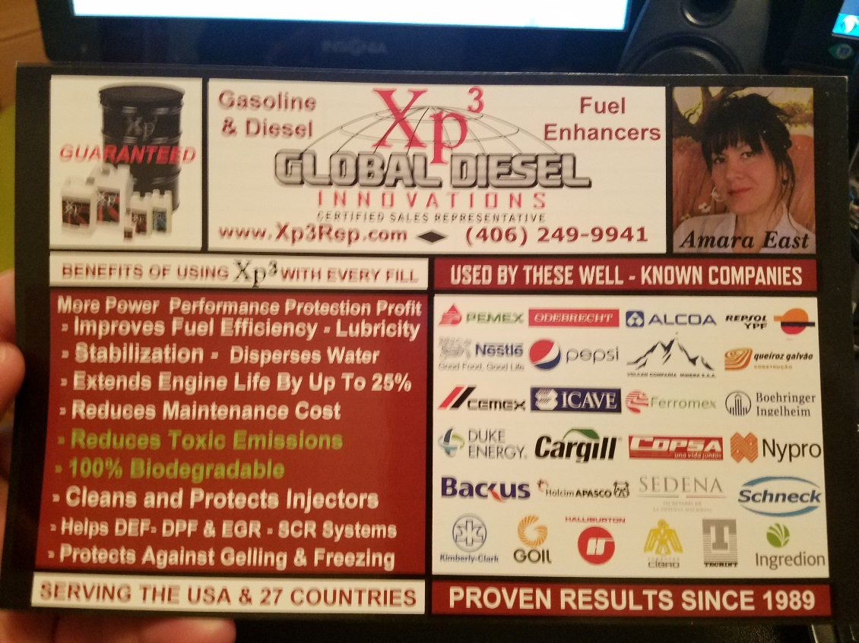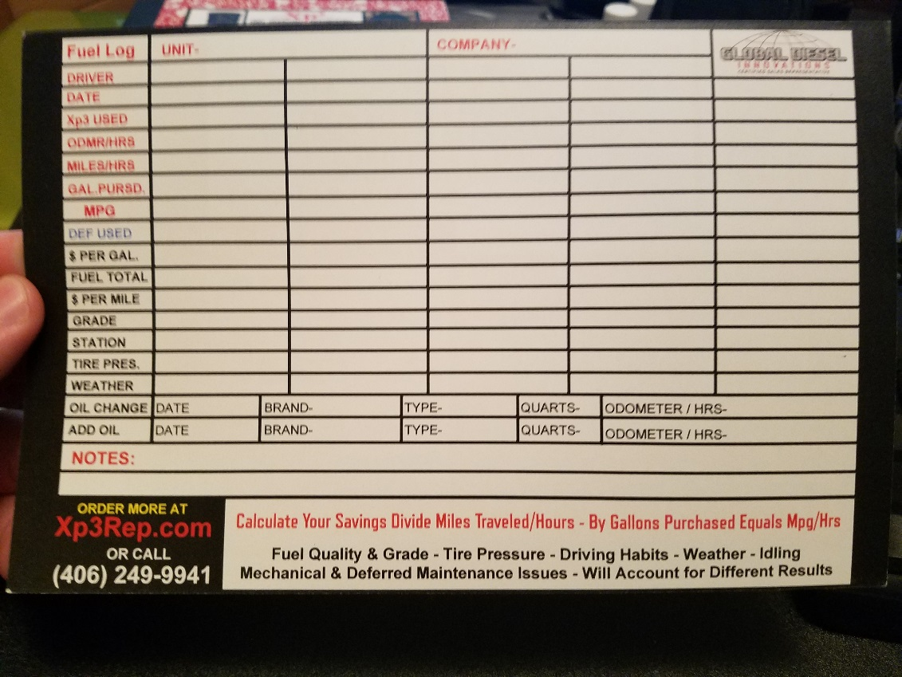

Great video I found talking about the importance of prospecting
- https://thesalesblog.com/2017/09/06/prospect-now-or-pay-later-episode-195/
  - Talks about discipline, doing consistent prospecting – especially when things are going great.
We have just over 3 months left in 2017.
What can you now to start preparing yourself for success in the rest of 2017 and the start of 2018?
- Check out the GDI checklist
Article that indirectly deals with what happens when you don’t have the decision makers clearly identified, Conditions of Satisfaction clearly identified, AND when you don’t hold your value.
- https://www.salesgravy.com/sales-articles/negotiating/Never-Let-a-Customer-Pay-in-Promises-or-Compliments
  - “…with the results they would achieve, he would be able to take it “up” the chain and that it would lead to so much more business I better start staffing up now.”
    - This manager didn’t have the authority to make a decision for the other “branches” and the sale never materialized.
  - When dealing with companies with multiple locations, branches, or hubs; help them see the value at the retail price and use larger size containers and volume discounts to increase the value for the customer.
Article from Sales Gravy blog about talking with a gatekeeper
- https://www.salesgravy.com/sales-articles/objections/A-Guide-to-Getting-Past-Gatekeepers
  - “Using please three times, you will be put through an astounding 60% of the time without any additional screening.”
Additional Sales Resources:
59 Sales Quotes (reminders) to Help You Close More Sales
- https://www.marcwayshak.com/sales-quotes/
  - #10 – We don’t want to persuade everyone to buy from us, we want the right people to buy from us!
  - #14 – There is no room in sales for improvisation
  - #31 – Always answer a question with a question
    - “That’s a great question and I’ll be happy to answer it in a moment. Just curious, if you feel positive and see green lights based on the answer I provide, does that mean you’ll be ready to move forward in our partnership today?”
  - #35 – Have a collection of case studies that appeal to a prospect’s hurt
  - #41 – Create a clear and effective playbook and follow it consistently
  - #59 – What gets tracked gets done

Marketing Resources:

