Commercial Training 9-1-15
Updates:
- On Wednesday (September 16th), Mauricio and Alan will be doing a live training at the GDI office in Minnesota. Please start thinking of questions that you’d like to get answered and email them to tom@peakadvantageconsulting.com or tom@partnerwithgdi.com
- You should have seen an email from corporate inviting you to register and attend the event if you are able. I will be talking with Randy regarding the possibility of recording the training for those who are not able to attend.
- We still have 3 comprehensive trials available for qualifying companies, but are working on 1 right now.
  - At least 400 pieces of equipment and at least 1000 gallons of fuel consumed per month and per piece of equipment.

Training Information
Recent Meetings/Demos, Questions, or Success Stories:
- Recent Meetings/Demos:

- Questions:

- Success Stories:

Your business depends on 2 areas of focus:
  - Getting more companies to try Xp3
    - Finding interested companies (a.k.a. – getting leads)
    - Guiding them to make a decision to partner with us
    - Partnering with them through a trial
    - Meeting after the trial and proving the results
  - Getting consistent repeat orders
    - Setting up a schedule for repeat orders
      - Having the belief (and proof) that your customers are better with Xp3
    - Getting referrals and testimonies
- Pick at least 1 skill to improve in each of the 2 areas listed above.

The little things make a difference -
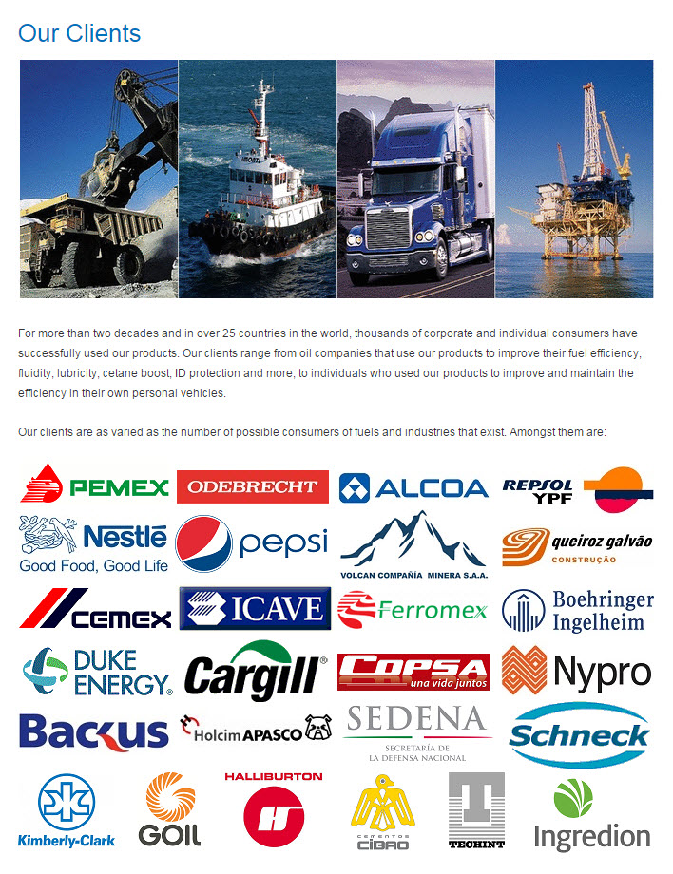

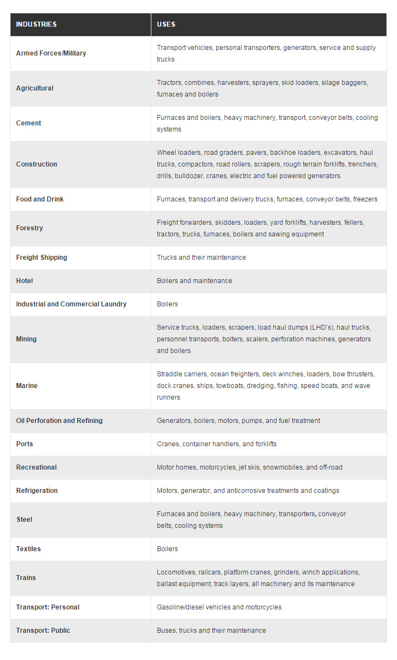

How do you feel about selling?
Do you consider yourself to be a salesperson?

Bob Marx Tips:
- If someone asks, “Why should I buy from you?” or any question like that - try responding with
  - “I can tell you why other people have bought from me (list two or three reasons) and then say “Do any of those reasons mean anything to you?” Great posture!
- Your prospects want to know that you’re an expert in getting them the results they want.
- It’s not our job to make people interested and it’s not our job to give away our expertise without the customer knowing what’s going to happen after you share your knowledge/offer.
- Get them to tell you all the reasons they should buy –
- If we say it – it could be BS, but if they say it – it’s great!
  - Tell stories and ask great questions
- Let go of the outcome – we can only control what we put into the process. They have to want to buy!
- “Hi Jim – this is Tom Spudic with GDI. Don’t worry about calling me back – I’ll call back on (day). Just wanted to share this… (information, thought, story, etc.”
- Someone saying “no” is not saying “no” to you.
- Let go of pressure and anxiety – we’re simply trying to find out if the person is Beth or Bob.
Grant Cardone:
- Presentation, skill, posture – close someone on Xp3
- Value is exchanged when a purchase is made
- We are all closers – we have to ask for the person’s business
- Do you know what causes someone to make a decision?
  - “Once you know that – you can repeat those steps, help more people, and make more money!”
- We are not paid to be a salesperson – we are paid to close sales!

https://www.youtube.com/watch?v=Wrb4pl03xCg 1 ounce of water can cause phase separation in 1 gallon of ethanol gasoline.
http://mitspages.com/mits/ITP/itb1

- http://100ksalesteam.com - Free training resource for Certified GDI Sales Reps to help consistently put those steps together!

