Commercial Training 8-8-17
Updates:
There are 3 comprehensive trials available for qualifying companies
- At least 400 pieces of equipment and at least 1000 gallons of fuel consumed per month and per piece of equipment.
- The next 1-day workshop located at the Maple Grove corporate office will be
  - Saturday August 19th, 2017 from 9am to 5pm
    - New GDI Reps and Certified GDI reps need to register by visiting http://becomeproworkshop.com
    - New GDI reps are required to have completed the online training before attending a workshop.
  - We invite all currently certified GDI reps to attend - there is a $25 fee for currently certified reps, which covers lunch, printed materials, and a new GDI thumb drive with current GDI documents.
    - Currently Certified Reps can purchase their $25 ticket by logging into your back office and clicking “Shop Now” > Then select your catalog > then select “Xp3” > and you’ll find Item #9700 available for purchase.
Questions, Comments, and Successes:
- Questions for Xp Lab and/or GDI -
- Marketing and Qualifying Potential Clients –
- Xp3 Questions -
- Sales Questions or Experiences You’d Like to Review -
Fuel and Industry News:
Great article with updates on new CK-4 and FA-4 oils
- http://trucker.com/trucks/nine-months-update-ck-4fa-4
  - “It is highly recommended that a used oil analysis program is implemented when extending drain intervals…”
    - “Just curious if any of fleets have switched over to the API CK-4 or FA-4 oils?” (CK-4 is backward compatible & FA-4 compatibility depends on OEM)
      - If so, ask “About how many miles are you averaging between oil changes?”
        - This opens the door for sharing this article about the importance of used oil analysis. If they are already doing used oil analysis, you have an easy way for them to prove the lubricity benefits of Xp3.
          - Be sure to ask if they are doing soot analysis as part of their used oil analysis.
  - Supplemental article about CK-4 and FA-4 compatibility
    - http://www.truckinginfo.com/blog/pc-11-the-new-engine-oils/story/2016/09/q-what-is-the-difference-between-ck-4-and-fa-4-oils.aspx
Article talking about 26 states that have raised fuel taxes for highway funding
- http://www.equipmentworld.com/more-than-half-of-all-u-s-states-have-raised-fuel-taxes-for-highway-funding/
  - Increased operating expenses for companies and owner operators
    - Tremendous opportunity to market to companies in these states because Xp3 provides an additional opportunity to save money regardless of the inevitable increases in fuel.
Supplemental Fuel and Industry News:
Interesting article talking about ways to boost working capital for trucking companies
- http://trucker.com/business/how-boost-working-capital-your-trucking-company
  - Xp3 is a great way to address the section “Look for ways to save on your expenses”

Sales Training:
Takeaways from a conversation with a GDI teammate and myself with a large company (over 1500 pieces of equipment) this week.
- One of the decision makers was “skeptical” and questioning why they should pay more for an additive when they already have a high fuel bill and very small budget.
  - What thoughts come to mind from that statement?
- I also asked if they own or lease their equipment?
  - Why did I ask that question?
    - How long do you usually keep your equipment?
- Another question I asked was “What percentage of your fleet is under Tier 4 emission standards?”
  - Why did I ask that question?

The difference between marketing and prospecting
- Marketing is typically indirectly talking with your potential leads/customers using things like paid advertising, blogs, podcasts, social media pages/posts, videos, etc.
- Prospecting is done by talking directly to people we know or meet. Prospecting can be done by talking to people individually, at trade shows, through referrals, using social media, etc.
- How many of you would agree that in order for a business to grow, the business must be doing at least one of these things really well?
  - Which of these is how you are primarily growing your business? (could be both)
- On a scale from 1 to 10 with 10 being “GREAT”, how would you rate your prospecting and/or marketing?
  - If you were asked to pic an area to improve that would make it inevitable to improve in prospecting or marketing, what would that specific item be?
Great article on product selling to consultative selling
- https://blog.hubspot.com/sales/how-to-create-a-great-sales-pitch
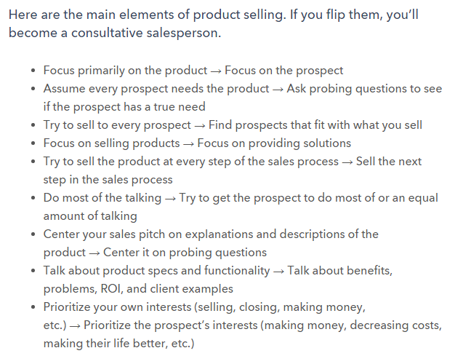
- T

Supplemental Sales Resources:
I came across a great article on Hubspot featuring 50 sales quotes
- https://blog.hubspot.com/sales/motivational-quotes-sales-drive-2015

Marketing:
Great article talking about some of the ways social media marketing has changed
- https://blog.hubspot.com/marketing/future-of-social-media-trends

Insights from the book S.P.I.N. Selling by Neil Rackham
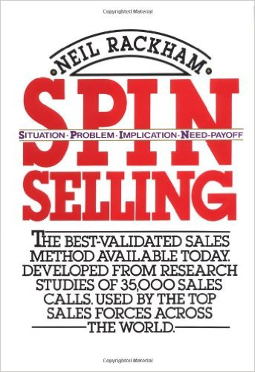
- Success in the sales process for products/services over $100 means the lead did 1 of the following things:
  - Purchased – the customer orders product
  - Advanced – the potential customer agrees to attend a demonstration or meeting, gets you in front of other decision makers, agrees to run a trial, or gets you access to other parts/members of the company you previously did not have access to.
- Failure In the sales process for products/services over $100 means the lead did 1 of the following things
  - Continuation – no specific action has been agreed upon to move the sale forward
    - “Why don’t you visit us again the next time you’re in the area.”
    - “Great information, give us a call in the spring”
    - “We liked what we saw and want to do some research so we’ll call you if we’re interested in going ahead.”
  - No sale – the lead makes it clear that no sale was possible in now or in the future.
- Our goal is to get more purchases and advances AND to turn continuations into advances
The key is to refer back to the checklist and start tracking -
-------------------------------------------------------------------------------------------------------------------------------------
https://blog.hubspot.com/marketing/ai-marketing-use-cases

