Commercial Training 8-4-15
Updates:
We still have 3 comprehensive trials available for qualifying companies, but are working on 1 right now.
- At least 400 pieces of equipment and at least 1000 gallons of fuel consumed per month and per piece of equipment.
- Request – please continue to ask for testimonies (16 oz. bottle of Xp3 for each useable testimony).

Training Information
Recent Meetings/Demos, Questions, or Success Stories:
- Recent Meetings/Demos:

- Questions:

- Success Stories:

Building Your Business
- Your business depends on 2 areas of focus:
  - Getting more companies to try Xp3
    - Finding interested companies (a.k.a. – getting leads)
      - DEF/Emissions related issues
      - Anti-gel
    - Guiding them to make a decision to partner with us
    - Partnering with them through a trial
    - Meeting after the trial and proving the results
  - Getting consistent repeat orders
    - Setting up a schedule for repeat orders
      - Having the belief (and proof) that your customers are better with Xp3
    - Getting referrals and testimonies
- Pick at least 1 skill to improve in each of the 2 areas listed above.

Website Resources
Phase separation and problems caused by ethanol:
What is phase separation?
Alcohol is hydrophilic (absorbs water), which causes problems in fuel. There is a point when a certain amount water is absorbed by the ethanol (in gasoline) that causes the ethanol to separate from the gasoline and form a water/ethanol layer at the bottom of a tank. Phase separation becomes worse with higher percentages of ethanol and lower temps.
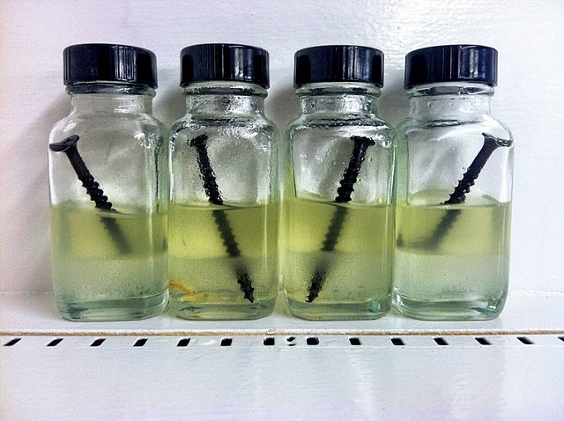
  - Great PDF explaining examples of gasoline’s ability to absorb and hold water VS. gasoline/ethanol blends - http://www.epa.gov/OMS/regs/fuels/rfg/waterphs.pdf
  - “…leaves gasoline at the top level of the tank with a lower ethanol content and a reduced octane level.” http://k-100.com/?page_id=3231
- Octane and water issues:
  - Lower octane and pre-ignition problems
    - Increasing temperature/pressure that pre-ignite pockets of air/fuel mix
      - Great video explaining engine knock and the causes of it –
        - https://www.youtube.com/watch?v=maZyPJIOknE
  - Water can cause major damage to internal engine parts – such as injectors
Another great resource about phase separation http://www.lcbamarketing.com/phase_separation_in_ethanol_blen.htm

- Micro-Organisms
  - When ethanol separates from fuel because of phase separation, there is a layer of water that settles at the bottom of the tank.
    - There is layer where the water and ethanol meet where micro-organisms begin to feed.
    - There micro-organisms multiply and produce more waste which causes sludge and “acidic byproducts”.
      - In certain conditions – can cause filters and fuel systems to plug
      - Can cause corrosion and/or tank failure in some instances
    - Accelerated Corrosion and Conductivity - http://k-100.com/?page_id=3231
      - Ethanol has “higher electrical conductivity and oxygen content” compared to gasoline.
        - Can cause galvanic corrosion and rusting because of high oxygen environment.
        - In certain conditions, “…can lead to corrosion and ultimately metal loss in various components that are not normally impacted by gasoline.”

- Older engines have parts that were not made to handle ethanol –
  - http://www.popularmechanics.com/cars/hybrid-electric/a6244/e15-gasoline-damage-engine/
    - “…corrosive and can degrade plastic, rubber or even metal parts in the fuel system that weren't engineered to use alcohol-bearing fuel.”

- http://www.lcbamarketing.com/phase_separation_in_ethanol_blen.htm

General Questions:

- http://100ksalesteam.com - Free training resource for Certified GDI Sales Reps to help consistently put those steps together!

