Commercial Training 8-22-17
Updates:
There are 3 comprehensive trials available for qualifying companies
- At least 400 pieces of equipment and at least 1000 gallons of fuel consumed per month and per piece of equipment.
The next 1-day workshop located at the Maple Grove corporate office will be
- Saturday November 18th, 2017 from 9am to 5pm
  - New GDI Reps and Certified GDI reps need to register by visiting http://becomeproworkshop.com
    - New GDI reps are required to have completed the online training before attending a workshop.
  - We invite all currently certified GDI reps to attend - there is a $25 fee for currently certified reps, which covers lunch, printed materials, and a new GDI thumb drive with current GDI documents.
    - Currently Certified Reps can purchase their $25 ticket by logging into your back office and clicking “Shop Now” > Then select your catalog > then select “Xp3” > and you’ll find Item #9700 available for purchase.
Questions, Comments, and Successes:
- Questions for Xp Lab and/or GDI -
- Marketing and Qualifying Potential Clients –
- Xp3 Questions -
- Sales Questions or Experiences You’d Like to Review –
- Motorhome was about 8 mpg before using Xp3 and went to 12 mpg
Fuel and Industry News:
At our GDI training, we tested a new water dispersion resource:
We now have the ability to show water suspended in diesel fuel where previously we could only show the water that had settled out at the bottom of the tank.
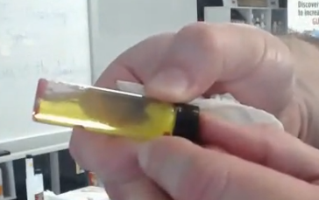
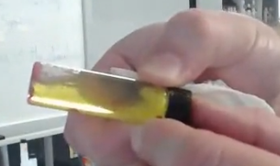
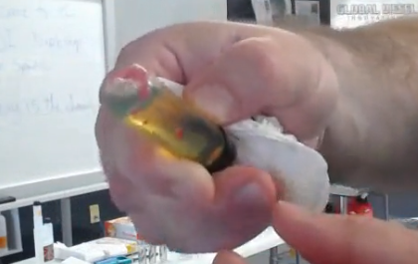
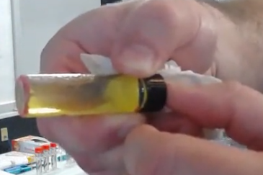

Here is another screenshot showing an example from a video provided by the company as an example for the water contamination.
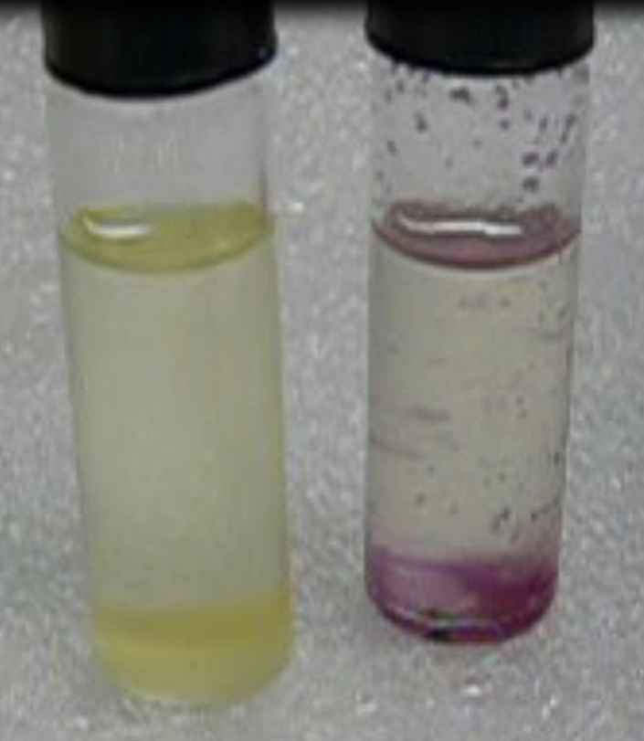
At the end of the training, we tested water and Xp3 and then used a “capsule” to prove that the water was dispersed and the “powder” stayed white.
THIS IS HUGE BECAUSE IT PROVES Xp3 DISPERSES WATER IN SUPSENSION
Supplemental Fuel and Industry News:
ATRI (American Transportation Research Institute) is conducting a survey to get feedback on the top issues and concerns for the transportation industry.
- https://atri.checkboxonline.com/2017-Top-Industry-Issues.aspx
There has been more discussion about the review of Phase 2 Greenhouse Gas Emissions and Fuel Efficiency Standards
- http://www.truckinginfo.com/news/story/2017/08/greenhouse-gas-rule-review-pleases-trailer-makers-concerns-some-stakeholders.aspx
Sales Training:

Supplemental Sales Resources:
Interesting article on ways to be persistent in your sales process
- https://blog.hubspot.com/sales/persistence-in-sales
Another interesting article with 25 sales experts to follow on Twitter
- https://blog.hubspot.com/sales/sales-experts-twitter

Supplemental Marketing Resources:

Insights from the book S.P.I.N. Selling by Neil Rackham

- Success in the sales process for products/services over $100 means the lead did 1 of the following things:
  - Purchased – the customer orders product
  - Advanced – the potential customer agrees to attend a demonstration or meeting, gets you in front of other decision makers, agrees to run a trial, or gets you access to other parts/members of the company you previously did not have access to.
- Failure In the sales process for products/services over $100 means the lead did 1 of the following things
  - Continuation – no specific action has been agreed upon to move the sale forward
    - “Why don’t you visit us again the next time you’re in the area.”
    - “Great information, give us a call in the spring”
    - “We liked what we saw and want to do some research so we’ll call you if we’re interested in going ahead.”
  - No sale – the lead makes it clear that no sale was possible in now or in the future.
- Our goal is to get more purchases and advances AND to turn continuations into advances
The key is to refer back to the checklist and start tracking -
-------------------------------------------------------------------------------------------------------------------------------------
https://blog.hubspot.com/marketing/ai-marketing-use-cases

