Commercial Training 8-15-17
Updates:
There are 3 comprehensive trials available for qualifying companies
- At least 400 pieces of equipment and at least 1000 gallons of fuel consumed per month and per piece of equipment.
- The next 1-day workshop located at the Maple Grove corporate office will be
  - Saturday August 19th, 2017 from 9am to 5pm
    - New GDI Reps and Certified GDI reps need to register by visiting http://becomeproworkshop.com
    - New GDI reps are required to have completed the online training before attending a workshop.
  - We invite all currently certified GDI reps to attend - there is a $25 fee for currently certified reps, which covers lunch, printed materials, and a new GDI thumb drive with current GDI documents.
    - Currently Certified Reps can purchase their $25 ticket by logging into your back office and clicking “Shop Now” > Then select your catalog > then select “Xp3” > and you’ll find Item #9700 available for purchase.
Questions, Comments, and Successes:
- Questions for Xp Lab and/or GDI -
- Marketing and Qualifying Potential Clients –
- Xp3 Questions -
- Sales Questions or Experiences You’d Like to Review -
Fuel and Industry News:
Not a lot of news directly related to fuel and Xp3, but numerous supplemental articles

Supplemental Fuel and Industry News:
Article talking about small trucking fleets
- http://www.truckinginfo.com/channel/fleet-management/article/story/2017/08/inside-the-small-fleet.aspx
  - There are more than ½ million “for hire” carriers and 97% own fewer than 20 trucks
  - “Comdata recently shared with us some research it’s done on small fleets of 100 trucks and fewer. Out of its respondents, the biggest group was the 2-10 truck segment at 53%.”
    - The very encouraging part of working with these companies is that it’s usually pretty easy to contact a decision maker, which can help speed up the decision-making cycle!
Interesting article talking about the challenges of measuring fuel economy
- http://fleetowner.com/ideaxchange/challenges-measuring-fuel-economy
  - “The easiest measurement is taken from the CAN bus using telematics. It’s a well know fact that CAN bus fuel consumption is an estimate based on the engine maker’s own algorithm. It’s usually optimistic.”
External factors have a big influence on MPG:
- Payload
- Increase or decrease in elevation
- The driver (who can influence fuel consumption by 30% or more)
- Temperature
Supplemental article on drivers effecting fuel economy
- http://www.truckingtruth.com/wiki/topic-49/truckers-fuel-efficiency
Interesting article talking about the savings of fuel and emissions reduction associated with diesel emissions equipment in trucks from 2011 to 2016
- http://www.truckinginfo.com/channel/fuel-smarts/news/story/2017/08/state-truck-fleet-benefits-from-clean-diesel.aspx
  - Saved an estimated 4.2 billion gallons of fuel
    - By comparison, the USA consumes about 35 billion gallons of diesel (on highway) each year
  - 43 million tons of CO2
  - 31 million tons of NOx, and 1.2 million tons of particulate matter.
  - Supplemental article with interesting statistics on emissions
    - https://www.greenbiz.com/article/top-us-truck-fleets-pave-way-fuel-efficiency
    - “It takes about 80 trucks today to emit the same levels of pollutants as one truck built in 2000.”
Interesting supplemental article talking about Cummins DPFs compared to “will fit” DPFs
- http://www.overdriveonline.com/partner-solutions-article/cummins/the-best-answer-to-a-1400-question/

Webpage that shows price comparisons between diesel and alternative fuels
- https://act2017.wpengine.com/actcalc/AltFuelCalculator.php
Interesting article talking about the challenges of measuring fuel economy
- http://fleetowner.com/ideaxchange/challenges-measuring-fuel-economy
Sales Training:
Welcomed Guest or Uninvited Pest – Dan Kennedy
- This is the key distinction in the sales process
- We are either going to put ourselves in a path to be “invited” into the conversation with potential clients OR get the skills to help us quickly transition from “pest to guest”.
I came across a hubspot article on 13 sales related podcasts, so I checked out some of them.
- https://blog.hubspot.com/sales/top-sales-podcasts
In the “Advanced Sales Podcast” one of the episodes was talking about potential customers who say they don’t have a budget for the product right now. Their response can be summarized by this statement: “There is an unlimited budget for things that produce results!”
- Here is a suggestion they gave for starting that discussion and I added a question at the end that I learned from a Tony Robbins sales and persuasion training.
- “I appreciate the importance of budget and I want to make sure we’re both looking at budget the same way. Would you agree that when it comes to budget, if something is easy to implement and actually pays you to use it through savings – then the question we should be asking is where can we find the money for that solution in the budget?”
Another article from HubSpot on why salespeople should never ask “Is this a bad time to talk?”
- https://blog.hubspot.com/sales/reasons-why-salespeople-should-never-ask-bad-time-to-talk
  - A sales call is an interruption in their day, but they picked up the phone. The only thing you can do is learn and hone the skills to help your “interruption” become profitable for your potential customer?
  - You’re making the prospect think about their schedule and workload
  - Everyone asks it
  - You’re wasting the opportunity to make an impact
    - “Hi Beth - do you have a clock or cell phone you? Fantastic, my name is Tom and the reason I asked is so you can keep track that this call will be 1 minute.
      - “Increasing your company’s profits, reducing maintenance costs and down time, or keeping your equipment running better and longer. Which of those 3 would help your company the most?
        - “Whoa, what are you selling?”
      - Thanks for asking. As I said, my name is Tom and the purpose for this call is to offer a solution, which helps companies to do the 3 things I just mentioned. Which of the 3 things do you think would help your company the most.”
        - “So what are you actually selling?”
----------------------------------------------------------------------------------------------------------------------------
Timeout: This conversation would not be going this way if we were an invited guest!
----------------------------------------------------------------------------------------------------------------------------
    - “That’s a great question, if you have about 10 minutes, I’ll be happy to share it with you right now. Is now a good time?”
      - If “Yes”. Before we get started, in addition to yourself, is there anyone else we need to invite to this meeting - like the person who handles the finances and signs the checks or the person in charge of the fuel and maintenance for your fleet?
        - If they say there are other people and they can’t be in the meeting right now. “No problem. So we don’t waste your time OR mine, let’s schedule a meeting when all of us can get together at the same time. Can we take care of that right now together?
          - If yes, you know what to do. If no, “Beth are you willing to talk with (name(s) of people who also need to be in the meeting) and find out some days/times that work for all of you and get back to me?”
      - If “No.” I completely understand. How does (insert 2 days like - Thursday or Friday) work best for us to meet for 10 minutes? Great. How does 10 am work for you?
        - If that doesn’t work, let them propose a day/time.
      - One last thing, my name is Tom and please grab a pen and write down my direct number in case you need to reach me between now and (appointment date).
        - Great, thanks for your time and I look forward to our 10 minute call on (day/time).
  - You broadcast insecurity
    - There is nothing worse than “needing a sale”
  - Buyers expect it and it signals “sales call”
    - Our goal is to get attention
I came across an article from HubSpot with 20 different suggestions to get attention with your closing for your emails
- https://blog.hubspot.com/sales/email-sign-offs-put-best-thanks-to-shame
Great article with an important point on objections:
- https://blog.hubspot.com/sales/what-to-do-when-you-get-tough-objection
  - “Only the prospect can overcome an objection!”
    - “Reverse the direction of the conversation to get into a deeper conversation to uncover more information about what’s important to the prospect.”
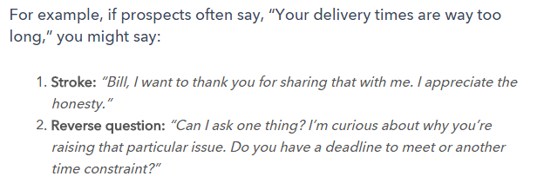
T

Supplemental Sales Resources:

Supplemental Marketing Resources:

Insights from the book S.P.I.N. Selling by Neil Rackham
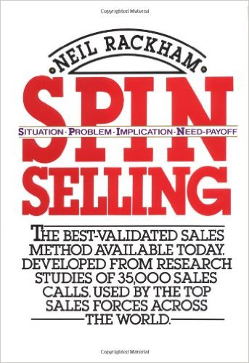
- Success in the sales process for products/services over $100 means the lead did 1 of the following things:
  - Purchased – the customer orders product
  - Advanced – the potential customer agrees to attend a demonstration or meeting, gets you in front of other decision makers, agrees to run a trial, or gets you access to other parts/members of the company you previously did not have access to.
- Failure In the sales process for products/services over $100 means the lead did 1 of the following things
  - Continuation – no specific action has been agreed upon to move the sale forward
    - “Why don’t you visit us again the next time you’re in the area.”
    - “Great information, give us a call in the spring”
    - “We liked what we saw and want to do some research so we’ll call you if we’re interested in going ahead.”
  - No sale – the lead makes it clear that no sale was possible in now or in the future.
- Our goal is to get more purchases and advances AND to turn continuations into advances
The key is to refer back to the checklist and start tracking -
-------------------------------------------------------------------------------------------------------------------------------------
https://blog.hubspot.com/marketing/ai-marketing-use-cases

