Commercial Training 7-14-15
Updates:
We still have 3 comprehensive trials available for qualifying companies
- At least 400 pieces of equipment and at least 1000 gallons of fuel consumed per month and per piece of equipment.
- Request – please continue to ask for testimonies (16 oz. bottle of Xp3 for each useable testimony).
We will have our Commercial Call next Wed 7-22 instead of Tuesday

Training Information
Emissions Benefits:
- http://www.overdriveonline.com/emissions-system-newer-trucks-potential-handicap/
- “For buyers of new post-2010 emissions-spec equipment in Overdrive’s survey, 23 percent reported the emissions system as their most significant maintenance issue.”
- http://blogsdir.cms.rrcdn.com/8/files/2015/07/Overdrive-2015-Truck-Purchase-and-Lease-Survey.pdf
Out of the 496 truckers surveyed –
- 59.9% bought a new truck
- 22.8% bought a used truck
- 12.6% bought, leased, or built a “glider”
  - http://www.truckinginfo.com/article/story/2011/07/is-there-a-glider-kit-in-your-future.aspx
  - https://www.youtube.com/watch?v=V-8gWxJVH60
    - “…The Environmental Protection Agency will allow the engine in the glidered truck to match the certification of the "donor" truck, which means if you're tearing down a 2001 model truck and dropping those components into your glider, the glider would be a 2001 model for EPA certification purposes.”
Mexican Petroleum Institute - http://xplab.com/wp-content/uploads/2015/05/LabTest_Xp3D_Emissions_Particles-Pemex_Eng.pdf
- 38.5% reduction in particulate emissions

Lubricity Benefits:
http://www.overdriveonline.com/emissions-system-newer-trucks-potential-handicap/
- “If I were a used-truck buyer,” notes Fleet Advantage’s Mike Meehan, “I’d be very reluctant to buy if I can’t see maintenance and repair records”
http://xplab.com/lab-tests - look under the HFRR study labeled as “Lubricity1”
- Showed a 16.6% improvement in lubricity by treating Xp3 at the standard dosages rate.
Antibacterial Benefits:
I spoke with Alan (Xplab) today and he informed me that they expect to have testing results showing the benefits of Xp3 related to microbial growth.
- http://www.oillab.co.nz/diesel_bug_explained
- As many as 27 different bacteria cause a majority of problems with diesel fuel.
  - “Bacteria utilize hydrocarbons and reproduce...double their numbers every 20 minutes – one spore converting to 262,144 in 6 hours.”
  - “….when water is present (a droplet is a lake to a microbe)…”
  - http://www.mycleandiesel.com/pages/ProblemMicrobialGrowth.aspx
  - http://www.hpcdfuel.com/pdf/DOWfuel_training.pdf
Anti-gel Benefits:
In my conversation with Alan, he also said he would be sending some information in the next few weeks on their plan for Xp3W next winter to help address the gelling issues.

Fuel Benefits: We are well aware of these, so we won’t spend time on this today. The trial covers this process.
- http://www.thetruckersreport.com/infographics/cost-of-trucking/

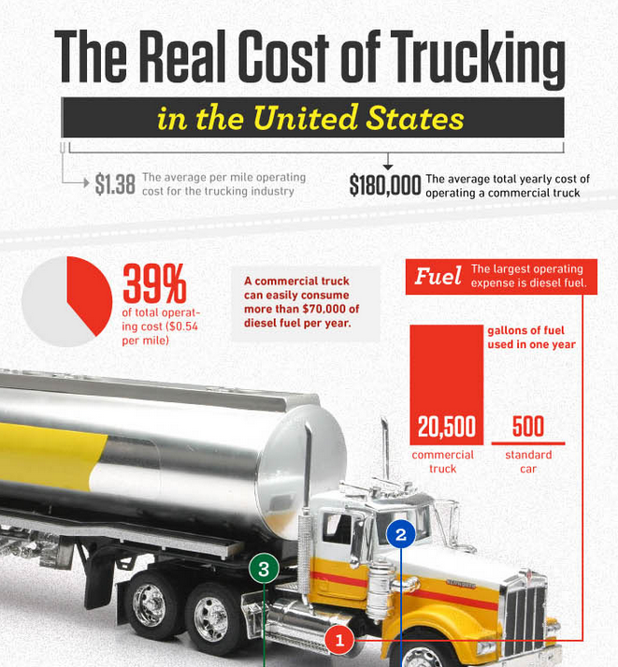

Sales Training - 3 common mistakes sales people make when talking to c-suite
- Being underprepared – the c-suite expects you to know about their business and industry.
- Mindset and attitude – project confidence, how you speak, how you sit, and how you stand
- Not thinking at all levels – aspirations (what do we want to achieve), afflictions (what pain are they trying to solve or deal with), risk
https://www.youtube.com/watch?v=6gWABvE5_lQ

- http://100ksalesteam.com - Free training resource for Certified GDI Sales Reps to help consistently put those steps together!

