Commercial Training 6-6-17
Updates:
There are 3 comprehensive trials available for qualifying companies
- At least 400 pieces of equipment and at least 1000 gallons of fuel consumed per month and per piece of equipment.
- The next 1 day workshop located at the Maple Grove corporate office will be
  - Saturday June 24th, 2017 from 9 am to 5 pm
  - Saturday August 19th, 2017 from 9am to 5pm
    - New GDI Reps and Certified GDI reps need to register by visiting http://becomeproworkshop.com
    - New GDI reps are required to have completed the online training before attending a workshop.
  - We invite all currently certified GDI reps to attend - there is a $25 fee for currently certified reps, which covers lunch, printed materials, and a new GDI thumb drive with current GDI documents.
    - Currently Certified Reps can purchase their $25 ticket by logging into your back office and clicking “Shop Now” > Then select your catalog > then select “Xp3” > and you’ll find Item #9700 available for purchase.
Questions, Comments, and Successes:
- Questions for Xp Lab and/or GDI -
- Marketing and Qualifying Potential Clients –
- Xp3 Questions -
- Helping Customers Prove Benefits –
- Sales Questions or Experiences You’d Like to Review -
- Referrals and Testimonials –
- Books/Resources –
Fuel and Industry News:
Article related to school bus fleets and looking at alternative fuels
- http://www.schoolbusfleet.com/article/722745/directors-weigh-pros-and-cons-of-alt-fuels-clean-diesel
  - “We’re moving away from diesel because of the issues we’ve had with [filter regeneration] to make them clean,”
    - Definite opportunity to helps schools (especially those with bulk tanks) to reduce maintenance issues with Xp3
2015 article on ethanol related problems
- http://www.rentalmanagementmag.com/Art/tabid/232/ArticleId/23136/Ethanol-and-small-engines-An-educate-on-fuel-usage.aspx
  - 2017 article from Washington Times talking about ethanol and small engines
    - http://www.washingtontimes.com/news/2017/apr/9/ethanol-industry-small-engine-manufacturers-clash-/
  - Good supplemental article from Popular Mechanics (2010) – http://www.popularmechanics.com/cars/hybrid-electric/a6244/e15-gasoline-damage-engine/
    - See section – “Keeping water where it belongs”
Supplemental Fuel and Industry News:
Interesting article talking about tire pressure and fuel economy
- http://www.truckinginfo.com/channel/drivers/article/story/2017/05/keep-up-the-pressure.aspx
Sales Training:
In the past 2 weeks, I had conversations with three different GDI teammates. At one point early in the 2nd call, I realized that I could have recorded my responses from the first call because the issues were exactly the same and they are the same in 3rd call. Here are some important takeaways from the conversations:
- You can have the right instrument AND know how to play it, but if you play the right notes out of order- your favorite song will sound horrible
  - Practicing the right steps until you feel confident in them AND then doing them in the right order is key!
- If you are part-time in your GDI business, that’s fantastic and it is imperative that you strive for “perfect practice” because you don’t get as many swings at the ball.
- You, your time, and Xp3 are all valuable – this means we don’t work for free!
  - Give me the product for free and we’ll test it!
  - Do you have the SAE J1321?
  - Who are some of the companies around here that are using your product?
  - I’ll try a couple of bottles and we’ll see (they own 5 over-the-road trucks)
- Make the conversation about them – they did not jump out of bed this morning because of Xp3 and it will not be what gets them out of bed tomorrow morning either
Never hesitate to call Tom for help or with questions! Whenever possible, it would be ideal to have these things identified before you call Tom.
- What benefits (specific) are looking to accomplish by using Xp3? (Are they Beth or Bob?)
- Conditions of Satisfaction from the decision maker(s) including:
  - How are they measuring their current problems and the costs associated with the problems?
  - What products or things have they tried to address these issues, how did they measure or test their effectiveness, what were the costs, and are they still using them?
  - What specific measurable benchmarks need to be met in order to use the product in all their equipment after the testing?
  - What trial process is being proposed (you are always welcome to call Tom for help with this step or with any questions you have)?
Victor Antonio - https://www.youtube.com/watch?v=oJp6FpYn4_I
- Imagine you are meeting with the owner of a company, fleet supervisor, and their head mechanic. The head mechanic says something like, “Additives don’t work.”
  - What do you say (or do)?
- Rule of Consistency – The more public the commitment (or the statement), the more likely you are to behave accordingly
  - In sales, this means that when people voice an objection (especially in front of other co-workers) they will feel the need to defend what they said and are less likely to change their position.
  - Selective perception – thinking about buying a “red sports car” and you see a lot more “red cars” all around you
  - Inconsistencies between what people say and what they do will cause psychological tension – this will lead people to change their beliefs to fit their actual behavior
  - The After Effect – objections spread among the customer(s) and their team when you’re gone.
- Back to our head mechanic story - At that point, there are 3 issues:
  - The mechanic just spread is incorrect opinion or bias about additives to the owner/supervisor and put you and them at odds.
  - The mechanic now feels the need to defend that statement because he said it publicly.
  - We now have face the challenge of overcoming that objection without causing the mechanic to lose face.
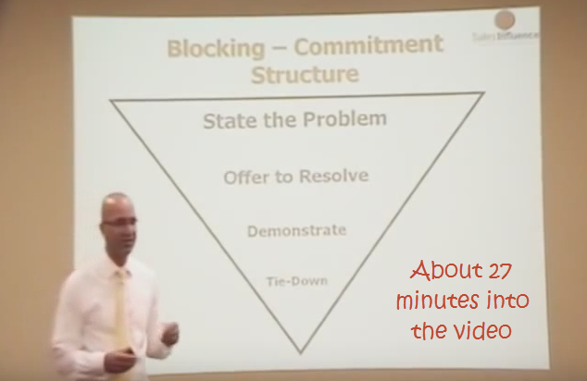
- State the problem or objection – Many of our current clients felt the same way. Let me (share a testimony, show a case study, or tell a story).
- Offer to resolve the problem – Here’s how easy it is to…
- Demonstrate – show them that they are already doing about 90% of the trial already, but without getting the benefits of Xp3. Is it fair to say that your operators are consistently putting fuel to your vehicle? Is it fair to say that someone is consistently doing maintenance and oil changes? Is it also fair to say that someone is tracking fuel consumption? See – you’re operators are already doing 90% of the work, all we have to do is add Xp3 (have them squeeze the bottle to add Xp3 to reservoir).
- Tie-Down: Based on what I’ve shown you, how many of you would you agree that the process is pretty easy?
The pic below was not in the video link we just covered, but is an important reminder
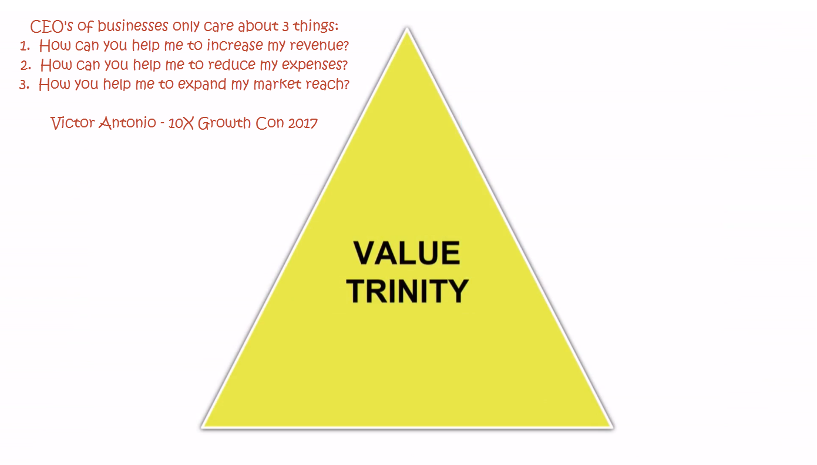

Victor Antonio - Additional Resources
- https://www.youtube.com/watch?v=mUNT4dO9nxM
- http://www.sellingergroup.com/free-books.html
- http://www.sellingergroup.com/
- http://www.seminarsonselling.com/
- http://www.sellingergroup.com/uploads/1/1/2/2/11220314/responseblockselling-ebook.pdf
Insights from the book S.P.I.N. Selling by Neil Rackham (June 13th – we will talk about the notes below and KPI’s)
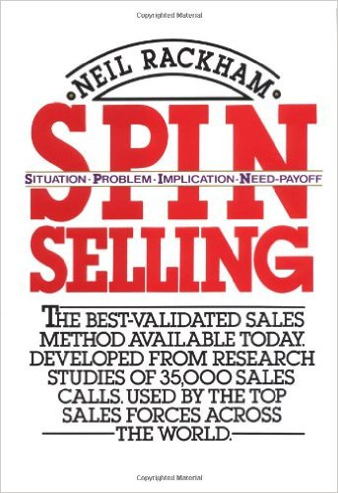
- Success in the sales process for products/services over $100 means the lead did 1 of the following things:
  - Purchased – the customer orders product
  - Advanced – the potential customer agrees to attend a demonstration or meeting, gets you in front of other decision makers, agrees to run a trial, or gets you access to other parts/members of the company you previously did not have access to.
- Failure In the sales process for products/services over $100 means the lead did 1 of the following things
  - Continuation – no specific action has been agreed upon to move the sale forward
    - “Why don’t you visit us again the next time you’re in the area.”
    - “Great information, give us a call in the spring”
    - “We liked what we saw and want to do some research so we’ll call you if we’re interested in going ahead.”
  - No sale – the lead makes it clear that no sale was possible in now or in the future.
- Our goal is to get more purchases and advances AND to turn continuations into advances
-------------------------------------------------------------------------------------------------------------------------------------
Sales and Marketing related resources:
Video with 5 tips on leaving a perfect sales voicemail
- https://www.marcwayshak.com/the-5-keys-to-a-perfect-sales-voicemail/
T

