Commercial Training 6-20-17
Updates:
There are 3 comprehensive trials available for qualifying companies
- At least 400 pieces of equipment and at least 1000 gallons of fuel consumed per month and per piece of equipment.
- The next 1 day workshop located at the Maple Grove corporate office will be
  - Saturday June 24th, 2017 from 9 am to 5 pm
  - Saturday August 19th, 2017 from 9am to 5pm
    - New GDI Reps and Certified GDI reps need to register by visiting http://becomeproworkshop.com
    - New GDI reps are required to have completed the online training before attending a workshop.
  - We invite all currently certified GDI reps to attend - there is a $25 fee for currently certified reps, which covers lunch, printed materials, and a new GDI thumb drive with current GDI documents.
    - Currently Certified Reps can purchase their $25 ticket by logging into your back office and clicking “Shop Now” > Then select your catalog > then select “Xp3” > and you’ll find Item #9700 available for purchase.
Questions, Comments, and Successes:
- Questions for Xp Lab and/or GDI -
- Marketing and Qualifying Potential Clients –
- Xp3 Questions -
- Helping Customers Prove Benefits –
- Sales Questions or Experiences You’d Like to Review -
- Referrals and Testimonials –
- Books/Resources –
Fuel and Industry News:
Great article about keeping fuel clean
- http://www.equipmentworld.com/keeping-fuel-clean-in-modern-engine-era-extra-attention-to-fuel-filtration-is-wise/
  - Check out the “New engines and fuel issues” section –
    - 4th and 5th paragraph talks about changes in engines over the past 10 years and costs associated with them
      - 3k psi for injection pumps vs. up to 36k psi in some
      - $1200 to $1700 injectors and fuel pumps costing $1,000’s
  - Check out the “Water’s destructive impact” section –
    - “In our older Tier 1 engines, water could be a nuisance. In today’s high-tech engines, it can destroy entire fuel systems in just a few short minutes.”
    - “But, the most frequent danger is that water in the fuel will blow out the tips of your injectors. And even on a four-cylinder backhoe or skid steer, you could be talking $4,000 or more on injectors alone.”
  - Check out the “Don’t get complacent” section –
    - “By leaving tanks empty overnight, you’re collecting water through condensation in your tanks, negating your filtration efforts at the distribution center. Fuel management doesn’t end until the fuel has been burned in the combustion chamber.”
Great supplemental article on fuel filters and filtration (2010)
- http://www.truckinginfo.com/channel/maintenance/article/story/2010/12/filtering-out-the-facts.aspx
  - Article talks about problems with microbial growth, condensation, damage caused by contamination

Supplemental Fuel and Industry News:
Link to FDA food hauling training/certification provided by OOIDA Foundation - $100 course that takes 1 hour to complete
- http://www.overdriveonline.com/ooida-offering-training-course-to-meet-new-fda-sanitary-food-hauling-regs/#
Great article on several new engines and their fuel efficiency
- http://www.truckinginfo.com/channel/fuel-smarts/article/story/2017/06/the-latest-fuel-sipping-engines.aspx
Really great charity article about PetSmart and trucking
- http://trucker.com/must-reads/hauling-free-food-pets-need

Sales Training:
On a scale from 1 to 10, how confident are you in:
- Scheduling time to work and grow your business?
- Finding new potential customers consistently?
- Starting a conversation with a potential customer?
- Identifying their needs and showing how Xp3 will help address or solve their needs?
- Answering questions and handling objections from potential customers?
- Identifying the steps for a successful trial?
- Getting a commitment and the Conditions of Satisfaction before an order is placed?
- Guiding the customer through the trial and analyzing the data?
- Asking for the next order and/or setting up a reorder schedule?
- Asking for a testimony and referrals?
If you were to pick an item from the list above that if you improved in that area, would have the biggest impact in your business?
Would you like some help with that item?
Approximately what percentage of time do you refer potential customers to the Xp Lab website?
Approximately what percentage of time do you refer potential customers to the GDI website?
When the new GDI website is activated, do you plan to refer people to the website more often?
Do you do any paid advertising for your business?
Do you have an automated follow up system?

A great article with 7 tips to keep your sales pipeline full
- https://blog.hubspot.com/sales/daily-habits-grow-sales-pipeline
  - Always be prospecting
    - Looking for people to help and asking questions like – “Who do you know that might be interested in…?”
  - Pay attention to which types of clients or industries that convert to the most sales
  - Automate as much as possible – especially with follow up
  - Ask for referrals -
  - Never stop learning because industries, equipment, and your prospects change
- Great supplemental article listing 21 habits to become a more successful sales person
  - https://blog.hubspot.com/sales/habits-to-become-a-more-effective-salesperson
Great article talking about the “buyer’s journey” –
- https://research.hubspot.com/reports/buyers-speak-out-how-sales-needs-to-evolve?_ga=2.126821901.1088613330.1497997928-486514174.1482249730
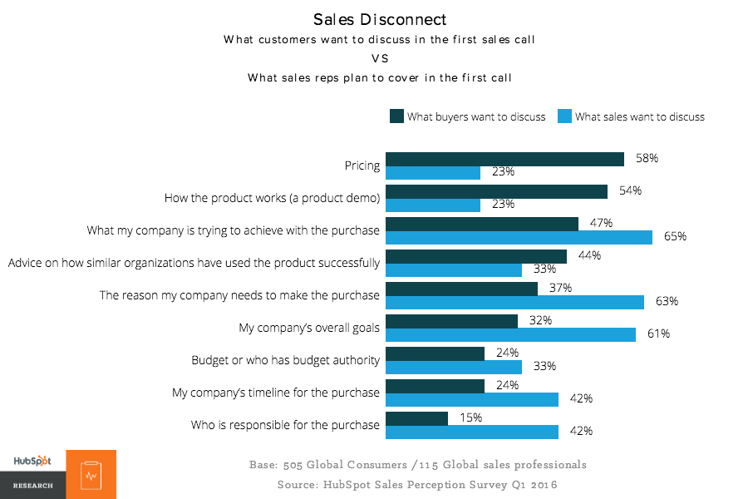
Marketing Resources:
Great article with tips on how to make better headlines
- https://blog.hubspot.com/marketing/a-simple-formula-for-writing-kick-ass-titles-ht
  - Great supplemental article - http://contentmarketinginstitute.com/2011/06/headline-click-through-rate/
Another great article with 14 tips for using LinkedIn Sales Navigator
- https://blog.hubspot.com/sales/hidden-sales-navigator-features
Insights from the book S.P.I.N. Selling by Neil Rackham
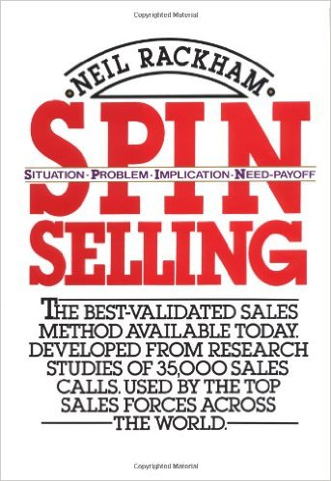
- Success in the sales process for products/services over $100 means the lead did 1 of the following things:
  - Purchased – the customer orders product
  - Advanced – the potential customer agrees to attend a demonstration or meeting, gets you in front of other decision makers, agrees to run a trial, or gets you access to other parts/members of the company you previously did not have access to.
- Failure In the sales process for products/services over $100 means the lead did 1 of the following things
  - Continuation – no specific action has been agreed upon to move the sale forward
    - “Why don’t you visit us again the next time you’re in the area.”
    - “Great information, give us a call in the spring”
    - “We liked what we saw and want to do some research so we’ll call you if we’re interested in going ahead.”
  - No sale – the lead makes it clear that no sale was possible in now or in the future.
- Our goal is to get more purchases and advances AND to turn continuations into advances
The key is to refer back to the checklist and start tracking -
-------------------------------------------------------------------------------------------------------------------------------------

