Commercial Training 5-23-17
Updates:
There are 3 comprehensive trials available for qualifying companies
- At least 400 pieces of equipment and at least 1000 gallons of fuel consumed per month and per piece of equipment.
- The next 1 day workshop located at the Maple Grove corporate office will be
  - Saturday June 24th, 2017 from 9 am to 5 pm
  - Saturday August 19th, 2017 from 9am to 5pm
    - New GDI Reps and Certified GDI reps need to register by visiting http://becomeproworkshop.com
    - New GDI reps are required to have completed the online training before attending a workshop.
  - We invite all currently certified GDI reps to attend - there is a $25 fee for currently certified reps, which covers lunch, printed materials, and a new GDI thumb drive with current GDI documents.
    - Currently Certified Reps can purchase their $25 ticket by logging into your back office and clicking “Shop Now” > Then select your catalog > then select “Xp3” > and you’ll find Item #9700 available for purchase.
Questions, Comments, and Successes:
- Questions for Xp Lab and/or GDI -
- Marketing and Qualifying Potential Clients –
- Xp3 Questions -
- Helping Customers Prove Benefits –
- Sales Questions or Experiences You’d Like to Review -
- Referrals and Testimonials –
- Books/Resources – Start with Why (Simon Sinek) and Socratic Selling
2 Important Questions:
  - What are some topics that your customers ask about and that you would like more information about?
  - “If you had a “wish list” of the content and information provided on the GDI website or store, what would be included?”
    - Mobile optimized website –
    - Product and pricing information to be clearer -
Type them in the chat box, email me, or call me privately with your questions/requests

Highlights from our recent trip to Xp Lab:
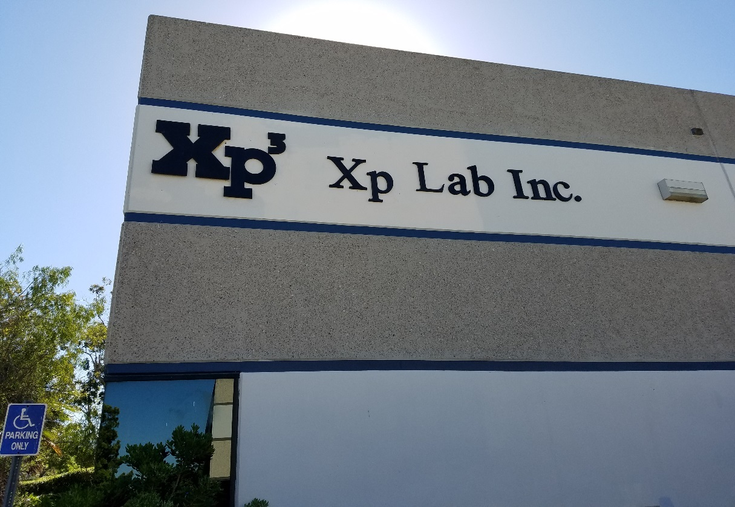
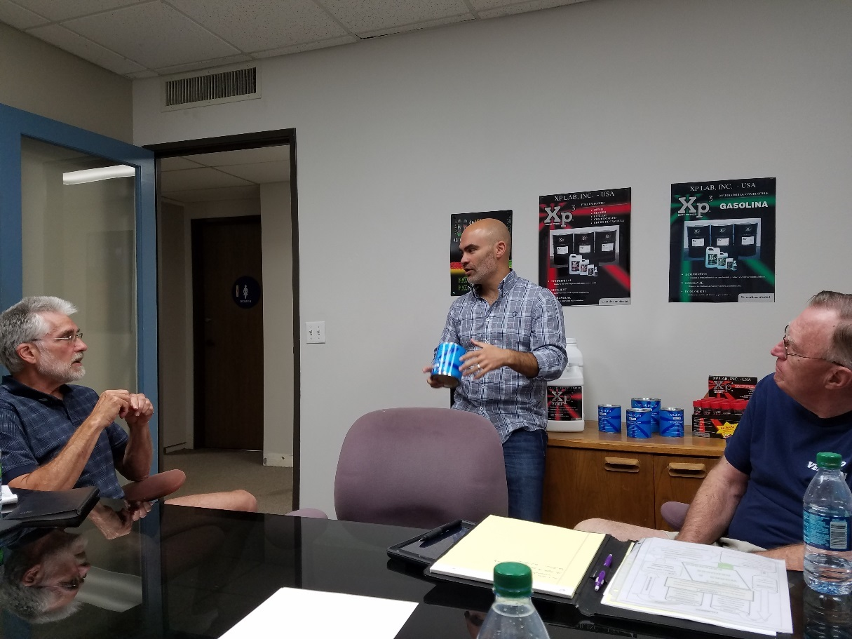

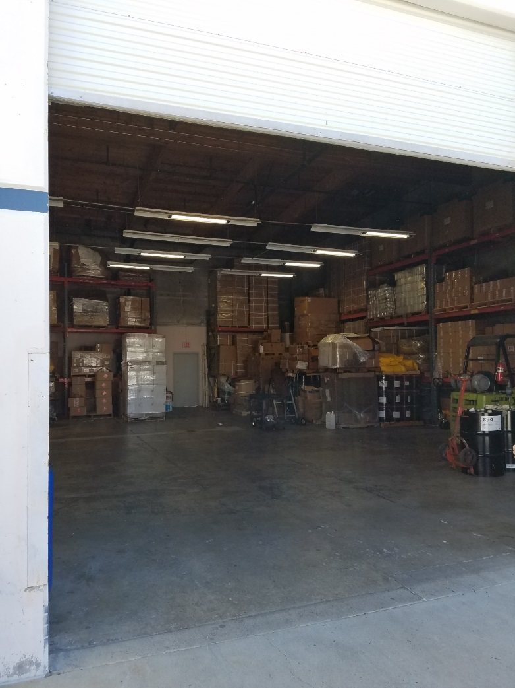
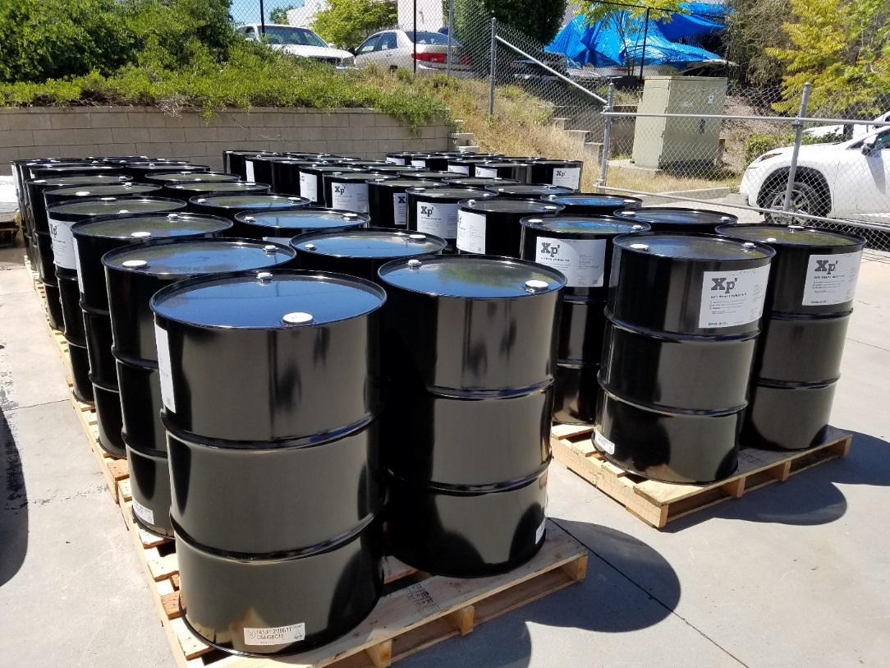









- Xp Lab officially incorporated in 1994, but existed 6 years earlier
- Technology was conceptually invented by oil companies, but wasn’t finished
- Mauricio (and his partner at the time) worked with 2 universities in the USA to further develop the technology
- Plants in USA, Canada, Brazil (because of costs to import), and China because the Chinese like to purchase from the Chinese.
- Engines have become more efficient, but fuels/fuel standards have not changed in 30 years
- The USA produces a lot of power without the use of heavy fuel consuming generators
  - Outside the USA many people burn heavy fuels in ships and power plants because it is cheaper, but has issues with impurities (like vanadium) which is very corrosive to metal
    - This is why XP Lab started doing business outside of the USA and does a lot of business outside the USA
- Americans think they have superior diesel fuels, but Europe has the best performing fuels because of their cetane number (50 vs. 40 minimum in the USA).
  - Crude oil is mined all over the world and sold to oil companies all over the world.
  - Fuels vary based on sulfur content and specific gravity
  - USA imports about 25% of petroleum it consumes (2016 statistic)
- Xp3 diesel/gas, the anti-friction engine oil treatment, and the cleaner/degreaser are the products Mauricio feels have the best potential in US markets

Fuel and Industry Related Info:
Interesting news about Cummins officially recommending Power Service Diesel Kleen + Cetane Boost and Diesel Fuel Supplement + Cetane Boost
- https://finance.yahoo.com/news/cummins-inc-officially-recommends-power-123000842.html
  - The big takeaway (and victory) for Xp3 and the entire fuel additive industry is that an OEM acknowledged the need for additives
    - “…encounter challenges with their fuel such as poor lubricity, low cetane numbers, low temperature operability issues, injector deposits, etc.”
Fantastic 2015 article from equipmentworld.com talking about new and serious challenges related to diesel fuel
- http://www.equipmentworld.com/from-refinery-to-delivery-trucks-to-your-storage-tank-chances-for-diesel-fuel-contamination-are-ever-present/
Check out the water section in the article, “diesel fuel tanks are subject to water condensation because, unlike gasoline, diesel fuel has no vapor pressure to displace or push out air. When a fuel tank warms up on hot days, the air expands and is forced out. As the tank cools at night, thermal contraction causes humid air to be sucked back into the tank and water condenses on the cooler inner tank wall surfaces. A 7-degree difference in air temperatures can cause this to be an issue. This is one reason to keep diesel fuel tanks topped off, if possible. A full tank provides less surface area for condensation droplets to collect.”
  - Check out the section on ethanol creeping into diesel fuel supplies and “switch loading”
Interesting May 2017 article talks about diesel pollution being “vastly underestimated”
- http://www.thetrucker.com/News/Story/StudyGlobaltailpipetestsvastlyunderestimatedieselpollution
  - “Pollution from diesel trucks, busses, and cars globally is more than 50% higher than levels shown in government lab tests.” –
  - Researchers estimated, “That extra pollution translated to another 38,000 deaths from soot and smog in 2015.”
    - Equals an estimated 1,100 more deaths associated with soot/smog in the USA
    - Example of this in the news - https://www.constructionequipment.com/epa-claims-fiat-chrysler-used-software-cheat-emmisions-100k-vehicles
------------------------------------------------------------------------------------------------------------------------------------------
Supplemental Industry Info:
About 25% of USA petroleum consumption comes from imported oil
- https://www.eia.gov/tools/faqs/faq.php?id=32&t=6

------------------------------------------------------------------------------------------------------------------------------------------
Sales Training:
Here are some of the question responses from the email I sent our last week:
- Generating leads (in addition to cold calling/knocking on doors)
- Scheduling time to regularly to do specific actions to grow our GDI businesses
  - This is why the lead generation discussion is so important
- Ways to start conversations (over the phone or in person) about GDI
  - Use the bottle and ask if they are interested in any of the items listed?
  - Whenever possible, look for an introduction a decision making contact in the company. If that is not possible, make a stop in and/or make a phone call and ask to speak with them or schedule a time to meet with them.
    - We partner with companies to do 3 important things
      - Increase their profits
      - Decrease maintenance costs and down time
      - Keep their equipment running better and longer
    - Which of these would help your company the most?
- Raising extra cash to cover the $399 commercial kit
  - Whenever possible, work with the GDI rep who introduced you to GDI to set up some appointments and to help you close some sales. You can work out any extra compensation between you and the GDI rep and use the rest to pay for your Certification.

