Commercial Training 4-18-17
Updates:
There are 3 comprehensive trials available for qualifying companies
- At least 400 pieces of equipment and at least 1000 gallons of fuel consumed per month and per piece of equipment.
- The next 1 day workshop located at the Maple Grove corporate office will be
  - Saturday June 24th, 2017 from 9 am to 5 pm
  - Saturday August 19th, 2017 from 9am to 5pm
    - New GDI Reps and Certified GDI reps need to register by visiting http://becomeproworkshop.com
    - New GDI reps are required to have completed the online training before attending a workshop.
  - We invite all currently certified GDI reps to attend - there is a $25 fee for currently certified reps, which covers lunch, printed materials, and a new GDI thumb drive with current GDI documents.
    - Currently Certified Reps can purchase their $25 ticket by logging into your back office and clicking “Shop Now” > Then select your catalog > then select “Xp3” > and you’ll find Item #9700 available for purchase.

Questions, Comments, and Successes:
- Questions for Xp Lab and/or GDI -
- Marketing and Qualifying Potential Clients –
- Xp3 Questions -
- Helping Customers Prove Benefits –
- Sales Questions or Experiences You’d Like to Review -
- Referrals and Testimonials –
- Testimonial – Larry Frank
  - .2 ml of Xp3 in a weedwhipper – ran much cleaner and kept running better
2 Important Questions:
  - What are some topics that your customers ask about and that you would like more information about?
  - “If you had a “wish list” of the content and information provided on the GDI website or store, what would be included?”
    - Mobile optimized website –
    - Product and pricing information to be clearer -
Type them in the chat box, email me, or call me privately with your questions/requests

Fuel and Industry Related Info:
One topic that was discussed at a recent GDI workshop was sludge and problems cause by microbial growth and this article raises and important point
- http://www.axi-international.com/news/truth-biocides-fuel/
  - “Remove water, the main source of fuel contamination, from the tank so that the microbes do not have anywhere to live or grow”
  - “Filter out the sludge and contamination…it can still do damage and it needs to be filtered out of the fuel.”
  - Remember that Xp3 Diesel is documented (see “Lab Tests” page on Xp Lab’s website) to be an effective biocide on contaminated fuel.
  - Like the article states, our goal is to use Xp3 to disperse the water so the conditions do not exist for microbial contamination to exist or continue.
    - Doing this will help to protect fuel tanks, fuel lines and filters, and protect injectors and other vital engine parts from damage caused by water.

------------------------------------------------------------------------------------------------------------------------------------------
Supplemental Industry Info:
Article talking about Tesla’s electric semi will be unveiled in September
- http://www.overdriveonline.com/tesla-says-it-will-unveil-an-electric-truck-this-year/
Truck platooning will be a reality this year
- http://www.truckinginfo.com/channel/fuel-smarts/news/story/2017/04/peloton-announces-60-million-omnitracs-investment-confirms-platooning-system-launch-by-year-s-end.aspx
------------------------------------------------------------------------------------------------------------------------------------------
Sales Training:
When someone gives you an “objection”, how do you feel (excited, nervous, etc.)?
- Grant Cardone
- Great opportunity to discover if their “final objection”
  - Remember that some people may not give you their “final objection”, but we can continue to ask better questions to get closer to it.
How would you reply if someone says something like, “I would like to use your product, but I can’t because it will void my warranty?”
- T
- “I can appreciate you wanting to protect your equipment. Am I correct in understanding that if we could address the warranty to your satisfaction, that you would be ready to move forward in our partnership today?”
- If they say “Yes”, introduce them to the Magnuson-Moss Act first and if necessary – the additionally insured option.
- If they say “No”, simply say, “I’m sorry, I thought that (insert problem or result they expressed interest in earlier) was an important priority that you wanted to address. Is that still true and if so, what other questions can I address to help you feel confident to move forward in our partnership?”
Remember that we have numerous websites and letters from engine manufacturers:
- Review the “Warranty” section at the bottom of John Deer’s web page
  - https://www.deere.com/en_US/industry/engines_and_drivetrain/learn_more/biodiesel/what_every_biodeisel_user_needs_to_know/every_biodiesel_user.page
- Review AMSOIL’s warranty PDF file “Amsoil Warranty Magnuson-Moss Act”
- Review our Magnuson-Moss Act PDF
Handling the “I need to think about it” objections
- How do you typically handle this?
  - T
- First rule, find out If it is their “final objection”
  - Think about it – “No problem – take all the time you’d like. Would a couple of days or a couple of weeks be enough time to review things? (Answer) “Fantastic – could I share one more thing with you? (Yes) “Most of my customers in this situation ask themselves 3 important questions as they think about things:
    - “Do I want to work with (our name)?” (Notice I didn’t say the company)
    - “Do I believe that Xp3 can help me solve these problems?”
    - If question #2 is “yes” - “Do I want to invest in solving these problems?”
    - Possible 4th question – “Are there good reviews and information on Google?”
- “We encourage everyone to do their due diligence and we ask that you remember this important piece of information. If you were to look up Menards in the Better Business Buarea you might be surprised to learn that they have a “F” rating and yet many people have great experiences with the company. Just like every other company, you’re going to find a range of reviews with Xp3. When you do your research, will you be looking for reasons to partner with us or reasons not to?
- Check out the Menard’s Better Business Bureau review below
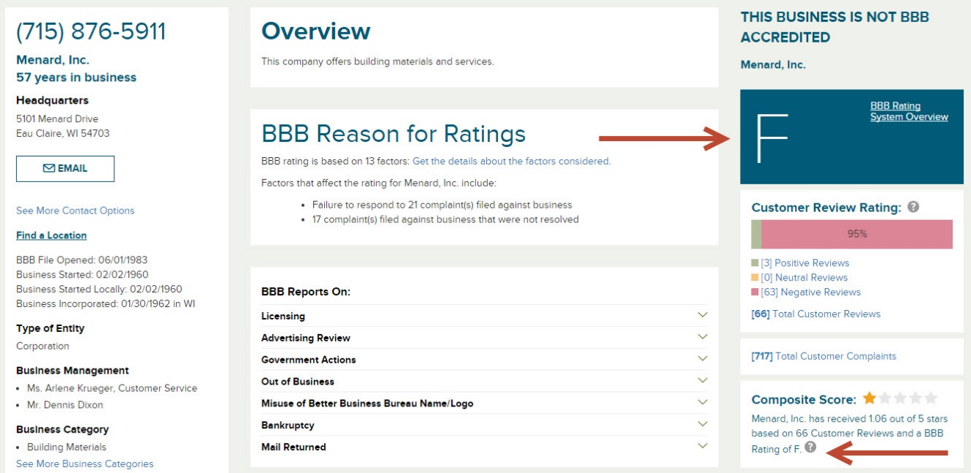

--------------------------------------------------------------------------------------------------------------------------------------
Marketing related resources:
Interesting article talking about the declining reach in “organic reach” in Facebook and some tips to make sure more people see your posts
- https://blog.hubspot.com/marketing/facebook-declining-organic-reach#sm.000t7ca6bl1qcvk11eb2g0x5m3q7y
Article listing 6 different suggestions for getting a response from CEO’s
- https://blog.hubspot.com/sales/4-secrets-to-getting-a-response-from-the-ceo#sm.000t7ca6bl1qcvk11eb2g0x5m3q7y
  - Email tip about being a “curious student”
  - Write emails on your phone
  - Call late
  - Call cadence
------------------------------------------------------------------------------------------------------------------------------------------
Supplemental Resources:
Simon Sinek – “The Golden Circle” concept about growing successful businesses
- https://www.youtube.com/watch?v=fMOlfsR7SMQ
  - When I watched this video, I thought about our vision to help companies and help people (Fuel Hope).

Next week I plan to share a few more insights from the book S.P.I.N. Selling by Neil Rackham
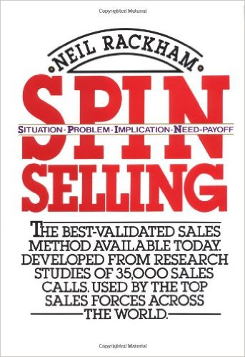
- T
-------------------------------------------------------------------------------------------------------------------------------------

