Commercial Training 4-11-17
Updates:
There are 3 comprehensive trials available for qualifying companies
- At least 400 pieces of equipment and at least 1000 gallons of fuel consumed per month and per piece of equipment.
- The next 1 day workshop located at the Maple Grove corporate office will be Saturday April 15th, 2017 – New GDI Reps and Certified GDI reps need to register by visiting http://becomeproworkshop.com
  - We invite all currently certified GDI reps to attend - there is a $25 fee for currently certified reps, which covers lunch, printed materials, and a new GDI thumb drive with current GDI documents.
    - Currently Certified Reps can purchase their $25 ticket by logging into your back office and clicking “Shop Now” > Then select your catalog > then select “Xp3” > and you’ll find Item #9700 available for purchase.
- TaxBot – http://taxbot.com
- https://www.waveapps.com/ - free version and paid for accounting
- tom@partnerwithgdi.com

Questions, Comments, and Successes:
- Questions for Xp Lab and/or GDI -
- Marketing and Qualifying Potential Clients –
- Xp3 Questions -
- Helping Customers Prove Benefits –
- Sales Questions or Experiences You’d Like to Review -
- Referrals and Testimonials –
2 Important Questions:
  - What are some topics that your customers ask about and that you would like more information about?
  - “If you had a “wish list” of the content and information provided on the GDI website or store, what would be included?”
    - Mobile optimized website –
    - Product and pricing information to be clearer -
Type them in the chat box, email me, or call me privately with your questions/requests

Fuel and Industry Related Info:
Great information from John Deer’s website on biodiesel
- https://www.deere.com/en_US/industry/engines_and_drivetrain/learn_more/biodiesel/what_every_biodeisel_user_needs_to_know/every_biodiesel_user.page?
  - “Biodiesel impacts all diesel engines – no matter what brand.”
  - “Brass, bronze, copper, lead, tin, and zinc can accelerate the oxidation of biodiesel and create deposits in the engine.”
    - Supplemental article on specific metals that are used to make engine parts
http://www.mechanicalbooster.com/2014/07/internal-combustion-engine-parts-and-metals-from-which-it-is-manufactured.html
    - Another great supplemental article on copper in engine oil - http://machinerylubrication.com/Read/646/copper-diesel-engine-oil
  - “Biodiesel can accelerate the degradation of crankcase oil”
  - “Tanks should be kept as full as possible to minimize condensation because water accelerates microbial growth.”
  - “Biodiesel tends to increase NOx emissions while reducing smoke”
    - Supplemental article on what might cause biodiesel to produce more NOx
      - http://www.biodieselmagazine.com/articles/426/knocking-out-nox
    - Fantastic article showing test results of various types and percentages of biodiesels and their impact on NOx emissions
      - https://www.arb.ca.gov/fuels/diesel/altdiesel/meetings/20141024LyonsPresentation.pdf
        - Check out page 34 talking about cetane numbers and biodiesel
        - Another benefit of our cetane booster for biodisel up to B20
      - Another supplemental article on the causes and health impacts of NOx
        - http://www.icopal-noxite.co.uk/nox-problem/nox-pollution.aspx
    - SCR systems have proven to reduce NOx “in excess of 90&”
      - http://www.factsaboutscr.com/scr/
- Check out the “Warranty” section at the bottom of the page and it coincides with the typical verbiage we see in the Magnuson-Moss Act.
Good article from AMSOIL on why engine oils deteriorate
- https://www.amsoil.com/newsstand/motor-oil/articles/why-motor-oil-deteriorates/
  - Oxidation – “Over time oxygen can break down base oils and lead to increased viscosity and can cause formation of harmful deposits and sludge.”
  - High heat – “Today’s engine run hotter than ever, with temperatures up to 235 degrees and even hotter when hauling or towing. The rate of oxidation for oil doubles for every 18 degree increase in temperature.”
    - Xp3 helps engines to run cooler which will help with high heat issues
  - Moisture – “Your vehicle is subject to temperature swings…which cause condensation to form inside your engine, leader to water contamination. Water can lead to the formation of sludge.”
  - Viscosity Loss – “The intense pressure that the oil bears as it’s squeezed between moving parts can tear apart or shear its molecular structure, leading to viscosity loss.”
    - Xp3 helps to increase lubricity, reduce wear metals in oil, improve combustion which reduces soot = longer lasting oil
  - Fuel dilution – “Fuel can wash past the piston rings and contaminate the motor oil causing it lose viscosity. Excessive fuel dilution leas to sludge and varnish.”
2014 article on DPF warning lights, filter cleaning expenses, and replacement info
- http://www.traceyroad.com/dpf-lights-what-to-look-for-when-they-come-on/
  - Can cost more than $3,000 to replace
  - Industry average for trucks manufactured between 2007-2009 is for manual cleaning between (baking) around 300K miles and for new trucks around 400K miles
  - We know Xp3 can positively impact the life of emissions equipment and the number of regenerations can be pulled off the ECM (electronic control module) for before-and-after comparison purposes.
Article talking about 20 cent increase in excise tax on diesel in California
- http://www.overdriveonline.com/higher-diesel-taxes-coming-in-california/
  - Will go into effect on Nov. 1st
  - As we know, Xp3 can help them save money & absorb some of the increased expense

------------------------------------------------------------------------------------------------------------------------------------------
Supplemental Industry Info:
Article talking about the high number of used trucks that are available in the market
- http://www.overdriveonline.com/used-truck-glut-can-spell-bargains-for-buyers/
Merger between Knight Transportation and Swift
- http://www.cnbc.com/2017/04/10/us-trucking-giants-swift-and-knight-to-merge-wsj.html
Information on new rules that effect construction companies which take effect September 23rd regarding breathable silica standards on jobsites
- http://www.equipmentworld.com/osha-delays-silica-rule-says-more-time-needed-for-outreach-education-and-guidance/
------------------------------------------------------------------------------------------------------------------------------------------
Sales Training:
A few highlights from the GDI workshop
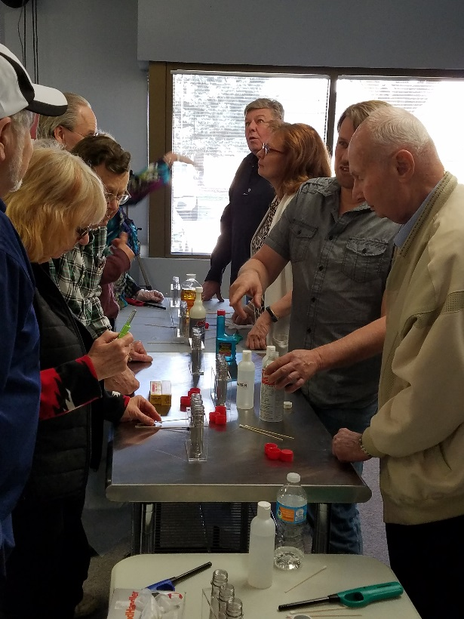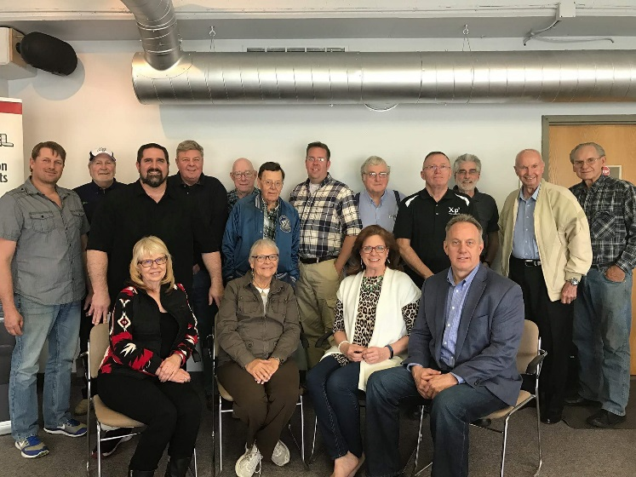
-----------------------------------------------------------------------------------------------------------------------------------------
I was helping another distributor with a GDI sale and the customer expressed interest in using Xp3 to decrease emissions and protect his DPF. Then he started to “quiz me” on various topics like gelling, DPF filter replacement intervals, etc. What are some ways you might handle a situation like that:
- T
Here are some ways I could have responded:
- “Why do you ask?”
- “I’m always happy to answer questions for people who are serious about proving the benefits of Xp3 – I’m just curious how this question relates to helping you (insert benefit of Xp3 they said they were interested in)?”
- “When we first started talking today, you told me that you were interested in (insert their need). I know you’re an expert when it comes to your vehicle and I’m an expert on how Xp3 can help you (insert the benefit connected to their need). Do you have a specific question for me about how Xp3 can help you to (insert benefit connected to their need)?”
- “My job is to be an expert at helping people who are seriously interested in proving that Xp3 will (insert benefit). Do you have a specific question about that?
Remember these important points:
- You don’t have to be an expert on their engines or know everything about their industry!
- Our role is to be the expert on helping them get the results they are after from Xp3
- Simply matching the customer with the benefits they want from our “Xp3 benefit menu”

Have you heard of the “sell me this pen” sales interview question? Here’s a great article on the process of selling and what makes a great salesperson great
- https://blog.hubspot.com/sales/answer-sell-me-this-pen-sales-job-interview#sm.000t7ca6bl1qcvk11eb2g0x5m3q7y
  - “At one stage in the interview… I would place my iPhone carefully on the middle of table and say, “Sell me these sunglasses”
    - Most responses are people pointing out the features OR they are asking questions about current problems that can be solved with the sunglasses.
    - Best response in this scenario – “The candidate sat there in silence and didn't ask any questions. Seeing the iPhone, they simply turned on the flashlight (which can be done without knowing the passcode on the latest versions), and said, "How would you like some sunglasses now?"
    - Good sales people solve problems, but the best sales people are able to create them with the customer and then help them to solve them.
--------------------------------------------------------------------------------------------------------------------------------------
Marketing related resources:
Great article explaining the different types of Facebook ad types for anyone considering Facebook ads
- https://blog.hubspot.com/marketing/the-facebook-ad-types#sm.000t7ca6bl1qcvk11eb2g0x5m3q7y
Article explaining 6 recent updates on LinkedIn
- https://blog.hubspot.com/marketing/new-linkedin-features#sm.000t7ca6bl1qcvk11eb2g0x5m3q7y

------------------------------------------------------------------------------------------------------------------------------------------

Next week I plan to share a few more insights from the book S.P.I.N. Selling by Neil Rackham
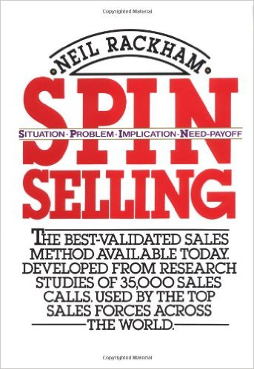
- Continuations –

-------------------------------------------------------------------------------------------------------------------------------------

