Commercial Training 3-29-16
Updates:
- There are 3 comprehensive trials available for qualifying companies
  - At least 400 pieces of equipment and at least 1000 gallons of fuel consumed per month and per piece of equipment.
Questions, Comments, and Successes:
- As you may have heard, we are in the process of reviewing and enhancing the GDI training procedures/process. GDI and XpLab are partnering together and always want to include feedback, suggestions, and the expertise of the GDI distributors to contribute to make the training and support the best it can be. Please email or call me with any suggestions and/or questions.
- There are 3 topics or areas we are looking for your feedback on which are:
  - The industries you’d like additional information about
  - The common objections you encounter
  - If you are an expert in a particular industry (or know someone who is) and would like to share some of your expertise
Fuel and Industry Related News:
- Great short article explaining the three main types of diesel engine smoke and some of the possible causes of them:
  - http://www.bellperformance.com/blog/bid/115989/Diesel-engine-problems-black-smoke-explained
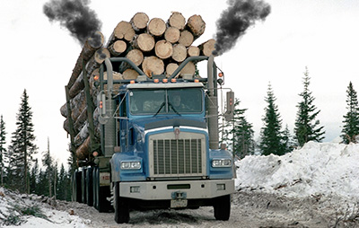
    - Black smoke – too much fuel OR not enough air into the combustion cycle. The black smoke is “…full of particulates that are basically large diesel particles that normally be burned as fuel.” Money going out the exhaust stack
      - Possible causes - injectors, EGR valve, or air filter
    - White smoke – means the fuel being injected into the combustion chamber is not being burned properly.
      - Possible causes – low compression or water in the fuel.
    - Blue smoke – results from burning engine oil. “This is a mechanical problem because engine oil isn’t supposed to be getting into areas where it can be burned.
      - Possible causes – worn cylinders and piston rings
2015 NHRDA’s Pro Stock World Champion – “Blown Smoke”
https://www.facebook.com/Xp3ExtraPower/photos/a.600073763383513.1073741832.574642345926655/1020201381370747/?type=3&theater
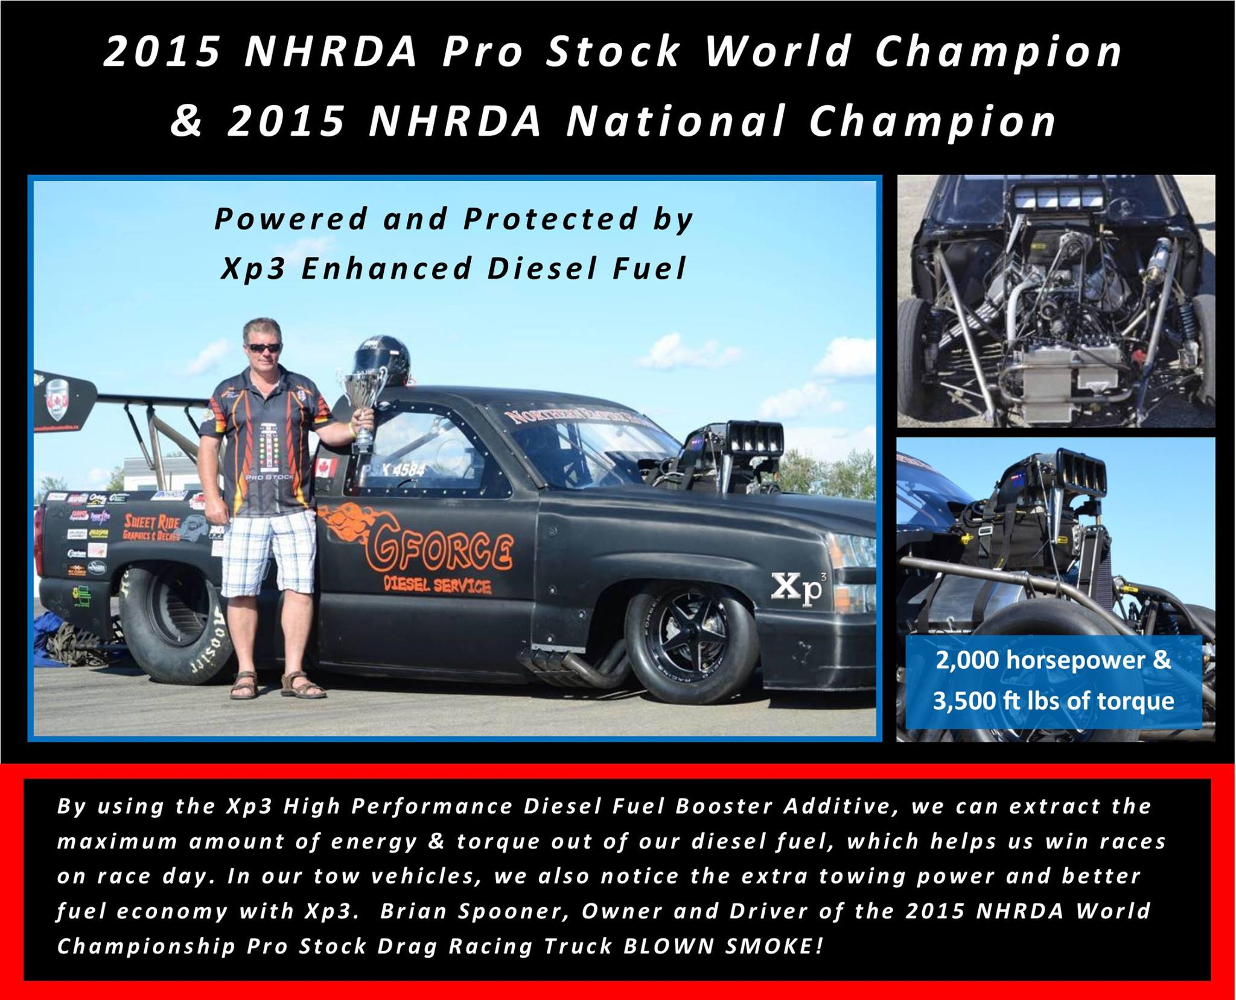
http://www.nhrda.com/homepage.php

Sales Training
Tony Robbins – (review of steps 1-5 on how to handle objections) from Mastering Influence course
- Ignore the objection – most people have what Grant Cardone calls RDR’s (Reactionary Defense Responses)
  - Stay calm and ignore it
  - You don’t want to answer every single objections
- Hear them out
  - Stop talking and listen attentively. Most people just want to be heard
- Feed it back to them nicely
  - It costs too much
    - Respond politely “Costs too much?”
  - In most cases
- Question the objection
  - I know you have reasons for saying that – do you mind if I ask what they are?
  - Don’t use the phrase “good reasons”
- Make it a final objection
  - Most objections will not make or break the sale – we’re trying to find out the real objections and help the person see we can meet their needs and overcome the concerns together.
  - Just suppose we handled (insert their objection) and really met your needs and delivered real results, then would you feel confident moving forward in our partnership?
  - If they say no, then say “What other questions can we get answered that will help you to feel confident in our partnership?”
Tony Robbins – (Steps 6-10)
- Align with the prospect and provide a cushion
  - Put them at ease
  - Agreement phrases - (their feelings or the intent of what they are saying)
    - I appreciate …
    - I respect and …
    - I agree and …
  - I can appreciate that and some of our best clients have told me they felt that exact same way and you know what you’re right – it is an investment that will (insert the benefits they want).

- Turn the objection into a question
  - “I can appreciate how you feel about that and you’re right – it is an important investment and that brings up an important question. In spite of the cost, isn’t the real question – Is it possible for you to get much more benefit than the cost?” You could also insert the benefit they want from partnering with us.
    - Then tell a story of a customer who actually experienced a net gain or benefit as a result of using Xp3.

- Answer the question - “Why T.O.M. and E.D.”
  - Why - Why would you even come up with that objection when you just told me that you wanted (benefit) because it will…
  - T – turn it around – I can’t afford it right now – That is probably the very reason you need to do it right now because the longer you wait the more it is costing you.
  - O – Outweigh it – stack the benefits – “I know you want to make sure that your customers receive their products on time and I know you have some questions about your investment. Isn’t it more important that you keep your equipment running and delivering for your customers while increasing your overall profit?”
  - M – Minimize – take objection like cost - $570 – treats 5,760 gallons of fuel – 10 cents a gallon – our customer often report savings well beyond the cost of the product and we guarantee you will increase your MPG so your investment is 100% covered.
  - E – Explain away the objection. Xp3 costs more because of the layers of benefits it provides in one product. It replaces the costs of numerous products and benefits in one powerful product.
  - D – Deny – it will void my warranty. I can appreciate your point and that brings up another great question. Have you heard of the Magnuson-Moss Act? Let me share a little about it and our million dollar insurance coverage that we can list you as “additionally insured” at no cost.

- Tie it down
  - “Now that solves that doesn’t it? So in your opinion….”
  - If they say no, say: “I’m sure you have a reason for saying that, what question can I get answered for you that will help you feel confident in moving forward in our partnership?”

- Assume the sale
  - “Fantastic! In your opinion would you like to include 5 or 10 vehicles in your trial?”
  - “Congratulations! Which vehicles (or drivers/operators) do you feel would be the best fit for the trial?”
  - Wait a minute, I didn’t say I was buying. “Well, you did say that you wanted to (insert benefits they want?). Great, (insert a buying related question like the ones above)?”

