Commercial Training 3-22-16
Updates:
- We are looking for 3 comprehensive trials available for qualifying companies
  - At least 400 pieces of equipment and at least 1000 gallons of fuel consumed per month and per piece of equipment.
Questions, Comments, and Successes:
- As you may have heard, we are in the process of reviewing and enhancing the GDI training procedures/process. GDI and XpLab are partnering together and always want to include feedback, suggestions, and the expertise of the GDI distributors to contribute to make the training and support the best it can be. Please email or call me with any suggestions and/or questions.
- There are 3 topics or areas we are looking for your feedback on which are:
  - The industries you’d like additional information about
  - The common objections you encounter
  - If you are an expert in a particular industry (or know someone who is) and would like to share some of your expertise
Fuel and Industry Related News:
- Interesting blog post from Trucker Magazine in January 2016 talking about whether natural gas will replace diesel – obviously an important discussion for GDI distributors
  - Mauricio and Alan did say they are working on a version of Xp3 for natural gas, but did NOT say when they anticipate having it available to market.
  - http://truckermagazine.com/will-natural-gas-replace-diesel/
    - “JOC.com is a company that provides shipping data and analysis. They report that capital cost of operating a truck with natural gas can be twice of that of the diesel run truck. While the fuel might be cheaper, the price of buying new natural gas powered trucks would prove to be an obstacle many companies could not overcome. They project that even with a grant of $54,000 per truck those operated with natural gas will still cost 40% more. Some think that the cost of an entire new fleet would be counter productive in saving money on fuel.”
- Interesting article from December 2015 talking about the costs of Tier 4 emissions equipment on construction companies and how they affect their equipment purchase decisions.
  - Includes survey results from company owners and “Top 10 Concerns” with Tier 4 equipment.
  - http://www.constructionequipment.com/blog/tier-4-equipment%E2%80%99s-effect-2016-acquisition-plans
  - “Fleet managers have responded to cost increases in three ways: They have or will boost equipment-acquisition budgets, they will reduce the number of machines they replace, or they will turn to alternative acquisition strategies such as rental or used-equipment purchases.”
- Great article talking about diesel soaps causing engine problems (contains 2013 NY city bus fleet data)
  - http://www.constructionequipment.com/diesel-soaps-cause-engine-problems
  - “The investigation uncovered excessive soot deposits in the turbocharger, resulting from over-fueling, which was determined to be the result of fuel injectors sticking because of deposits that were “rich” in the metals of sodium and calcium.”
- Great article about fuel standards and what engine manufacturers and fuel suppliers are saying about the standards
  - http://www.constructionequipment.com/challenging-world-1296-and-fuel-cleanliness
- IMPORTANT ARTICLE – Pay attention to testing of fuel efficiency by Top 5 Construction Equipment OEM’s (Question 3)
  - http://www.constructionequipment.com/oems-talk-fuel-efficiency
  - Case fuel efficiency testing – “You’re placing two machines, the previous model and the new model, in a head-to-head comparison on the same day, with the same environment, in the same operating conditions…”
Jing -

Sales Training
Which of these companies would you talk to 1st and why?
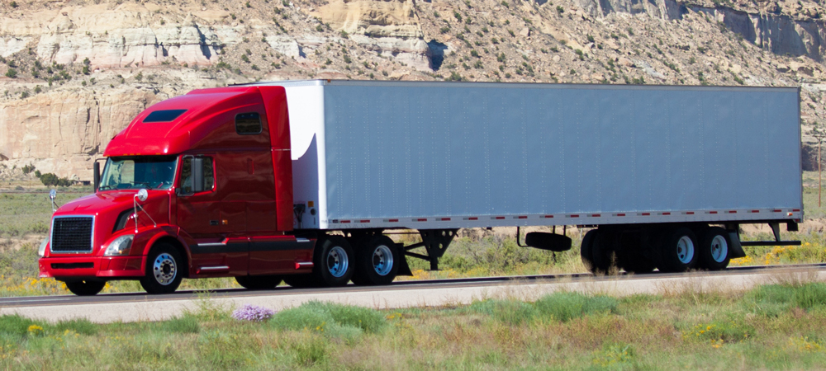
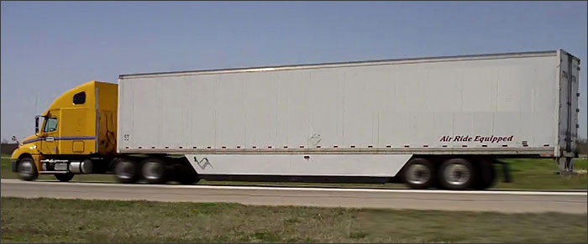
Trailer Tails and Trailer Skirts – tell you that the company is interested in decreasing fuel costs and/or emissions. Why not start with someone who has clearly told you they are “Beth or Bob”?

Tony Robbins – 5 steps to handling objections
- Ignore the objection – most people have what Grant Cardone calls RDR’s (Reactionary Defense Responses)
  - Stay calm and ignore it
  - You don’t want to answer every single objections
- Hear them out
  - Stop talking and listen attentively. Most people just want to be heard
- Feed it back to them nicely
  - It costs too much
    - Respond politely “Costs too much?”
  - In most cases
- Question the objection
  - I know you have reasons for saying that – do you mind if I ask what they are?
  - Don’t use the phrase “good reasons”
- Make it a final objection
  - Most objections will not make or break the sale – we’re trying to find out the real objections and help the person see we can meet their needs and overcome the concerns together.
  - Just suppose we handled (insert their objection) and really met your needs and delivered real results, then would you feel confident moving forward in our partnership?
  - If they say yes, then say “What other questions can we get answered that will help you to feel confident in our partnership?”
Proof of concept – people aren’t going to buy in large quantity unless they have proven and understand the process.

