Commercial Training 3-20-18
Updates:
There are 3 comprehensive trials available for qualifying companies
- At least 400 pieces of equipment and at least 1000 gallons of fuel consumed per month and per piece of equipment.
- We will have our next full day, in-person GDI workshop on Sat. May 19th
  - Register at http://becomeproworkshop.com
Questions, Comments, and Successes:
- Questions for Xp Lab and/or GDI -
- Marketing and Qualifying Potential Clients –
- Xp3 Questions -
- Sales Questions or Experiences You’d Like to Review –
Fuel and Industry Related:
Interesting article on “eco flaps” and their impact on fuel efficiency
- http://www.truckinginfo.com/channel/fuel-smarts/news/story/2018/03/eco-flaps-tested-on-ltl-equipment.aspx
  - “…found an estimated 2.7% fuel savings based on the reduction in drag.”
  - This technology is further proof of the importance of efficiency in improving the bottom line for transportation companies.
  - Xp3 can be another contributor to that goal for companies
    - Look for companies that are using trailer kites, trailer tails, cab top deflectors, and other aerodynamic technology because they are broadcasting they care about fuel efficiency
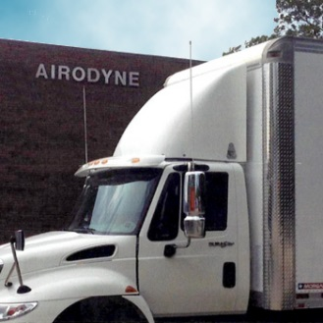
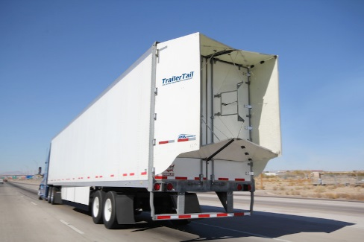
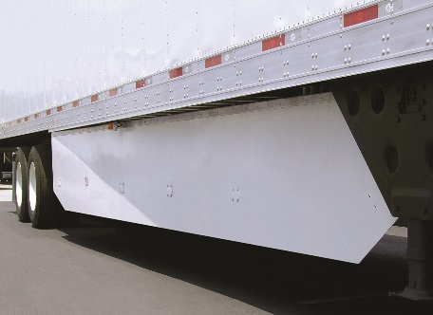
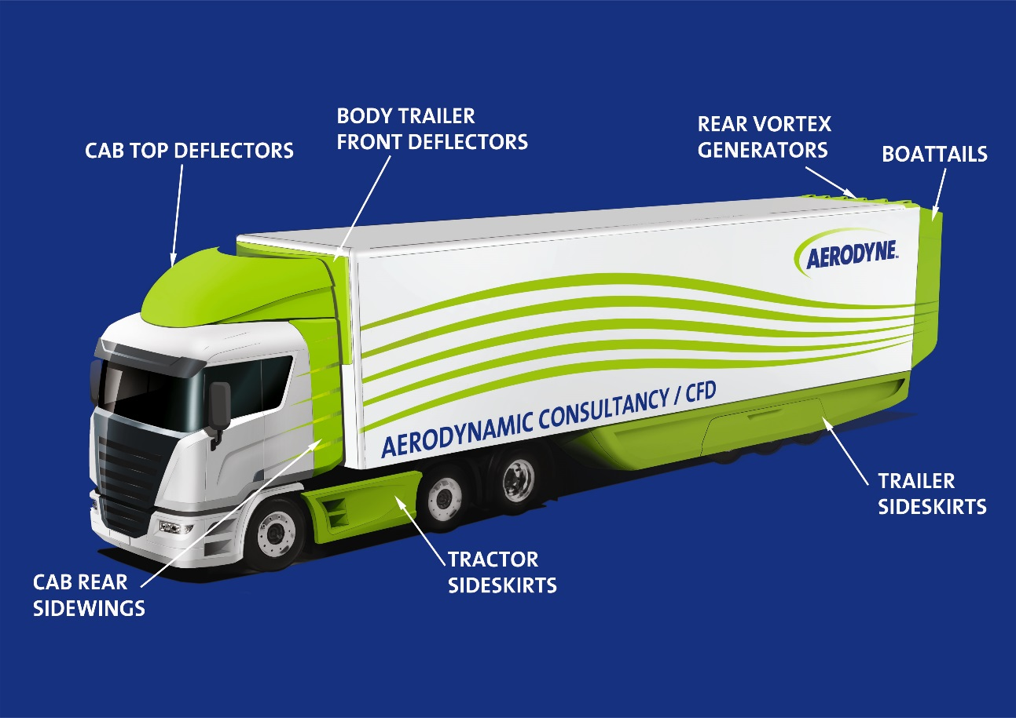
- Supplemental resource page on Aerodyne technology
  - http://aerodyneuk.com/truck-aerodynamics/

Supplemental articles
Article talking about sleep and trucker health – issue of interest to spark conversation and share with people in transportation industry
- http://www.fleetowner.com/trucks-work/getting-good-sleep-it-still-ain-t-easy-especially-trucking
Another article talking about cosmetic repairs can be good for the bottom line
- http://www.truckinginfo.com/channel/equipment/article/story/2018/03/keeping-trucks-repaired-is-good-for-the-bottom-line.aspx

Sales Training:
Article talking about 7 different kinds of questions to ask in the sales process:
- https://blog.hubspot.com/sales/types-of-sales-questions
Questions we need to go through in the qualifying stage of the sales process:
- Beth or Bob?
- Decision maker and anyone else involved in the process?
- (What) Need or purpose for looking at Xp3?
- (Why) in the benefit or solving that problem?

Questions:
- Are they “Beth or Bob”
- Are they the decision maker(s)?
- Which items from the “Xp3 menu of benefits” are they most interested in?
- Why are you interested in the (benefit or solving the problem)?
- On a scale from 1 to 10 (with 10 being extremely important), how high would you rate the company’s desire to solve the challenge(s)?
- What have you tried to solve that challenge in the past?
  - Currently and/or in the past?
- What was the testing and evaluating process that used?
  - Engine oil analysis?
- What was the cost of the product? - What was your return on the investment (ROI)?
- How will solving this challenge help you and the company?
- If you found a product that delivered those benefits and made sense financially and logistically, would you implement it in all your equipment?
- What specific, measurable benchmarks would have to be met for you to feel confident in using a solution like ours in all your equipment? (Conditions of Satisfaction)
- What questions or concerns do you have that we can address to help you feel 100% confident in moving forward in our partnership?

Questions we need to consider during the setting up the trial stage of the sales process:
Remember all of these questions are designed to help you cover the variables and make sure we get a baseline of the benefit(s) we are planning to measure:

Questions:
- Make, Model, Year of equipment
- Similar routes and loads/operating time or conditions?
- Same or different drives/operators?
- Seasonal or temperature changes happening?
- Fueling from same location (bulk tanks) or different locations?
- Oil change intervals and when are the next oil changes scheduled?
- Using used oil analysis as part of your preventative maintenance?
  - If so, does it include soot analysis?
- What percentage of biofuel are you using?
- Do they know the cetane number of their fuel?
- If applicable, how are you tracking:
  - MPG/gallons per hour
  - Fuel filter replacements?
  - Oil change intervals and replacement oil?
  - DEF consumption?
  - DPF regens/cleanings/replacement?
  - Trailer washing frequency (for transportation equipment)?
  - EGR system replacement?
  - Fuel injector replacement?
  - Down time and Average maintenance cost per mile?
- Whenever possible, ask them to purchase enough oil for the amount of used oil analysis tests you plan to run during the trial PLUS any additional replacement oil that may be needed. This helps to eliminate another variable in the testing process.

Supplemental sales resource:
This article was talking about a great cold call script. One nugget for me was the point they make about pausing after your cold call greeting.
- https://blog.hubspot.com/sales/cold-call-script
Great tip about attending events hosted by your customers (or that your customers attend)
- https://blog.hubspot.com/sales/creative-sales-prospecting-ideas
  - Great opportunity to get connected with their professional network and have them introduce you
Infographic on what is currently happening (statistics and trends) in outbound and inbound marketing and what data proves is most profitable
- https://www.insidesales.com/wp-content/uploads/2018/03/infoGraphic_SalesFollowUpGuide.pdf
Marketing Resources:
Great article for creating infographics
- https://blog.hubspot.com/marketing/create-infographics-with-free-powerpoint-templates

