Commercial Training 2-9-16
Updates:
- We are looking for 3 comprehensive trials available for qualifying companies
  - At least 400 pieces of equipment and at least 1000 gallons of fuel consumed per month and per piece of equipment.
Questions, Comments, and Successes:
- Shelf life of Xp3 is indefinite - fuel treated with Xp3 will be stabilized for 6 months and will need to retreated and stirred (agitated) after 6 months to prolong fuel stability.
  - Retreated = adding the appropriate amount of Xp3 needed for the remaining gallons (and any additional gallons that may also be added) and then agitating
Fuel and Industry Related News:
Great article talking about generator failure and preventative maintenance
- http://www.sbsbattery.com/UserFiles/File/Power%20Qual/PT-7004-Maintenance.pdf
- One of the “Top 3” reasons generators fail to automatically turn on or run:
  - Fuel filter is clogged due to old or contaminated fuel
  - Xp3 can help prevent these issues by stabilizing the fuel and helping to eliminate bacterial issues in fuel
    - See section in article called “Fuel System Service”
Outstanding article talking about the problems caused by hard particulates (rust, dirt, coal, salt, etc.) getting into the engine
- http://www.mycleandiesel.com/pages/ProblemDirt.aspx
- Today’s fuel filters can typically remove contaminants from 3 to 10 microns in size, but “…there are smaller micron contaminants (1 to 5 microns) that cause the most damage, virtually sandblasting part surfaces.”
- According to the article above “Typical engine manufacturer specifications require .07 grams (1/4 oz) of hard particulate allowed per 10,000 gallons of fuel. In some parts of the world, “typical” diesel contains 1 ½ pounds of hard particulate per 10,000 gallons of fuel. (1,000 times more than the ¼ oz).”
  - Pic below is from the article showing damage caused by hard particulate hitting engine parts at high pressures in today’s engines. Talk about Xp3’s lubricity

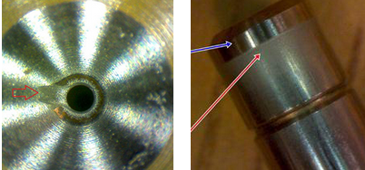

Use this document to prove the increased lubricity of Xp3 – 16% increase in lubricity!
- http://xplab.com/wp-content/uploads/2015/05/LabTest_Xp3D_Lubricity-FOI_Eng.pdf
One of the best (shorter) articles I have come across explaining problems with poor fuel quality
- http://esource.alstribology.com/WB045_May_2012/Effects%20of%20Poor%20Quality%20Fuel%20on%20Diesel%20Engine%20Reliability.html
  - “Injector life is reduced by about half with a water content of 0.05% (500 ppm) compared to 0.02% (200 ppm) ppm. Water content should optimally stay under 0.02%. When fuel contains up to 0.05% it will begin to show a haze. Water content at or above 0 .05% will cause damage to the fuel injection system. Moisture will also adversely affect the lubricating properties of diesel fuel by displacing the fuel. When moisture reduces fuel combustibility and becomes heated in the combustion chamber water immediately turns to steam and damage injector tips.”
    - Great supplemental article explaining types of engine damage caused by water
      - http://www.ktisystems.com/recent-news/water

“Water can cause the tip of the injector to blow off, reduce the lubricity of the fuel which can cause seizure of the close tolerance assemblies such as plungers. Water that enters the combustion chamber can result in even more serious damage. When water comes in contact with the heat of the combustion chamber it turns to steam and often explodes the tip off the injector or over pressurize the chamber and cause structural damage to the combustion chamber.”

Outstanding article on problems caused by water - http://www.mycleandiesel.com/pages/ProblemWater.aspx

Pictures showing injector tip ‘blow off’ - http://www.hardworkingtrucks.com/diesel-fuel-how-to-stop-engine-killing-crud/
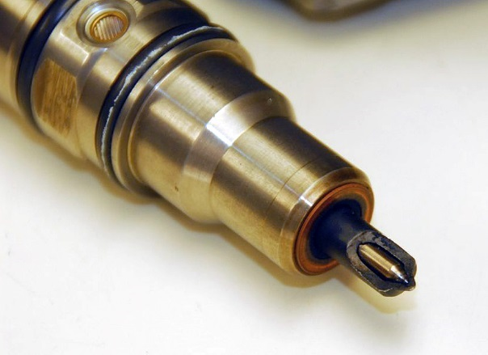
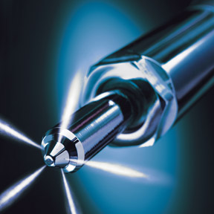

  - “Fuel stability is an ongoing concern, especially with recirculate fuel in the fuel system. Unstable fuels form insoluble gums and asphaltenes. Not only will these plug filters and injectors but they can also affect the combustion efficiency of the engine, resulting in a loss of power. Improper fuel droplet size due to damaged injectors combined with asphaltene particulates requires higher temperatures and compression to combust fully.”

Newsletter from Blackstone Labs – shows examples of what customers are able to learn (and prevent) from doing used oil analysis. – Good resource I will share when I get the emails
- https://gallery.mailchimp.com/f641390cba42169db49e0cd6e/files/ENG_Feb_2016_01.pdf

Sales Training
Three steps to improving in your sales of Xp3
- Increase your knowledge – Xp3, fuel, engines, issues, industries, etc.
  - Weekly calls
- Actually talking with customers and potential partners?
- Evaluating the successes and the areas for improvement and then repeating the process?

