Commercial Training 2-27-18
Updates:
There are 3 comprehensive trials available for qualifying companies
- At least 400 pieces of equipment and at least 1000 gallons of fuel consumed per month and per piece of equipment.
- We are planning a 2-hour GDI training on March 9th at the corporate office in Maple Grove from approximately 12 pm – 2 pm (Central). We have a group of teammates traveling into town and we wanted to help them and the rest of our team who is able to attend.
- We are also tentatively planning on our next full day, in-person GDI workshop on Saturday, April 21st
Questions, Comments, and Successes:
- Questions for Xp Lab and/or GDI -
- Marketing and Qualifying Potential Clients –
- Xp3 Questions -
- Sales Questions or Experiences You’d Like to Review –
Fuel and Industry Related:
Great article talking about preventative maintenance programs
- http://www.trucker.com/safety/preventive-maintenance-strategies
  - “The real issue is the quality of the PM you perform in order to maximize vehicle uptime.”
  - “In addition, cleaning DPF filters must be part of any trucker’s regular maintenance program, especially if they are planning on keeping their vehicle to and beyond the first required DPF cleaning cycle.”
  - Check out the “1-10-100” rule for maintenance – very helpful
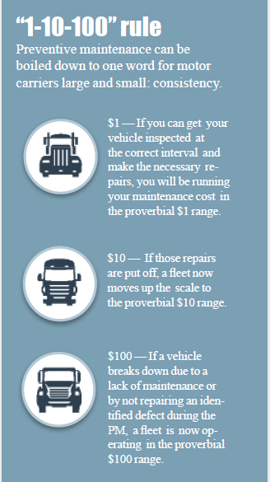
Another article on aftertreatment system maintenance (DPF, SCR, DEF, etc.)
- http://www.truckinginfo.com/channel/fuel-smarts/article/story/2018/02/what-you-should-know-about-aftertreatment-system-maintenance.aspx
  - “…if some preventive measures were put in place at some prescribed time or mileage, much grief and downtime could be prevented.”
  - Talk about using DPF exchange programs vs cleaning – benefit is less down time which makes sense when comparing costs to cleaning.
  - “Larger fleets that have their own cleaning equipment can turn a stage 1 cleaning around in a day, and maybe two days for a stage 2. If you have to send the filters out to have them cleaned, you’re probably looking at double that time, and that can keep affected trucks on the sidelines.”
  - “For example, Cummins now bases its recommended cleaning intervals on fuel economy. The published intervals for an X15 in on-highway service reads: 5.5 mpg: 250,000-400,000 miles, 5.5-6.5 mpg: 400,000-600,000, and 6.5+ mpg: 600,000-800,000. (That’s a lifetime average by the way, not just one particularly good day’s running.)”
  - Even “healthy” engines consume small amounts of lube oil, and most of that ends up going into the exhaust, explains Shawn Whitacre, senior staff engineer - engine oil technology with Chevron. “Because lube oils contain metallic components (from additives and from wear metals), some of these incombustible materials accumulate in DPFs and other exhaust components.”
  - “Any liquid, such as fuel, oil or coolant, that makes it into a cylinder and eventually into the exhaust stream will foul the DPF and lead to premature plugging, and perhaps permanent damage to the diesel oxidation catalyst, the DPF or worse, the SCR.”
    - “Once they have been damaged by coolant or oil contamination, they have to be replaced. They cannot be cleaned or repaired.”
  - “Rather than get caught on-road in an expensive predicament, take a proactive step and schedule a cleaning or replacement before the DPF plugs up for good and sticks you with a $1,000 bill and three days downtime.”
- Picture of Tier 4 emissions system on Class 8 truck
  - 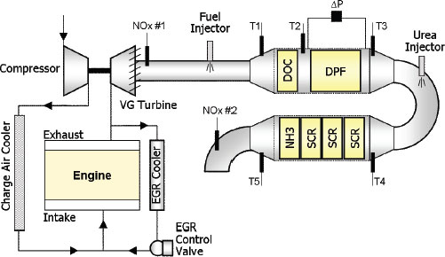
  - Another drawing
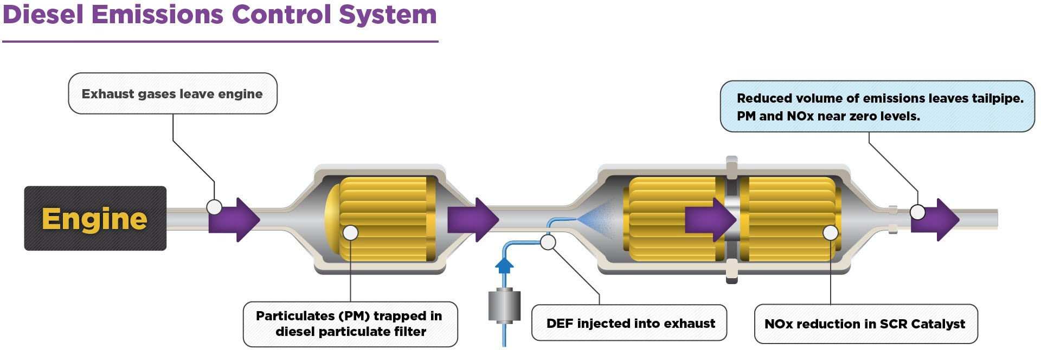
- Great supplemental document talking about the differences between DOC, DPF, and SCR
  - http://www.hartridge.com/blog/3-differences-between-doc-dpf-and-scr-filters
- Another supplemental document from 2012 on DOC and DPF
  - https://www.equipmentworld.com/maintenance-24/
- A video explaining more about DOC (Diesel Oxidation Catalyst) - https://www.youtube.com/watch?v=a23eWgbavNg
Check out the statistics on down time from emissions related issues in this example
- https://www.trucknews.com/features/how-to-keep-your-aftertreatment-system-from-eating-your-lunch/
  - “…3-4% of the company’s 5,500 trucks are down at any given time and that a quarter of all maintenance is emissions-related. “That’s a lot of technician time and a lot of downtime.”
  - “Some of the most common aftertreatment system failures are caused by water in the fuel, which can cause deposits and rust to form on injectors, leading to sticking injectors.”
Another great supplemental article from Peterbuilt on cleaning DOC and DPF
- http://www.allstatepeterbilt.com/blog/dpf-doc-cleaning/
  - “The DOC protects the DPF. Vapor can interfere with the DPF’s ability to trap and remove particulate matter, so manufacturers route the exhaust through the DOC first, then into the DPF. The DOC forces the exhaust over a honeycomb ceramic structure coated with catalyst which chemically changes carbon monoxide and hydrocarbons to carbon dioxide and water. Then the exhaust gases go through the DPF where it is forced through porous channel walls, trapping and holding the remaining ash and soot.”
Another article on emissions related down time and preventative maintenance –
- http://www.truckinginfo.com/channel/maintenance/article/story/2017/02/the-quest-for-uptime.aspx
  - Article talks about coolant and oil leaks causing havoc in engines.
  - “Billy Loller, vice president of maintenance at Alabama-based J&M Tank Lines, is a firm believer in oil sampling, and not just to extend service intervals. Oil analysis gives you clues about the physical condition of the engine and various parts inside that you can’t inspect,”
  - “Don’t wait for problems to crop up. Expect that they will, and search for clues as to what might be causing it. An extra hour spent on a PM could save you a day or more out on the road.”
Supplemental articles
Important article related to campaign to end human trafficking
- http://www.trucker.com/drivers/new-anti-trafficking-campaign-launched
Sales Training:
Tips for handling difficult sales calls
- https://blog.hubspot.com/sales/handle-difficult-sales-calls
  - Check out the “Call where someone takes over the conversation” section
Tips on selling to different personality types
- https://blog.hubspot.com/sales/how-to-sell-to-different-personality-types
  - Assertive =
  - Amiable =
  - Expressive =
  - Analytical =
Great script and tips for voicemail from Jill Konrath
- https://blog.hubspot.com/sales/sales-voicemail-tips-that-guarantee-callbacks
Supplemental sales resource:
8 great ways to generate leads –
- https://blog.hubspot.com/sales/how-salespeople-can-generate-their-own-leads
The top 29 sales related blogs
- https://blog.hubspot.com/sales/best-sales-blogs
21 books related to starting a business
- https://blog.hubspot.com/sales/books-about-starting-a-business
Marketing Resources:
Great tips for creating a Direct Mail piece –
- https://blog.hubspot.com/sales/how-to-write-sales-letter

