Commercial Training 2-23-16
Updates:
- We are looking for 3 comprehensive trials available for qualifying companies
  - At least 400 pieces of equipment and at least 1000 gallons of fuel consumed per month and per piece of equipment.
Questions, Comments, and Successes:

Fuel and Industry Related News:
Great article explaining some important information about bacteria and fuel
http://www.mycleandiesel.com/pages/ProblemMicrobialGrowth.aspx
- “Microbes are present everywhere, but without food and water they cannot multiply, diesel is food.”
- “By some estimates, a microbial colony can consume up to 1% of your fuel investment, while destroying the rest.”
- “Microbial colonies proliferate at the interface between fuel and free water that has settled to the bottom of the tank. This creates a “rag layer” which gives them everything they need to thrive.
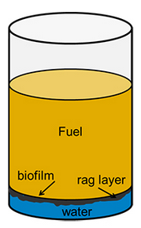
- “Biodiesel, being made from plant and animal fats, makes especially good food for these bugs and contributes to increased incidence of biological growth problems seen in recent years.”
- “With time, the microbial colony proliferates beyond control (stagnant tanks). This leads to acid formation, rust, corrosion, and filter plugging. Fuel degrades to the point that it can form a slimy sludge that is unusable as fuel.”
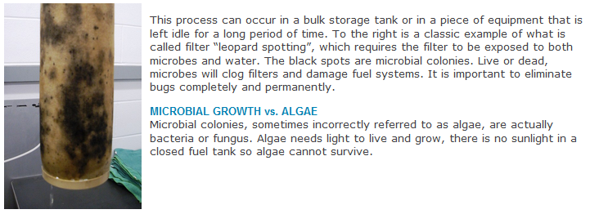
Another great article on bacteria in fuel - http://www.oillab.co.nz/diesel_bug_explained
- ”There are many differing types of bacteria which can infect systems and form bio-films on steel surfaces. Accelerated corrosion can also occur wherever the bio-film settles, usually in pits or crevices. Unlike general corrosion, it is an attack on a very specific area.”
- “A single cell, weighing only one millionth of a gram can grow to a biomass of 10 kilograms in just 12 hours, resulting in a biomass several centimeters thick across the fuel/water interface.”
- SRB (sulphate reducing bacteria) - “reduce sulphates and produce hydrogen sulphide (a lethal gas). They are directly involved with many microbial corrosion reactions and can cause sulphide souring of stored distillate products. Their action changes the Ph creating an acidic environment, conducive to accelerated corrosion. They attach themselves to the steel as a film and go to work. They derive their nutrition from the surrounding environment and multiply. They are particularly difficult to deal with and produce a sludgy by-product with a strong sulphur odor similar to rotten eggs (hydrogen sulphide)”
Testing process for diesel fuel bacteria contamination (land based and marine applications) http://www.oillab.co.nz/Site/Files/a/06cc20404d351cbaa2520fcd0d5adc3/f5e870faf330f6e480638b76b23ce74e/FUELSTAT%20Introduction%20Information%20-%20Oct%202011.pdf
- “Monitoring fuel systems for contamination on a regular basis is extremely important; particularly for Hormoconis resinae (H. res) – commonly referred to as “The Diesel Bug”.
  - “H. res. Is the one organism that will stick to the surface of a tank and is highly corrosive causing more physical damage to the tank and hull structures than any of the other microbes.”
  - “H. res is present in approximately 70% of all cases of contamination in diesel fuel.” The remaining 30% is made up of bacteria and/or other fungi (including some yeast).
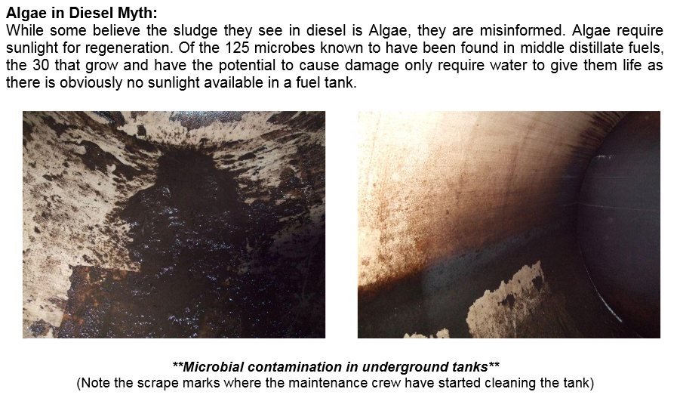
Article about 8 warning signs that you could have a bacterial problem in fuel –
http://www.bellperformance.com/blog/bid/45495/8-Signs-of-Diesel-Fuel-Contamination-by-Microbes-Fungus-and-Bacteria
- The need to replace fuel filters often
- Frequent cleaning or replacement of fuel injectors
- Premature wearing of rings and cylinder liners – microbes produce acidic byproducts that increase corrosion, as well as deposits that can produce wear in these areas
- Fuel discoloration – brown to dark khaki color
- Rotten fuel smell
http://xplab.com/wp-content/uploads/2015/08/LabTest_Xp3D-FOI-Biocide_Eng.pdf
Interesting video showing diesel fuel bacterial contamination over a period of 40+ days - https://www.youtube.com/watch?v=Qm3iM3nSj6E
Outstanding video showing examples of differences between water in diesel and biodiesel and talks about problems associated with water and fuel - (Talks about a kit to test for water at levels below the ASTM standards and water in suspension at 100 parts per million – could be big for biodiesel)
https://www.youtube.com/watch?v=-lh4qhXc_5s&ebc=ANyPxKo3P9Jn6Y_jDc_LkA60g7T6204rcQyqO5svAejD_GeGxA_2-8lWKJ7CjfxiVkkJ_4SzUum9UooPYXDZ_cq2Ec6N9pWK1A
A video from an owner of a Ford F250 showing fuel contamination (2014) video - https://www.youtube.com/watch?v=rgXI0GjoikE

Sales Training
Review of the 5 emotions (or stages) a person goes through when making a purchase – getting this order correctly determines your results and the speed of your results.
Bryan Franklin - https://www.youtube.com/watch?v=WCuNDR7bTB4
- Curiosity – concealing information in the initial stage and qualifying whether a person has a legitimate want (or need) for your product or service (Beth or Bob)
  - “I’m glad you’re asking these questions because it means you’re serious about solving problems. I’m just curious – which of the problems we’ve discussed today would you say is the biggest concern for your company?”
  - If you were to pick a number that represents the dollar amount that this problem causes for your company, what would that amount be? ($1,000 - $10,000 - $100K - $1 Million - $Millions, etc.)
- Empowerment - Most people walk around feeling frustrated because they don’t have the authority to spend money (their own or the company they work for)
  - We have to take care of a person’s ego – “Besides yourself – are there any other decisions makers who will be involved in making the decision to partner with us?”
- Possibility – we have to help the person (or business) to see a brighter and better future because of your product or service
  - The customer has to believe the possibility is real for them - trust that working with you will get them there!
  - This is where to have the discussion and/or demonstration about Xp3
- Urgency - has to be a reason that your potential partner (client) expresses that they want to fix now
  - This is where we restate or ask the questions below:
    - If you had a magic wand, how soon would you have a solution to this problem?
    - Are you ready to do something about that now?
      - Referring to the problem or solution they have stated earlier during the curiosity phase.
- Value and being right – the person has to believe that they made a great decision
  - If they haven’t asked to buy yet, we ask them a question like, “Ms. Jones, our guarantee covers up to 10 trial vehicles and most companies your size start with at least 5 vehicles to give a comprehensive trial. How many vehicles would you like to start your trial with today?”
    - When a person says they are ready to purchase, stop talking and start taking the order.

How many of you have a notebook or document that you use to track your experiences after sales calls or meetings for important things like:
- Successes
- Objections
- Opportunities for growth (aka – struggles or mistakes)
“The great sales people aren’t talkers, they’re professional stalkers!” – Grant Cardone
98/2 Rule – 98% of all people you interact with will not buy from you on your 1st contact. The fortune is in the follow up.
Let’s talk about any experiences that you’ve had recently when dealing with customers or potential customers that you’ve thought – “I wish I could redo that” or “What ways can I deal with that issue or objection in a better way?”
Here is a resource that shares sales information and tips - http://www.mrcoldcall.com/salesscripttips.html
- Ask for the order – so many times sales people neglect to ask for the order
- If we believe in our product, we have to ask people to buy it

