Commercial Training 2-16-16
Updates:
- We are looking for 3 comprehensive trials available for qualifying companies
  - At least 400 pieces of equipment and at least 1000 gallons of fuel consumed per month and per piece of equipment.
Questions, Comments, and Successes:
- S

Fuel and Industry Related News:
Great article talking about some of the problems of EGR valves for trucks
http://www.krazyon-highways.com/#!Dealing-With-EGR-Valve-Problems/ciy1/55a940450cf25b8bf7ebbe39
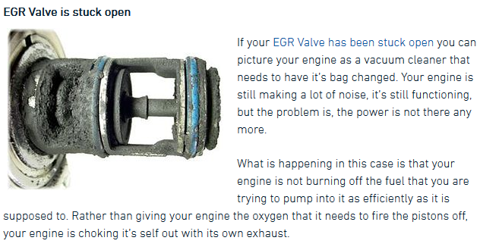
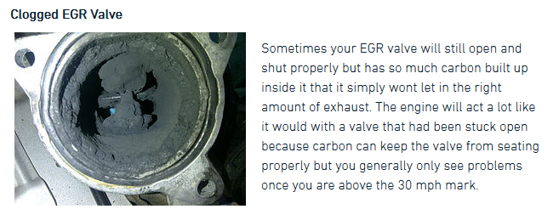
Outstanding article (with info graphic) explaining oil and things that will lengthen or decrease the life of engine oil
http://www.machinerylubrication.com/Read/28819/engine-lubrication
- Typical additive packages include a detergent, dispersant, and anti-wear formula
- “Soot is a good example of a deposit that is controlled by detergents and dispersants. Soot particles are enveloped by dispersant particles, forming a micelle, and are kept from attaching to metal surfaces. They are moved in this state through the oil system until they are removed by the filter. This also prevents a process known as congealing. During congealing, soot particles begin to stack upon each other or congeal into a larger particle. Smaller soot particles that could pass through components without interrupting the fluid film can congeal to make larger particles, which may disrupt the film and damage surfaces.”
  - Supplemental article explaining oil lubricity – http://www.machinerylubrication.com/Read/411/oil-viscosity
Basic video explaining engine oil and how it moves through the engine
https://www.youtube.com/watch?v=9RSWs44PdkE

Sales Training
5 emotions (or stages) a person goes through when making a purchase – getting this order correctly determines your results and the speed of your results.
Bryan Franklin - https://www.youtube.com/watch?v=WCuNDR7bTB4
- Curiosity – concealing information in the initial stage and qualifying whether a person has a legitimate want (or need) for your product or service (Beth or Bob)
  - "In the absence of knowledge your customers and prospects will always focus on price."
  - In this stage, it is critical that you maintain the posture and don’t let someone jump ahead to things like price before they have the proper info.
  - Without positioning need and value in front of price, the potential client views you (or your product) as a commodity and will always make this into a price discussion.
  - In some cases, the client wants to know whether they can dominate you because if they can, they feel you can’t help them. They do that by asking questions out of order and trying to take control of the conversation.
  - We ask questions in this phase like “Which of these 3 benefits do you think would help your company the most:
    - Improving fuel efficiency and performance
    - Decreasing maintenance costs and down time
    - Extending the life of your engines
  - Think about this stage as lingerie for your product or service
  - What to do when a customer asks, “How much is this going to cost?”
    - Keep bringing the conversation back to this curiosity and identifying the problem the person is looking to solve – price should not even be discussed until step 5
    - “I’m glad you’re asking these questions because it means you’re serious about solving problems. I’m just curious – which of the problems we’ve discussed today would you say is the biggest concern for your company?”
    - Once the customer states the specific problem(s), ask “If you had a magic wand, how quickly would you fix the problem?”
    - If the person doesn’t want to do something about the problem right now, then there is no reason for us to keep talking at this time. POSTURE
  - If you were to pick a number that represents the dollar amount that this problem causes for your company, what would that amount be? ($1,000 - $10,000 - $100K - $1 Million - $Millions, etc.)
- Empowerment - Most people walk around feeling frustrated because they don’t have the authority to spend money (their own or the company they work for)
  - We have to take care of a person’s ego – “Besides yourself – are there any other decisions makers who will be involved in making the decision to partner with us?”
  - “Assuming you’re the decision maker and assuming we’re going to work together, is there anyone else you need to include in this conversation before we begin this partnership?
  - If a person says they only have the authority to make a decision to a certain price and they need other approval after that - $10K example below
    - Great - If the solutions we come up with are under $10K, then you’re the decision maker. If it’s over $10K, who do we need to check with?
- Possibility – we have to help the person (or business) to see a brighter and better future because of your product or service
  - The customer has to believe the possibility is real for them - trust that working with you will get them there!
  - They have to believe that Xp3 is a proven technology that will address and/or eliminate the main problems
  - This is where to have the discussion and/or demonstration about Xp3
- Urgency - has to be a reason that your potential partner (client) expresses that they want to fix now
  - This is where we restate or ask the questions below:
  - If you had a magic wand, how soon would you have a solution to this problem?
  - Remind the person about the money and the problem question in the curiosity phase
  - Are you ready to do something about that now?
    - Referring to the problem or solution they have stated earlier during the curiosity phase.
- Value and being right – the person has to believe that they made a great decision
- In many cases, you will already have a customer by this stage and they will tell you they are ready to buy and ask about price
  - If they haven’t asked to buy yet, we ask them a question like, “Ms. Jones, our guarantee covers up to 10 trial vehicles and most companies your size start with at least 5 vehicles to give a comprehensive trial. How many vehicles would you like to start your trial with today?”
  - When a person says they are ready to purchase, stop talking and start taking the order.
- 1 + 1 = 2 The emotion and feeling we want the customer to feel at this stage is similar to the confidence that a person feels when answering 1 + 1
Great resource with some responses and quotes for sales and the sales process - http://www.mrcoldcall.com/salesobjectiontips.html

Three steps to improving in your sales of Xp3
- Increase your knowledge – Xp3, fuel, engines, issues, industries, etc.
  - Weekly calls
- Actually talking with customers and potential partners?
- Evaluating the successes and the areas for improvement and then repeating the process?

Let’s talk about any experiences that you’ve had recently when dealing with customers or potential customers that you’ve thought – “I wish I could redo that” or “What ways can I deal with that issue or objection in a better way?”
- I was talking with a potential partner (a.k.a. – customer) who stated they wanted to try Xp3. I answered their questions and asked if they had any other questions or are they ready to get started in the trial. Good up to this point, but there was an issue (that would not have normally happened to me…
  - I was trying to give the customer to a GDI teammate and I was talking after hours, so I couldn’t call the corporate office and make sure the sale was contributed to them. Told the person I would touch base in the morning because he needed to get me some oil change data from an oil change done that day. So where is the problem?
  - That’s right – the sale has to be made when someone is ready to purchase. In the future, I will take a credit card number and process the order in the morning.
- Another distributor told me a story about a company with about 600 pieces of equipment asking for an SAE test before trying the product. Options for handling that “objection”
  - “I can appreciate wanting quality testing for the products you’re using. I’m just curious – Are you saying that your company is ready make a purchase and begin our partnership based on simply having an SAE test?
  - “I can appreciate that – I’m just curious what bench marks need to be achieved in the SAE in order to begin our partnership and make your first purchase?”

