Commercial Training 12-6-16
Updates:
There are 3 comprehensive trials available for qualifying companies
- At least 400 pieces of equipment and at least 1000 gallons of fuel consumed per month and per piece of equipment.
- The next 1 day workshop located at the Maple Grove corporate office will be April 2017 and I will update everyone on the date as soon as I receive confirmation from Randy.
Questions, Comments, and Successes:
- Questions for Xp Lab and/or GDI -
- Marketing and Qualifying Potential Clients –
- Xp3 Questions -
- Helping Customers Prove Benefits –
- Sales Questions -
- Referrals and Testimonials -
Fuel and Industry Related Info:
OPEC has reached a deal to limit production, which has (and will) impacted fuel prices.
- http://www.thetrucker.com/News/Story/Dieselpricestakesharpturnupwardrise6centsto248
Great August 2016 article on preparing construction equipment for gelling
- http://www.constructionequipment.com/be-ready-when-weather-turns-cold
  - Fluid Considerations
    - Check out this section for useful info about oil weights
  - Fuel is also part of this section – some great bullets to share
    - “Operators should also top off their tank each day after use to prevent the opportunity for condensation.”
    - Always clear snow and dirt away from around the fill point
    - Water should be drained from the pre-filter and tank daily
  - DEF and Emissions Systems
    - DEF freezes around 12 degrees – not a problem with tank heaters
Remember that Xp3W-Xtreme reduces the pour point of the base fuel up to 35 degrees
Really good article from Oct. 2016 on fuel contaminants – check out the sections on asphaltenes and glycerides in biodiesel
- https://www.bellperformance.com/bell-performs-blog/the-fuel-contaminants-you-need-to-watch-out-for
  - Asphaltenes – “…complex and heavy carbon molecules that normally coexist in suspension with the fuel…But the refinery processing of ULSD destroys a lot of the natural dispersants. So the asphaltenes become unstable and turn the fuel dark a lot faster than in the past. These asphaltenes end up being a significant part of the dropout of the dark sludge dropout you see in many large fuel storage tanks.”
  - Glycerides and water in biodiesel
    - “Even if it says it’s just regular old diesel fuel. As long as the biodiesel content is 5% of less, they don’t have to disclose it.”
    - “…biodiesel fuel can have higher levels of different kind of glycerides and even excessive residual glycerin, a primary byproduct of biodiesel manufacturing reactions that’s supposed to be washed out of the fuel before it’s sold. These leftover contaminants can cause injector fouling and filter plugging, and they can attract excessive amounts of water into the biodiesel fuel.”
  - Good supplemental article - http://www.mycleandiesel.com/pages/SoftContaminants.aspx
    - “Once solid glycerin has formed, it most likely will not melt at normal ambient temperatures. It must be physically removed through tank cleaning and/or filtration. It can take as little as a few spoonful of glycerin to disable a filter, so if you do not thoroughly clean your tank, expect to use a large number of filters before it flushes itself out.”

Sales Training:
Here are two great articles listing possible questions to identify problem/pains and create urgency
- https://blog.hubspot.com/sales/sales-questions#sm.000t7ca6bl1qcvk11eb2g0x5m3q7y
  - Which of these issues are impacting your company?
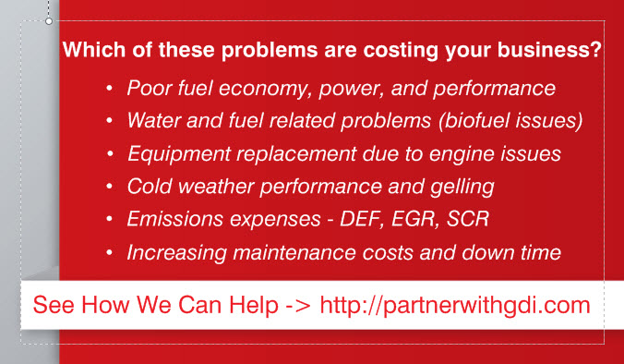
  - Can you tell me more about the problem?
  - How often has this problem come up?
  - Tell me more about (insert problem they identified)
- https://blog.hubspot.com/sales/sense-of-urgency-questions#sm .000t7ca6bl1qcvk11eb2g0x5m3q7y
  - Have you had this problem before?
  - What sort of solutions have you tried in the past?
  - How many people are affected by this problem?
  - How much is this costing your company?
  - If you were able to find a solution, how would that help your job?
New update from Google regarding the importance of “mobile friendly” websites
- https://blog.hubspot.com/marketing/mobile-first-google-index#sm.000t7ca6bl1qcvk11eb2g0x5m3q7y
- https://webmasters.googleblog.com/2016/11/mobile-first-indexing.html?m=1
Great infographic explaining more about how the brain processes different types of content
- https://blog.hubspot.com/marketing/brain-processes-different-kinds-of-content#sm.000t7ca6bl1qcvk11eb2g0x5m3q7y

