Commercial Training 11-7-17
Updates:
There are 3 comprehensive trials available for qualifying companies
- At least 400 pieces of equipment and at least 1000 gallons of fuel consumed per month and per piece of equipment.
The next 1-day workshop located at the Maple Grove corporate office will be
- Saturday November 18th, 2017 from 9am to 5pm
  - New GDI Reps and Certified GDI reps need to register by visiting http://becomeproworkshop.com
    - New GDI reps are required to have completed the online training before attending a workshop.
  - We invite all currently certified GDI reps to attend - there is a $25 fee for currently certified reps, which covers lunch, printed materials, and a new GDI thumb drive with current GDI documents.
    - Currently Certified Reps can purchase their $25 ticket by logging into your back office and clicking “Shop Now” > Then select your catalog > then select “Xp3” > and you’ll find Item #9700 available for purchase.
- The new GDI inserts are available for purchase.
  - Cetane Booster and Winter Xtreme are available on 1 insert printed front-to-back
  - Anti-Friction Engine Oil Treatment and Cleaner-Degreaser are also printed front-to-back
  - 25 pack - $7.50 (Item #200017)
  - 100 pack - $20 (Item #200018)
  - These are great products that can be used to open the door for cross-selling with Xp3
- Whenever possible, please look for opportunities to ask for testimonies (video and written) and remember that the foundation for testimonies is created in the beginning of the sale!
Questions, Comments, and Successes:
- Questions for Xp Lab and/or GDI -
- Marketing and Qualifying Potential Clients –
- Xp3 Questions -
- Sales Questions or Experiences You’d Like to Review –
What is the #1 area that you would more training about to help you grow your business?
- Lead generation?
- What to say to leads?
- Sales process?
- Handling objections?

Questions about gelling and Xp3W and Xp3 Winter Xtreme
- What we teach regarding the Xp3 Winter and Xp3 Winter Xtreme formulas will help provide the best cold weather protection for our customers and help you to keep satisfied and repeat customers.
  - We want our customers to make informed decisions and be educated about the difference between the products, so they keep their equipment running!
- While Xp3W does provide some additional anti-gel protection, we have found that it is best to advise our clients that IF they are at all concerned about the potential for gelling – use the Xp3 Winter Xtreme.
  - Xp3 Winter Xtreme – provides up to an additional 35 degrees of protection to the pour point rating of the fuel being treated.
  - It is possible to increase the treatment ratio of the Xp3 Winter Xtreme and receive some additional degrees of protection, but we generally do not recommend treating with more than 4 ounces per 30 gallons of fuel due to diminishing returns and higher costs.
    - Disclaimers:
      - We are NOT giving broad air temperature ranges as general statements for customers
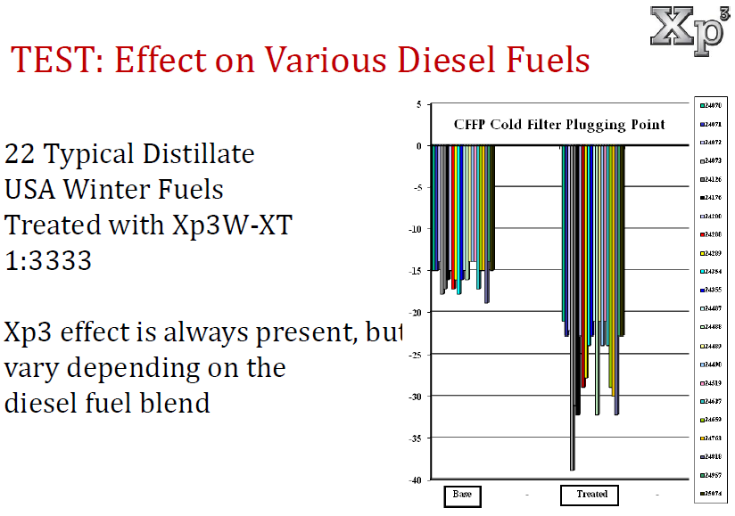
      - 2 variables that could impact cold weather performance of Xp3 Winter Xtreme are biodiesel blends higher than B20 and/or free water (out of suspension) in their tank.
      - Do not use Xp3 Winter Xtreme for demonstrations
Fuel and Industry News:
Article about diesel prices being highest level since June 2015
- http://www.truckinginfo.com/channel/fuel-smarts/news/story/2017/11/diesel-prices-hit-highest-point-in-over-2-years.aspx
  - Average price of on-highway diesel is $2.82 and is 41.2 cents/gal. higher than the same week last year.
  - Gasoline prices are currently 32.8 cents higher per gallon compared to 2016
  - Companies are (and should be) looking for ways to be competitive given variables like driver shortages, rising fuel costs, and rising equipment costs because it directly impacts their profitability. Xp3 can directly and indirectly impact these issues for companies.
Supplemental Fuel and Industry News:
By 2035, Port of Los Angeles and Long Beach will only allow zero-emissions vehicles to operate in the port.
- http://www.truckinginfo.com/channel/fleet-management/news/story/2017/11/clean-air-action-plan-approved-by-ports-of-la-long-beach.aspx
What appears to be an important EGR product –
- http://www.truckinginfo.com/channel/fuel-smarts/product/detail/2017/11/dorothy-tornadic-egr-cleaner-can-lower-emissions.aspx
  - Helps keep heavy soot particles out of engine, which would normally be circulated back into the engine because of the EGR system
    - https://www.pittsburghpower.com/meet-dorothy.html
Sales Training:
Great article from Hubspot listing 7 great questions to determine how serious a potential partner (customer) is about buying:
- https://blog.hubspot.com/sales/is-prospect-serious-about-buying
  - “How have you attempted to overcome this challenge in the past?”
    - “How did you measure the effectiveness of the product or service?”
      - This question tells you a lot about their approach and is an opportunity to differentiate yourself, protect your future sales, AND get a testimony/referral. All done in the start of the sales process!
  - “Why is solving this issue a priority now?”
  - “Change can be challenging for some companies. How committed are you to solving this problem and measuring the return on your investment with Xp3?”
  - “Our most successful customers have documented before-and-after comparisons to prove the return on their investment by using Xp3. This usually involves (list what steps you recommend based on what they are measuring). Is this something you understand the value of doing and are ready to commit to doing?”
  - Don’t forget the Conditions of Satisfaction – “What specific benchmarks would have to be accomplished during your trial with Xp3 in order for you to feel confident in using Xp3 in all your equipment going forward?”
  - “Once you have experienced and proven the benefits of using Xp3 in your equipment, what is your implementation plan?”
Great article talking about the 7 kinds of questions to ask in the sales process
- https://blog.hubspot.com/sales/types-of-sales-questions
  - https://blog.hubspot.com/sales/types-of-sales-questions
    - The main one I wanted to point out is #7 – objection surfacing questions
      - The best time to address an objection is before they have a chance to verbalize it (especially in front of their colleagues)
      - If everything is moving forward and “green lights”, then there is no reason to ask the following question or address objections. If there is hesitation, you can say something like one of the following options:
        - “I’m sensing some hesitation. What questions or concerns do you have that would prevent you from moving forward in our partnership?”
          - You can add the word “today” at the end of the sentence if you are talking to all the decisions makers.
        - “I’m sensing some hesitation. What questions can I get answered forward that will help you to feel confident moving forward in our partnership?”
      - In most cases, it’s the unspoken objection that prevents sales
        - See Grant Cardone’s 3 questions – I need to think about it
          - “Take all the time you need. About how much time do you think you will need - maybe a week or 2?”
          - “Before I go, can I share one last thing with you?”
          - “Most of our customers tell that tell me they need some time to think about it usually are looking for the answers to one of 3 questions:
            - “Do I feel confident working with (Your Name) and GDI?”
            - “Do I think Xp3 can help me solve (insert challenge they are dealing with)?”
            - “Where can I find the resources to pay for the initial investment with Xp3?”
        - Another great potential response, which I learned this from Ray Higdon
          - “I totally understand and take all the time you need. We want you to do your diligence because we take partnering with your company very seriously and since we’ll be working together to prove Xp3 solves (insert their challenge/need) and we don’t want to partner with anyone who isn’t ready and serious about doing that.”
Article from Hubspot talking about face-to-face communication
- https://blog.hubspot.com/sales/face-to-face-networking-stats
  - According to one survey, 9 out of 10 people say small meetings are their favorite communication method
  - Nearly 100% of people say face-to-face meetings are essential for long-term business relationships
  - For every $1 companies invest in travel, they receive $12.50 in value
  - The closing rate for in-person meetings is 40%
  - The average company would lose 17% of its profits if it eliminated travel
- While online marketing is important, we can’t diminish or eliminate the importance of people connecting with us.
  - Online tools like Skype, Zoom, and GoToMeeting make it possible to video conference which can help bridge the distance gap in some sales and allow us to see body language.
Article listing 33 best sales training YouTube channels
- https://blog.hubspot.com/sales/sales-training-videos-youtube

Additional Sales Resources:

Marketing Resources:
Great article talking about color psychology – think webpages, buttons, text, etc.
- https://blog.hubspot.com/marketing/psychology-of-color
Great resource for doing Facebook live videos
- https://blog.hubspot.com/marketing/facebook-live-guide
Great resource for the size of images on social media profiles/headers
- https://blog.hubspot.com/marketing/ultimate-guide-social-media-image-dimensions-infographic

