Commercial Training 10-4-16
Updates:
There are 3 comprehensive trials available for qualifying companies
- At least 400 pieces of equipment and at least 1000 gallons of fuel consumed per month and per piece of equipment.
- The next GDI 1 day workshop will be Saturday, November 19th from 9am to 4pm at the GDI corporate office in Maple Grove, MN. http://becomeproworkshop.com
Questions, Comments, and Successes:
- T

Fuel and Industry Related Info:
Great video from Tony Robbins about efforts to stop human trafficking - https://www.facebook.com/TonyRobbins/videos/10154628949709060/
- http://theabolitionistmovie.com
Good 2016 article for farmers on the causes of injector failure/poor performance in Tier 4 engines
- http://farmindustrynews.com/chs-inc/tier-4-troubles-preventing-fuel-injector-failures
  - “Tolerances inside Tier 4 fuel injectors are 1 to 3 microns. A red blood cell is about 8 microns wide,” says Chuck Hamilton, technical services manager, CHS. “With tolerances that small, even a stain or tarnish on an injector’s components can cause significant power loss.”
Article listing some of the benefits of improving cetane number
- http://farmweeknow.com/blogs-benefits-high-cetane-diesel-fuel-3681
  - Supplemental article talking about cetane number vs octane number and cetane index vs. cetane number:
    - https://www.bellperformance.com/bell-performs-blog/diesel-cetane-improver-busting-myths
Great article talking about some statistics of how long fleets are keeping their trucks
- http://www.truckinginfo.com/channel/equipment/news/story/2016/09/report-small-fleets-keep-trucks-nearly-twice-as-long-as-large-fleets.aspx
  - Recent survey shows that smaller fleets are averaging 5 years of age compared to larger fleets averaging 2.7 years.
  - Opportunity in both groups – extend engine life and reduce maintenance costs for smaller fleets and help reduce maintenance costs and improve resale value of trucks for larger fleets

Good article talking about 5 steps to help increase the resale value of machinery/vehicles
- https://www.rbauction.com/blog/how-to-maintain-the-resale-value-of-heavy-equipment-%E2%80%93-5-steps-to-help-you-get-the-best-price-when-selling-equipment-
  - “Tip: Document all maintenance, service and repairs in a log book. When it comes time to sell, make the maintenance log book readily available to the buyer. The more buyers know about the maintenance and usage history of the machine, the more willing they will be to spend top dollar on a machine that has been properly looked after.”
    - Secondary article on keys for considering when to retire a truck
      - http://fleetowner.com/fleet-management/knowing-when-retire-truck
Interesting article talking about the potential of using “truck platooning” in the future to cut costs (likely not seen on the road here in the USA 2018 to 2030 (equipment and training need to take place).
- http://www.truckinginfo.com/channel/fleet-management/news/story/2016/09/nacfe-report-truck-platooning-could-save-4-in-fuel.aspx
  - “Platooning – the electronic linking of trucks where a lead vehicle largely controls the one following -- would save about 4% in fuel compared to a pair of rigs running separately”

Sales Training:
Here are a couple of articles that I hope will be helpful:
- https://www.thebalance.com/how-to-overcome-a-fear-of-sales-2918607
  - Point #1 - Everyone faces fear at some point in sales
  - Point #4 - Do what you fear until you become skilled at it
    - Every master was once a disaster
    - If you don’t have times that you look back on and say, “I could have done that differently” or “I missed that opportunity” – then you aren’t growing.
    - When our desire to make a difference (for ourselves, our families, our charities/causes, our economy, the environment, etc.) becomes bigger than our fear – our results will change.
- https://www.facebook.com/rayhigdonpage/videos/1375495172464206/
  - Frustration is the gap between where we are at & where we think you should be
  - Both are opinions and are subjective
  - Often where we think we are is worse than where we actually are
  - Often where we think we should is bigger than what our skills/action would result in
  - Good news – we can do something about both through training and action

Summary from the book, High Probability Selling, by Jacques Worth and Nicholas E. Reuben:
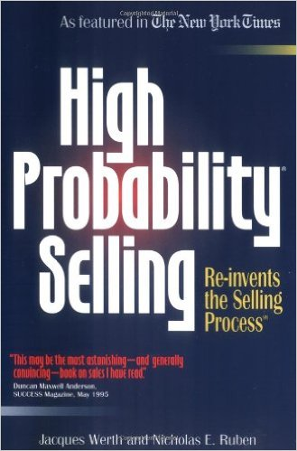

Pg. 36 – “High probability selling is really a method of inquiry. The inquiry is designed to arrive at a meeting of the minds and result in mutual commitments between a salesperson and the prospect by determining whether:
- The prospect needs, wants, and can afford our products
  - Try to identify whether they are “Beth or Bob” - somewhere around 40 -45 words
- The prospect is willing to define his/her Conditions of Satisfaction of which, if met, will result in the purchase of our products
- The commitment the prospect makes with regard to his/her Conditions of Satisfaction is specific as to all the necessary particulars and is absolute and unequivocal”
Don’t waste your resources on low probability prospects. All that activity costs money and more importantly takes away from the opportunity of working with High Probability Prospects
The more you try to convince the prospect that your product is the best, the more resistance you create.
Almost anything you say can be phrased as a question. If a sales person is doing more than 25% of the talking, the conversation is not going well.
Pgs. 57 and 60 – The Dis-Qualification Process:
- Does the person want or need our product?
- Does the person want to arrange the appointment?
- If not now, when?
- If not now, does the person want us to check back later?
- Why does the person want to meet with us at that time?
- What would the person like to accomplish at out next meeting?
Unless you’re literally getting paid for each appointment you set, getting appointments without qualifying and/or disqualifying someone is a losing approach to growing your business
When people know you are willing to take no for an answer, they are usually willing to talk with you openly and honestly.
Pgs. 59 and 60 - Deck of cards example:
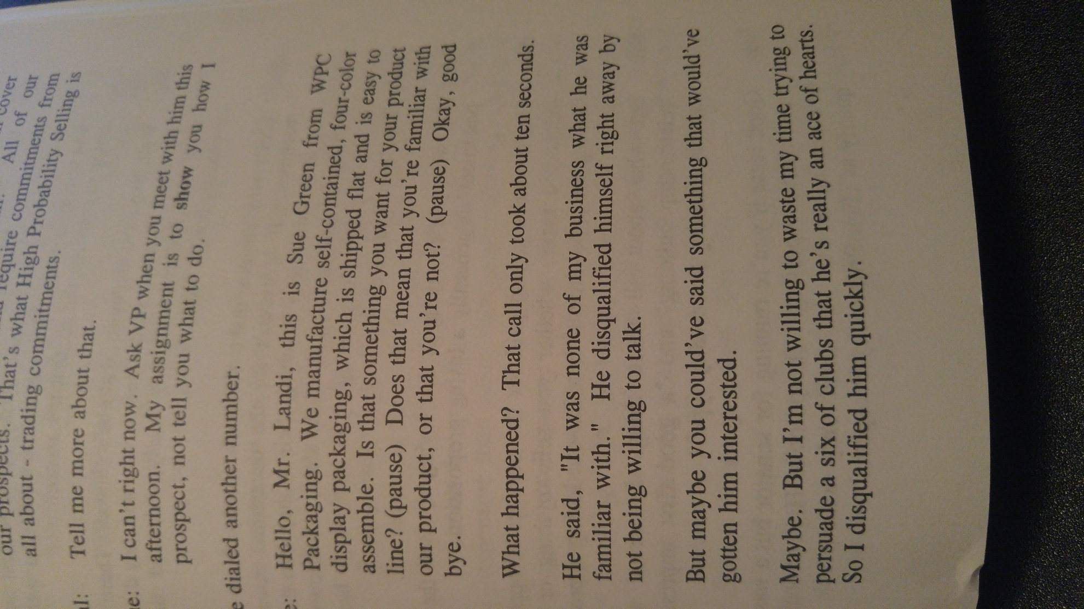
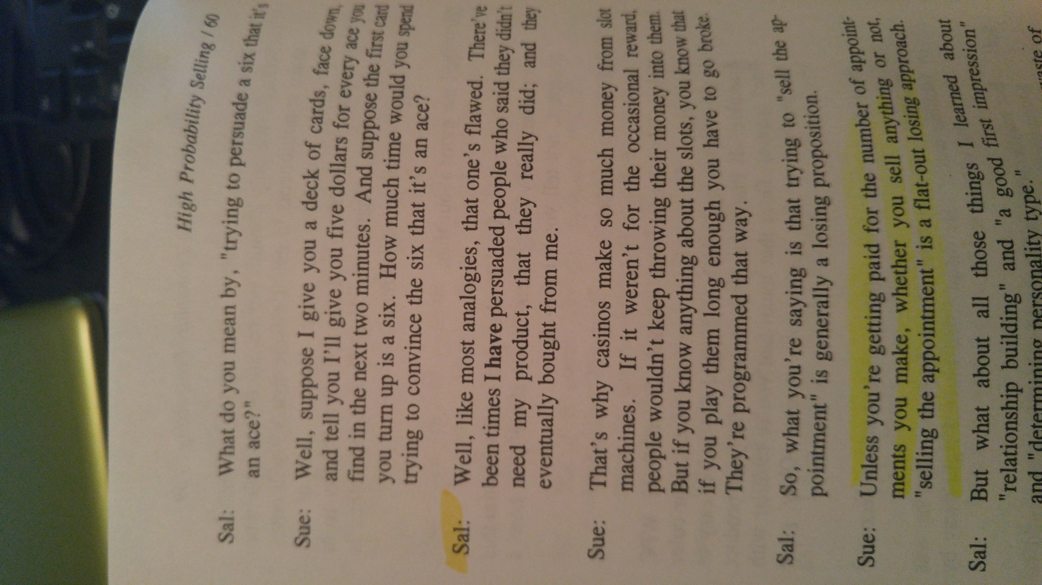

Be unwilling to spend time with prospects who aren’t willing to make commitments

Pg 63 – conversation about price and specifics about other terms. “I don’t discuss those issues unless I know the prospect wants what we’re selling. Always find out whether the prospect wants what you’re selling.”
  - What if they can’t determine whether they want what you’re selling unless certain questions are answered?
    - “Assuming we can work those things out (to your satisfaction), is this something you want or not?”
Pg 65 – The Fundamentals of High Probability Prospecting
  - Clearly language your offer in approximately 45 words (or less) – including your greeting
    - The greeting below is 49 words
    - Hi Mrs. Smith – my name is Tom with GDI. In order to be respectful of your time, I am curious which of the following three benefits would help your company the most:
      - Increasing your profits?
      - Decreasing maintenance costs and down time?
      - Keeping your equipment running better and longer?
  - Ask the prospect if they want you are offering? (See examples on pages 53-56 & 61)
    - “Excellent, so Mrs. Smith, if you felt confident that our solution would help you (restated benefit(s) they expressed above), what would you do?”
  - If they answer with something positive like “get started” or “make a purchase”, arrange a meeting or…
  - Reschedule your call to a time when the prospect wants you to contact them again with his commitment to move forward at that time if they felt confident that our solution would help them to (restate benefits they expressed above).
  - Assure the prospect that it’s ok to say “no” whenever you sense hesitation on their part and end the call if you get a negative answer to any of your questions.
  - Disqualify every prospect who doesn’t want what you’re offering or isn’t willing to buy from you.

The idea is to place ourselves in a high percentage situation where we have the competitive edge. Match your strengths to the prospects who want your strengths the most.
Price, Quality, Service
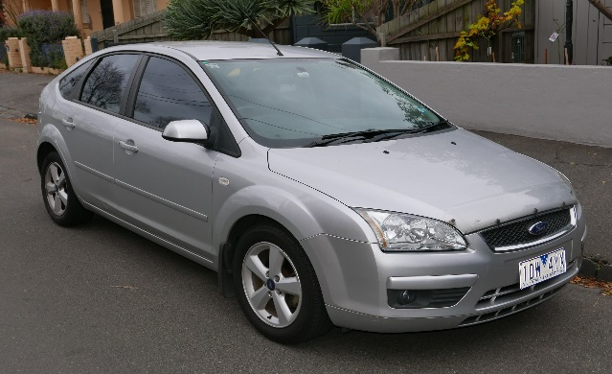
  - Xp3 is a multi-functional fuel technology (multi-functional problem solver). We offer the premier fuel enhancer technology, so why would we try to compete with them on price?
    - Our clients should not expect to have the lowest price (compared to other fuel additives)
Pg. 79
- What if someone is really interested in our product?
  - There is no commitment in interest – it is usually a cover for someone who doesn’t want to buy.
Pg. 80
- What if the prospect says, “Send me some information?”
  - “Usually when people say that to me it is a polite way of saying “Get lost”. If you want me to “Get Lost” just say so – it’s ok. I don’t send out information unless someone wants what I’m selling, needs the information, and there’s a strong likelihood that we’ll do business together once your conditions of satisfaction are met.”
Pg. 89
- “A hammer is effective whether you understand why it works or you don’t.”
  - When people want to understand every detail about Xp3.
Pg. 105
- This situation (and statement) requires posture – What to do when you are talking with one person and there are other decision makers involved (assuming you found this out before doing any presentation) –
  - You say something like, “Bob, besides yourself is there anyone else who would be involved in a decision to partner with another company?”
  - Bob replies, “Yes, my business partner Beth would also be involved.”
  - You say something like, “Great, I’m available Thursday afternoon this week or Tuesday morning next week. Which of those options would work for the three of us to meet?”
  - Bob replies, “I can meet with you and I’ll meet with Beth.”
  - You reply, “Bob, because I respect your time and want to partner with you to (insert the problem Bob wants to solve), it’s imperative that I meet with both of you at the same time. I’ve got my calendar open, when would be the next time that works for both of you?”
In high probability selling, we’re not willing to continue the sales process if Bob is unwilling to set up a time for all three of you to meet because we cannot have people selling Xp3 for us (that’s not their job or expertise).
Pgs. 120-121 (Maintaining posture)
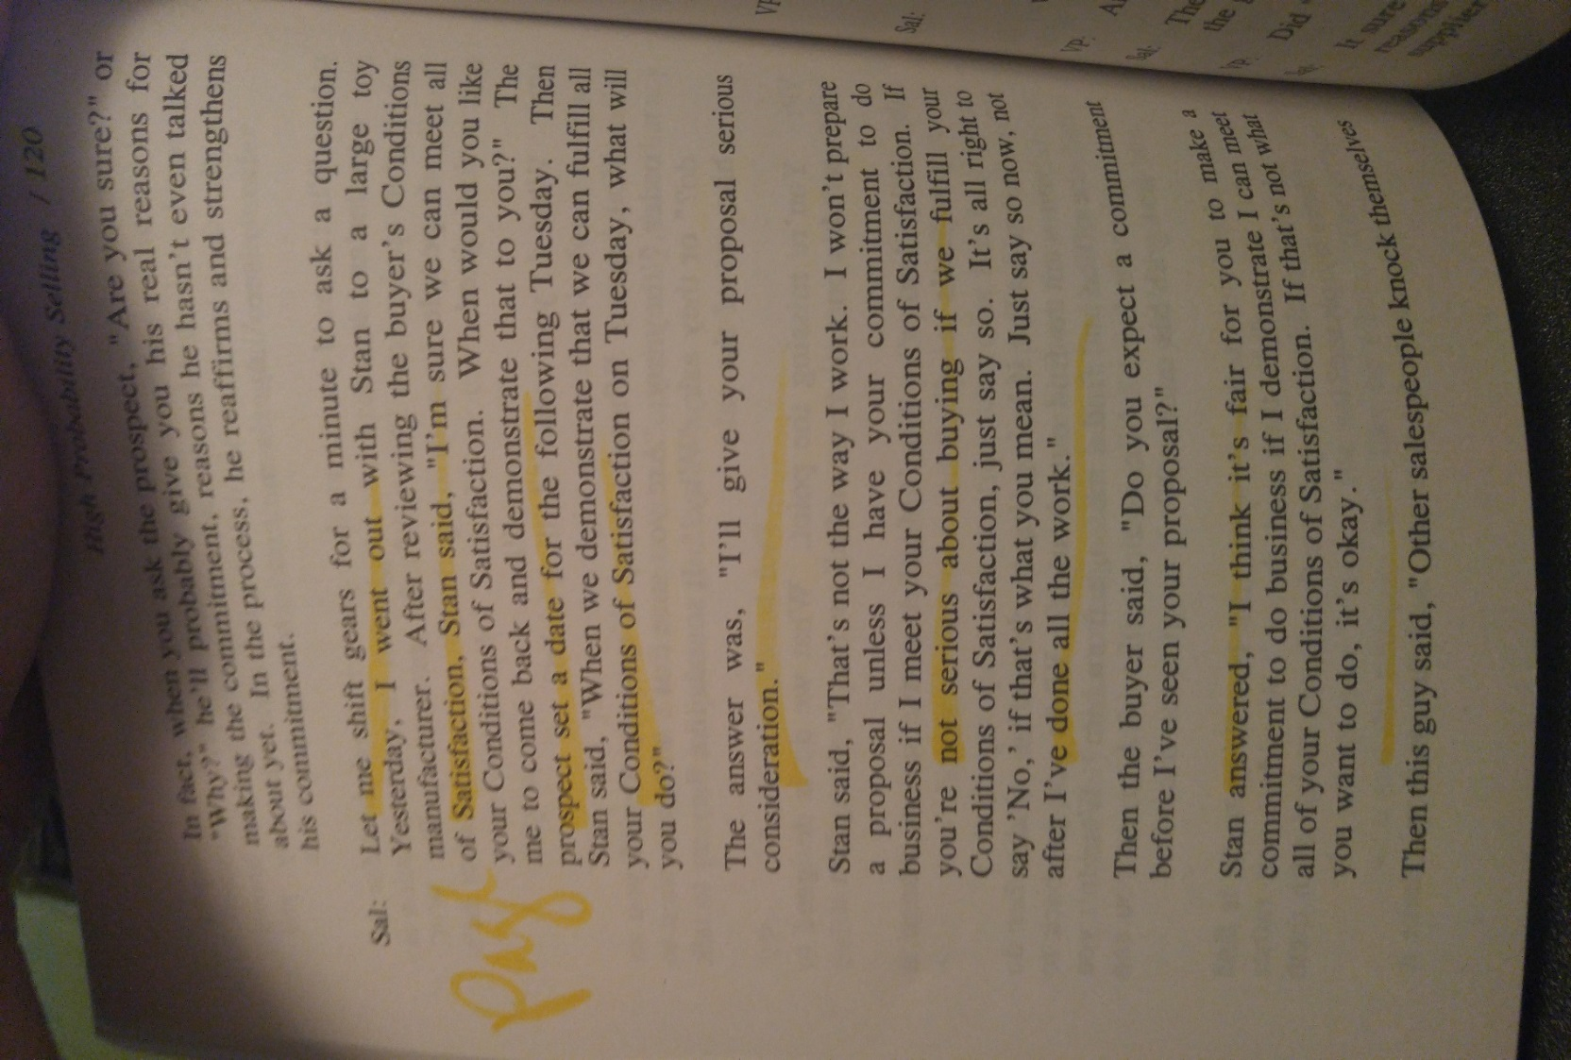
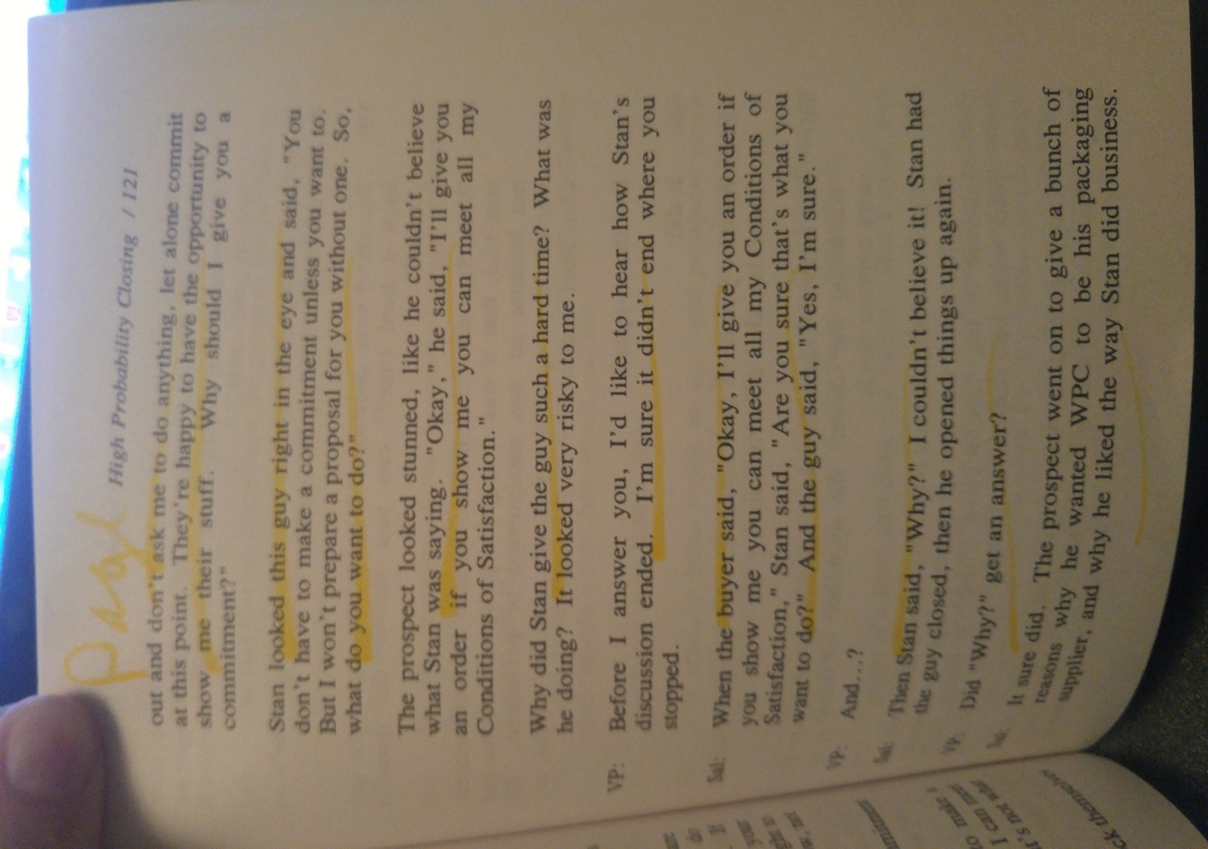
Pg. 122
“From beginning to end we offer the prospect a choice which includes his/her right to choose “No.” If he/she chooses “Yes”, the they are making a commitment and we proceed. If they choose “No”, then we disqualify them and conserve our resources for prospects willing to make a commitment.
- Some people may think they are going to “lose” prospects, but the reality is that you will likely gain more clients (and more qualified clients) much more quickly
Consistently evaluate your successes and your struggles
- Pg. 126 - “Once in a while, prospects buy even when you do everything wrong. We call that “Random Negative Reinforcement.” That kind of success sometimes reinforces approaches that are ineffective in the long run.
- Pg. 141 – “ A primary goal is to eliminate ambiguities so there are no reasons for the prospect to renege later on.”
Pg. 133 – “Most prospects want to be certain that their specific wants and needs (Conditions of Satisfaction) will be met before giving you an order.”
Pg. 144 – “If you don’t take responsibility for your results, you won’t discover your errors and you’ll keep repeating them.

