Commercial Training 10-24-17
Updates:
There are 3 comprehensive trials available for qualifying companies
- At least 400 pieces of equipment and at least 1000 gallons of fuel consumed per month and per piece of equipment.
The next 1-day workshop located at the Maple Grove corporate office will be
- Saturday November 18th, 2017 from 9am to 5pm
  - New GDI Reps and Certified GDI reps need to register by visiting http://becomeproworkshop.com
    - New GDI reps are required to have completed the online training before attending a workshop.
  - We invite all currently certified GDI reps to attend - there is a $25 fee for currently certified reps, which covers lunch, printed materials, and a new GDI thumb drive with current GDI documents.
    - Currently Certified Reps can purchase their $25 ticket by logging into your back office and clicking “Shop Now” > Then select your catalog > then select “Xp3” > and you’ll find Item #9700 available for purchase.
- The new GDI inserts are available for purchase.
  - Cetane Booster and Winter Xtreme are available on 1 insert printed front-to-back
  - Anti-Friction Engine Oil Treatment and Cleaner-Degreaser are also printed front-to-back
  - 25 pack - $7.50 (Item #200017)
  - 100 pack - $20 (Item #200018)
  - These are great products that can be used to open the door for cross-selling with Xp3
- Whenever possible, please look for opportunities to ask for testimonies (video and written) and remember that the foundation for testimonies is created in the beginning of the sale!
Questions, Comments, and Successes:
- Questions for Xp Lab and/or GDI -
- Marketing and Qualifying Potential Clients –
- Xp3 Questions -
- Sales Questions or Experiences You’d Like to Review –
Fuel and Industry News:
Interesting article talking about higher driver costs and how they are outpacing fuel savings from lower fuel costs
- http://www.overdriveonline.com/higher-driver-pay-drove-carriers-costs-higher-in-2016/
  - This provides another way to start talking about “savings” and looking at Xp3 as a tool to add to the bottom line of a business.
Another report cites the #1 concern for 41% of those surveyed is “managing costs”
- http://www.landlinemag.com/Story.aspx?StoryID=71064#.We-y4FtSxqM
  - Payroll, fuel, maintenance, insurance, vehicle purchase/lease costs
  - This is an opportunity to talk with companies about making an impact on their concerns (not just fuel and maintenance).
    - This also underscores the importance of talking with decision makers because they will understand the wide view of the entire company AND the impact Xp3 can have overall.
      - Moves Xp3 from commodity discussion to being seen for what it is which is a multi-functional problem solver!
ConstructionEquipment.com article that talks about testing drain intervals for Tier 4 emissions equipment and BlackStone Labs (the lab we use) in the picture for used oil testing
- https://www.constructionequipment.com/new-engine-oils-drain-intervals-tier-4
  - Check out “Oil-Analysis, Filtration Remain Key” section
    - “Kristin Huff, vice president, Blackstone Laboratories, reminds machine users that drain intervals are largely engine- and application-specific.”
    - “The most effective uses of oil analysis are preventive maintenance (finding potential problems before they take down an engine) and extending drain intervals. Most people don’t realize they can run the oil far longer than they currently are. So if the oil can handle more use, an analysis can determine that, and the lab can recommend how long to continue running before checking back.” – Kristin Huff
    - “Bruce Reader, regional product support manager, Case, suggests that emissions-control systems—especially exhaust-gas recirculation, which can expose oil to high soot levels—can have a significant influence on an oil’s useful life, making oil analysis an essential tool for monitoring oil condition.”
Supplemental Fuel and Industry News:
Short article talking about glider kits for trucks (to avoid emissions laws) and glider manufacturers trying to avoid the Phase 2 emissions umbrella.
- http://www.overdriveonline.com/epa-plans-to-nix-obama-era-emissions-standards-for-glider-kit-trucks/
  - “The EPA has formally proposed repealing Obama-era emissions regulations placed on glider kit tractors.”
  - Great supplemental video on glider kits – especially the from the start to 41 seconds into the video – thanks for sharing Amara
    - https://www.youtube.com/watch?v=cU5NBz2b1-M&feature=youtu.be
For those of you with clients in the Midwest – this class on fleet management may be helpful to them in Madison, WI on Nov. 14th and 15th – great to pass along and continue to add value
- https://www.equipmentworld.com/fleet-management-course-scheduled-in-wisc/
Sales Training:
Formula to make the most out of your sales opportunities
- Be prepared (this is about skills and you’re on these calls, so great job working on that part)
- Prospect and/or market whenever you can
- Reflect on your experiences – take notes
- Follow up
- Learn and apply new things
- Repeat
Missed opportunities
- Example – Talking with potential client and doing the demo without asking qualifying questions
  - What if you run into a product that performs “similarly” to Xp3 in the demo?
    - If that happens, the conversation shifts to a price and Xp3 becomes a commodity. If we ask questions ahead of time like:
      - What problem were you looking to address when you initially started using the fuel additive?
      - How did you measure its effectiveness?
      - Is the product and petroleum or alcohol base?
        - This gives you the opportunity to
      - Are you having issues with any of these other issues?
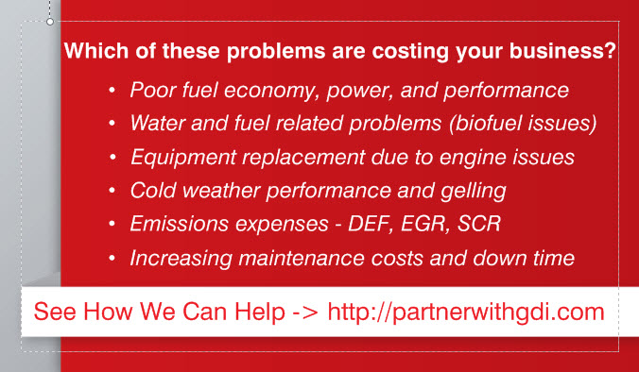
      - If so, how many other products are you using to address them?

What gets measured can be improved
- How many of your calls/meetings result in another meeting or demo?
  - Are you establishing what you will cover during the next meeting AND making sure all the decision makers will be there (if possible)?
- How many of your 2nd, 3rd, etc. meetings result in a sale?
- How many of your initial sales result in consistent repeat orders?
- How many referrals are you getting AND how many of them result in repeat sales?

Additional Sales Resources:
Blog from HubSpot listing 23 of the top sales books of all time
- https://blog.hubspot.com/sales/the-most-highly-rated-sales-books-of-all-time
A great article with 18 suggestions for empathetic phrases to use in the sales process
- https://blog.hubspot.com/sales/empathy-statements
  - If I skip anything important, please stop me and let me know?
  - How can I make this process easier for you?
    - Tom’s variation – “How can I make implementing this solution easier for you?”
  - Combination - I can appreciate that – can I make a suggestion?
Marketing Resources:
Great infographic with 8 key things to check for those of you who are doing online marketing through things like websites/blogs
- https://blog.hubspot.com/marketing/easy-ways-to-measure-the-effectiveness-of-your-content

