Commercial Training 10-17-17
Updates:
There are 3 comprehensive trials available for qualifying companies
- At least 400 pieces of equipment and at least 1000 gallons of fuel consumed per month and per piece of equipment.
The next 1-day workshop located at the Maple Grove corporate office will be
- Saturday November 18th, 2017 from 9am to 5pm
  - New GDI Reps and Certified GDI reps need to register by visiting http://becomeproworkshop.com
    - New GDI reps are required to have completed the online training before attending a workshop.
  - We invite all currently certified GDI reps to attend - there is a $25 fee for currently certified reps, which covers lunch, printed materials, and a new GDI thumb drive with current GDI documents.
    - Currently Certified Reps can purchase their $25 ticket by logging into your back office and clicking “Shop Now” > Then select your catalog > then select “Xp3” > and you’ll find Item #9700 available for purchase.
- The new GDI inserts are available for purchase.
  - Cetane Booster and Winter Xtreme are available on 1 insert printed front-to-back
  - Anti-Friction Engine Oil Treatment and Cleaner-Degreaser are also printed front-to-back
  - 25 pack - $7.50 (Item #200017)
  - 100 pack - $20 (Item #200018)
  - These are great products that can be used to open the door for cross-selling with Xp3
- Some of our GDI teammates have created “vehicle wraps” that are a great way to sell Xp3 and generate leads. Please email tom@partnerwithgdi.com before printing so we can have Randy review them before printing

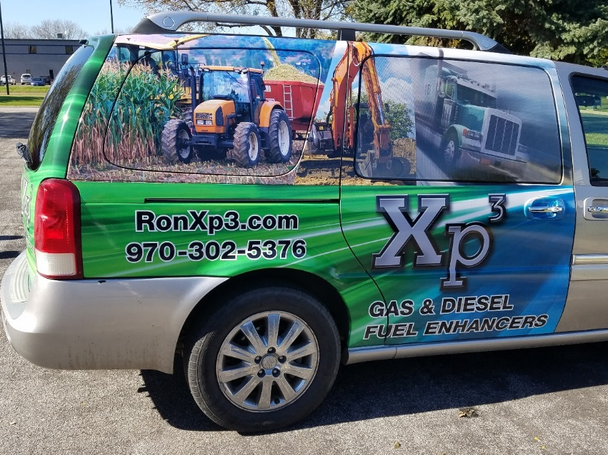
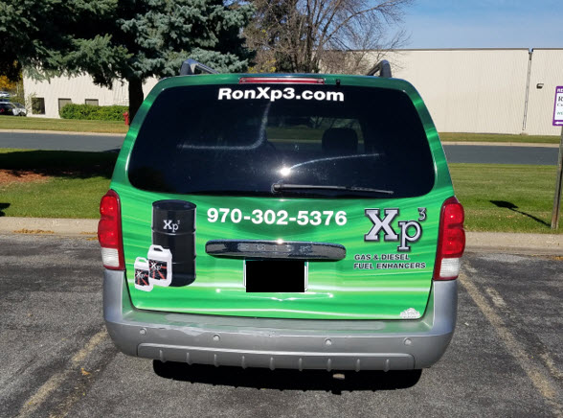
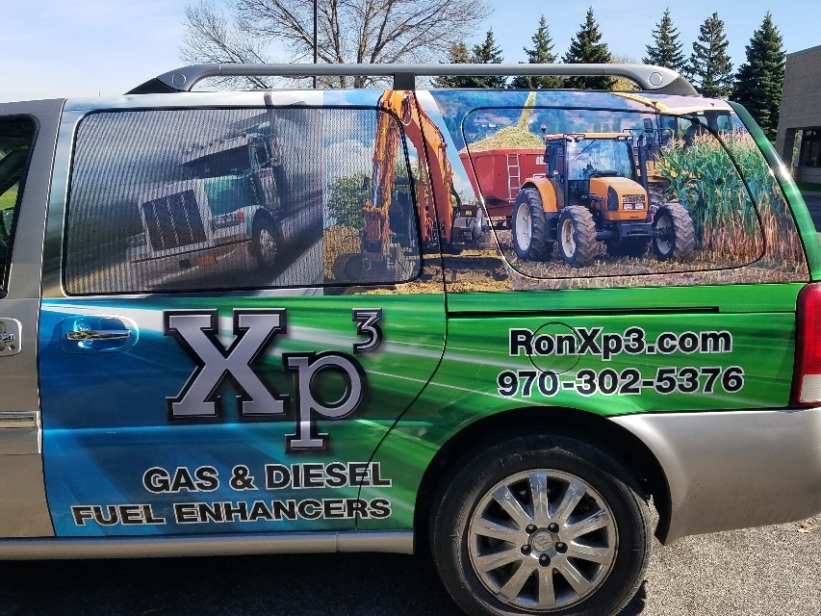
Questions, Comments, and Successes:
- Questions for Xp Lab and/or GDI -
- Marketing and Qualifying Potential Clients –
- Xp3 Questions -
- Sales Questions or Experiences You’d Like to Review –
Fuel and Industry News:
Interesting article/interview talking about maintenance related issues in transportation equipment
- http://www.truckinginfo.com/channel/maintenance/article/story/2017/10/q-a-bruce-stockton-talks-maintenance-challenges.aspx
  - Check out 2nd “Stockton” section, “What I learned is with the emissions engines – and everybody puts some EGR [cooled exhaust gases] back into the engine – it’s definitely having an effect on the life of the engine and other components.”
    - As we know Xp3 improves combustion and reduces soot, which extends oil life and protects engines.
  - 3rd “Stockton” section talks about doing used oil analysis on bulk oil tanks to make sure companies are receiving the oil they ordered
  - Check out the section on testing other fluids like coolant and the important of getting a baseline.
  - Check out the section under emissions requirements, “A lot of my work is coming from [fleets asking] why are our maintenance costs so high and what can we do to get it down. It takes sitting down and explaining what’s going on with their fleet after I look at their data and the mix of their fleet to explain why. On top of that you’ve got additional downtime with all the different sensors and emissions equipment. You have to have more pieces of equipment to do the same amount of work, because you have more trucks down.”
Supplemental Fuel and Industry News:
Ford approves several Shell Rotella oils for Ford’s Super Duty Trucks
- http://www.truckinginfo.com/channel/maintenance/news/story/2017/10/ford-approves-trio-of-shell-oils-for-diesel-trucks.aspx
- Another version of this information from a construction/heavy duty magazine
  - https://www.equipmentworld.com/shell-rotellas-new-t6-multi-vehicle-lube-oil-headlines-new-range-def-oil-filters-coming-to-retail/
Article talking about damage caused by the hurricanes and flooding equipment (especially mechanical issues related to salt water and corrosion
- http://beta.trucker.com/trucks/repair-tips-flood-damaged-equipment

Sales Training:
Setting expectations and tracking processes for customers determines the outcomes and future reorders (a majority of the time) – story from a recent conversation with a customer

Great article full of interesting statistics related to sales/sales process
- https://blog.hubspot.com/sales/sales-statistics
  - Almost 6 in 10 buyers want to discuss price in the 1st call – just don’t let them talk about price as the 1st thing before establishing their want/need, who are the decision makers, how quickly they want to proceed if they found a solution, etc.
  - More than 50% of buyers want to see how the product works on the 1st call – this works great for our demonstration
  - It takes an average of 18 calls to connect with a buyer –
  - Seven in 10 B2B buyers watch a video at some point in their buying process
  - Only 7% of companies respond in the 1st 5 minutes after a person “opts-in”
  - The vast majority of prospects want to read emails between 5 and 6 am
  - Top-performing sales people use collaborative phrases like “we”, “us”, “together”, etc.
  - 84% of buyers now start their buying process with a referral
  - 9 in 10 buying decisions are made with peer recommendations
Tips about meeting with C-level executives including:
- https://blog.hubspot.com/sales/how-meet-with-c-level-executives
  - Reintroduce yourself at the start of the meeting – they meet with a lot of people
  - Build rapport while maintaining professional focus by talking about news about their company, industry, or high-level topics.
  - Set a well-prepared agenda (some of which should be established when you schedule the meeting)
  - Focus on how you’re going to impact their bottom line
This article had some tips about ways to improve the quality of qualifying questions
- https://blog.hubspot.com/sales/ultimate-guide-to-sales-qualification
  - Under the “What is a qualifying question” section, you will see this question “Is this a priority right now?” To improve that questions, “Where does this rank on your list of business priorities?”
    - The article uses the word “fall” instead of rank, but the word fall indicates something moving lower which is why I suggested “rank”
Additional Sales Resources:

Marketing Resources:
For those of you who like to use emails or online marketing (such as blogs) – this is a great article with tips and resources for copywriting
- https://blog.hubspot.com/marketing/how-to-write-well-timeless-rules-david-ogilvy
Another great resource for using social media throughout your sales process
- https://offers.hubspot.com/thank-you/social-media-every-stage-funnel
Some great email marketing tips
- https://blog.hubspot.com/marketing/email-marketing-2017
  - Supplemental article about improving email subject lines
    - https://blog.hubspot.com/marketing/improve-your-email-subject-line

