Commercial Training 10-13-15
Updates:
- We still have 3 comprehensive trials available for qualifying companies – we still have several distributors (including myself) working on trying to close these trials.
  - At least 400 pieces of equipment and at least 1000 gallons of fuel consumed per month and per piece of equipment.
  - Xp3W-Xtreme is shipping
    - Remember that you don’t want to do your demo using the Xp3W-Xtreme
Your business depends on 2 areas of focus:
  - Getting more companies to try Xp3
    - Finding interested companies (a.k.a. – getting leads)
    - Guiding them to make a decision to partner with us
    - Partnering with them through a trial
    - Meeting after the trial and proving the results
  - Getting consistent repeat orders
    - Setting up a schedule for repeat orders
      - Having the belief (and proof) that your customers are better with Xp3
    - Getting referrals and testimonies
  - Pick at least 1 skill to improve in each of the 2 areas listed above.
Questions, comments, success stories?

Tonight’s Training
- Steps to creating a customer inside your GDI site
  - Click “Shop Now” on your replicated site
  - Add 1 item to your “Cart”
  - Click “Checkout”
  - You will be asked to “Log In” or “Register” – select “Register”
  - Fill in the form and save the details
  - When customer wants to order – send a link with the replicated site along with their “username” and “password” to ensure a quick and easy process AND that you receive credit for the sale.
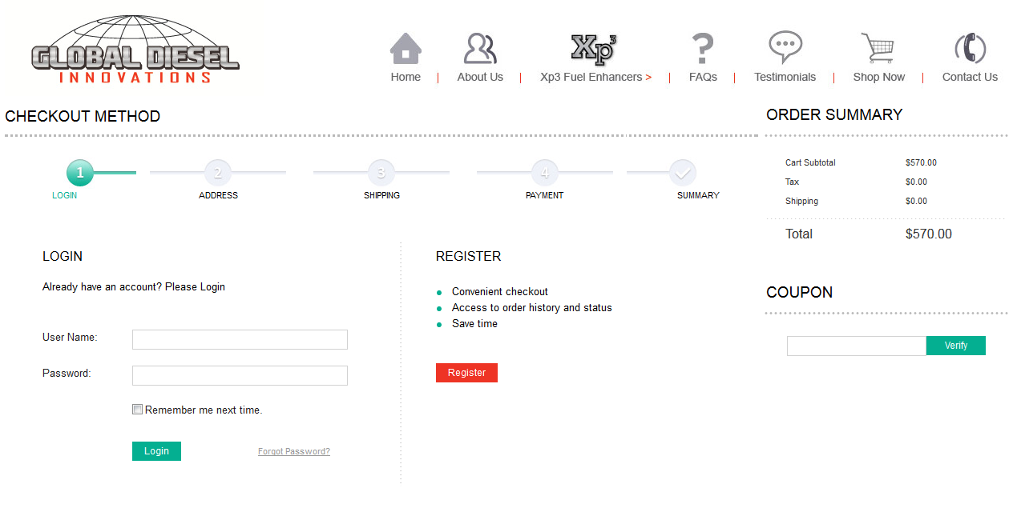
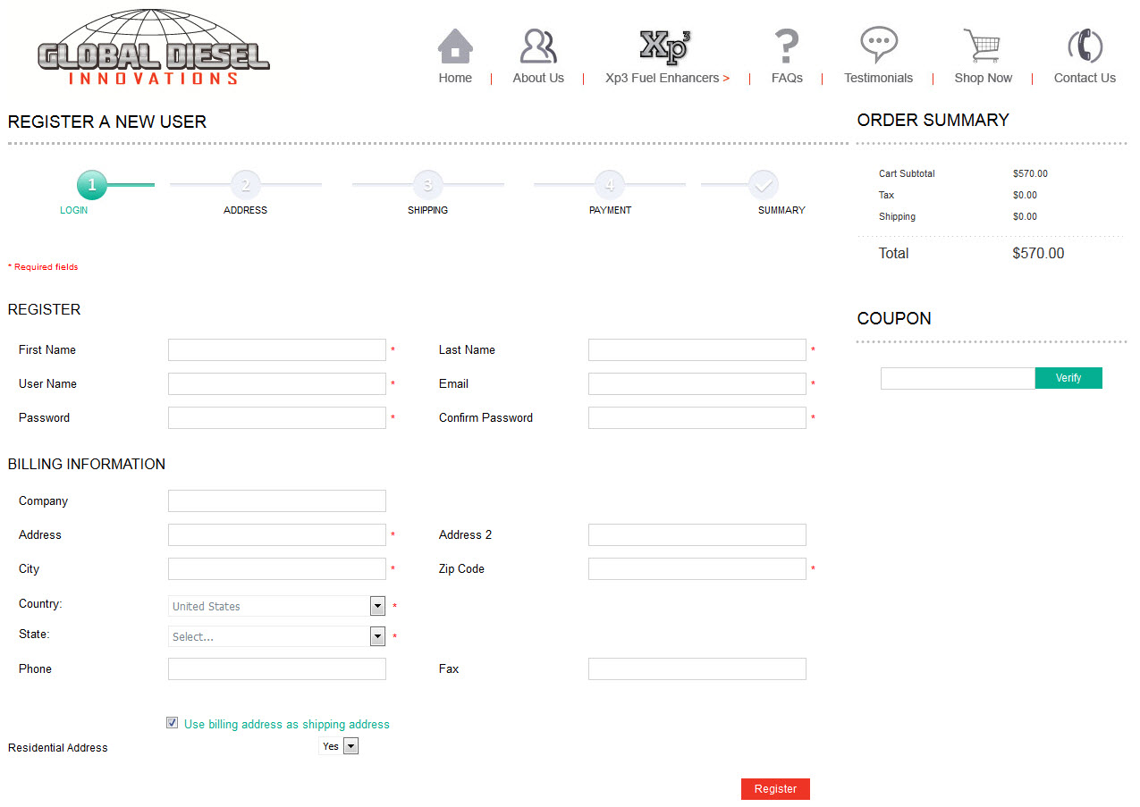

- Articles and Resources
Great information on world trends on diesel fuel lubricity (2014) article
http://www.infineuminsight.com/insight/sep-2014/new-lubricity-challenges
World Fuels Charter recommends lubricity levels of at least 400 microns for Wear Scar Diameter on HFRR testing – even in 2014 the average score is 340 microns which may be attributed to backing off of biofuels.
Important notes from the article (and the chart below)
- Lower wear scar number = better lubricity
- USA requires maximum wear scar diameter to be less than 520 microns
- Engine Manufacturers desire maximum wear scar diameter to be less than 460 microns
- Check out the section in the article on “Biofuel Use” and FAME (Fatty Acid Methyl Ester) for lubricity and the section called “Additive Chemistry” where they talk about some problems associated with using ester lubricity additives.
- Notice the lubricity quality has started to decrease (the wear scar diameter average is rising) from 2010 through 2014.
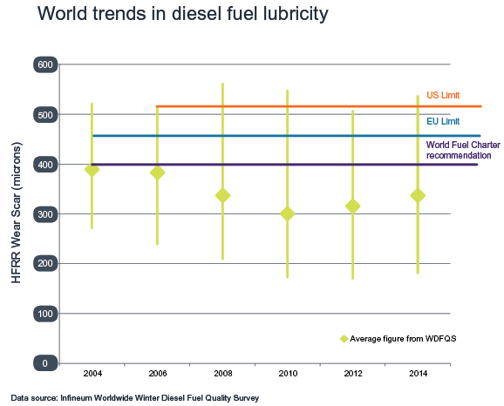

Great information to share with anyone working in construction:
http://www.forconstructionpros.com/article/12076509/diesel-fuel-housekeeping-cuts-construction-equipment-downtime
“In the past, a cleanliness of ISO 18/16/13 had been specified to handle 1300 to 2500 particles greater than 4 microns…Fuel for Tier 4 engines needs to be 100 times cleaner than that used in Tier 3 engines… While Tier 3 engines can operate with fuel containing between 1300 and 2500 particles greater than 4 microns, Tier 4 engines can only have between 20 and 40 particles greater than 4 microns.”
- ISO stands for International Organization for Standardization
- ASTM stands for American Society for Testing and Materials
Some great information on fuel filters – Spoke with (Randy) a technician with the company
http://www.baldwinfilter.com/literature/english/6%20dahl/Form4005.pdf
- Most filters are 4 microns (some claim to be 2 micron, but really are 4 micron)
- Remove a large percentage of emulsified water (in solution) – in the 90% range
- Since we’ve removed most of the sulfur from fuel – diesel fuel more readily absorbs water.

Some great information about reasons fuel injectors fail in modern engines - http://www.trucktrend.com/how-to/expert-advice/1211dp-why-diesel-fuel-injectors-fail/
- Particularly under the sections called “Excess Wear”, “Abrasion”, “Deposits” - about ½ way down the article under “Photo 10/14” – talks about particle size and quantity of impurities.

Great information about “coking” and injectors in Tier 3 and 4 engines
http://www.countrymark.com/countrymark/Portals/0/Documents/White_Paper_-_Deposit_Issues_with_Modern_Diesel_Engines_CountryMark(1).pdf
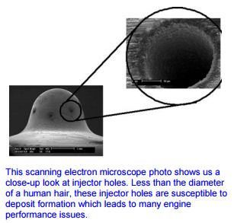

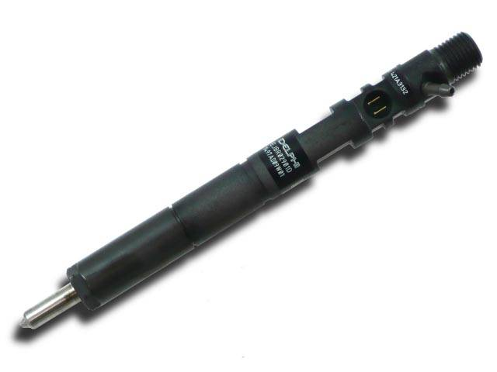

Article on the types of crude and different qualities in the world:
http://oilprice.com/Energy/Crude-Oil/A-Detailed-Guide-On-The-Many-Different-Types-Of-Crude-Oil.html

Additional Training: 100K Sales Team Training for GDI Reps

- http://100ksalesteam.com - Free training resource for Certified GDI Sales Reps to help consistently put those steps together!

