Commercial Training 1-30-18
Updates:
There are 3 comprehensive trials available for qualifying companies
- At least 400 pieces of equipment and at least 1000 gallons of fuel consumed per month and per piece of equipment.
Questions, Comments, and Successes:
- Questions for Xp Lab and/or GDI -
- Marketing and Qualifying Potential Clients –
- Xp3 Questions -
- Sales Questions or Experiences You’d Like to Review –
- Ask Randy about the Water Pill Test Kits -
Fuel and Industry Related:
Great article on 5 things fleets need to know about fuel quality and filtration
- http://www.truckinginfo.com/channel/fuel-smarts/article/story/2018/01/5-things-fleets-should-know-about-fuel-quality-and-filtration.aspx
  - “Clean fuel has never been more important for proper equipment operation and minimizing downtime. The sophistication of today’s transportation equipment requires higher fuel cleanliness to meet the demands of precision-designed fuel system pumps and injectors.”
  - “The smallest contaminants can be crippling”
    - “Systems are much more susceptible to damage from contaminants 20 times smaller than the diameter of a human hair.”
  - “Water is an ever-formidable enemy”
    - “HPCR systems are also more susceptible to damage caused by water. Water in the fuel supply is a significant hurdle in achieving the best performance and can also cause fuel filter plugging, injector deposit buildup, fuel instability and even bacterial growth in onboard and bulk fuel tanks.”
  - “Fuel additives require care”
    - “The transition to ultra-low-sulfur diesel (ULSD) has created the need for additives to replace the lubricating properties of sulfur-based compounds.”
  - “Watch your biodiesel blends”
    - “At low temperatures, however, glycerin assumes a solid waxy state where it can drop to the bottom of tanks, get caught in fuel filters, and form sticky, corrosive engine deposits. Ultimately, these deposits can immobilize a fleet.”
  - “Today’s fuel filters have evolved”
    - “Fuel filtration is on the front line of your defense against downtime and operational expenses. Contaminants in diesel fuel such as hard particles, dirt, water and organic soft particles can have a wide range of impacts to equipment, some of which can have profound issues relating to warranty and the total cost ownership.”
Fuel prices are rising which impacts bottom line:
- http://www.truckinginfo.com/channel/fuel-smarts/news/story/2018/01/diesel-fuel-prices-up-versus-2017.aspx
  - “All U.S. regions are experiencing an increase in U.S. on-highway diesel fuel prices compared with a year ago, with prices in California up $0.72 compared with the same time last year.”
  - Xp3 provides an opportunity for companies and owner operators to insulate themselves from fuel and maintenance cost increases.
Sales Training:
Three keys to growing your GDI business:
- Outstanding products that deliver what they promise – got that covered
- Consistent source(s) of quality leads
- Sales skills/process that helps you convert leads to sales
Approximately 8.2% of this year is already gone. It may not seem like much, but time goes by quickly and having a sense of urgency in our business will drive consistent action and results.
Will key area #2, #3 or both help your business grow the most in 2018?
I was also reading an email from Brian Carruthers and he talked about how people we speak to may have a hard time getting excited about the features of our products, but they can get excited about stories and the mission of our company
- Fuel Hope is an important part of the mission and impact that GDI is looking to make here in the USA
- https://www.facebook.com/Minneota/posts/1986750038262648
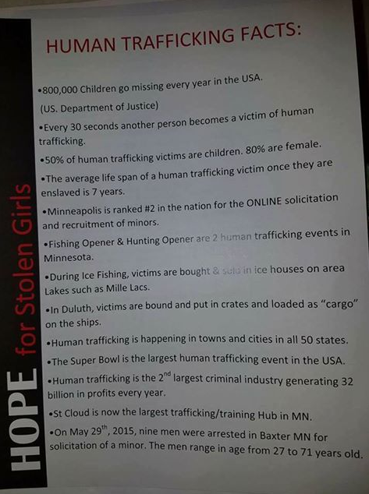

Hubspot article listing 10 suggestions for ways to start sales calls
- https://blog.hubspot.com/sales/how-to-start-a-sales-call

Marketing Training:
Good article on best days/times to make sales calls
- https://blog.hubspot.com/sales/best-time-to-make-a-sales-call
  - Wed and Thursday are still at the top of the list for best days to call prospects
  - Best time to call a prospect is between 4 and 5 pm
  - 2nd best time to phone is between 11 am and noon
  - Follow up is key – over 30% of leads never receive a follow-up after their initial contact
  - Leads receiving a phone call within 1 minute after their initial inquiry were 391% more likely to convert to a sale
Great resource with 20 different YouTube video hacks
- https://blog.hubspot.com/marketing/youtube-features-hacks-tricks
Two great resources for LinkedIn marketing
- https://blog.hubspot.com/sales/how-to-get-a-high-quality-linkedin-recommendation-email-template
- https://blog.hubspot.com/marketing/new-linkedin-features

