Commercial Training 1-2-18
Updates:
There are 3 comprehensive trials available for qualifying companies
- At least 400 pieces of equipment and at least 1000 gallons of fuel consumed per month and per piece of equipment.
Look for fuel quality comparisons across the world
Questions, Comments, and Successes:
- Questions for Xp Lab and/or GDI -
- Marketing and Qualifying Potential Clients –
- Xp3 Questions -
- Sales Questions or Experiences You’d Like to Review –
Sales Training:
- Important points to remember in the sales process
  - Start off with the right posture and process
    - It is difficult to turn around a poor (or incorrect) start to a professional partnership.
    - It can also be challenging to refocus a potential client who is off track and trying “run the conversation”.
  - Focus on them by asking questions to identify what matters most to them IF we can help them.
    - Don’t let them focus on Xp3 until you feel you have a clear understanding of their needs, challenges, and/or goals.
    - “I’d like to come by and show you a demonstration about our product...”
VS.
    - “We partner with companies to help them do 3 important things:
      - Increase their profits
      - Decrease maintenance costs and down time
      - Keep equipment running better and longer
Which of those 3 things would help XYZ company the most?”
    - This decreases the chances that someone can blow you off with the “snake oil” or additives don’t work objection.
      - If they ask, “What are you selling?”
        - How would you respond?

  - When they give you objections, remember that many of the are reactionary/defensive.
    - Additives don’t work – “I can understand your point and I’m sure you have reasons for saying that. Would you mind sharing what they are?”
    - Additives don’t work – “I can understand your point. Are you running straight crude from the ground as your fuel source?”
      - They will say “No” or tell you they are using gas/diesel. This gives you a chance to say something like – “Great, is it fair to say that your fuel supplier adds additives to the fuel you purchase?
        - They will say “Yes”
        - You can respond with something like, “So is it fair to say that some additives do work?”
    - Once you have identified their wants, needs, and/or goals AND both parties are interested in moving forward in discussions – Prior to OR if you get any objection to “additives” you can ask:
      - Could you please share your document or manual for additive testing protocol and requirements?
        - Did your fuel supplier provide the necessary documentation proving the additive package in your fuel has met your requirements and was approved by the OEM’s?
        - Disclaimer – I would use this process if they have tested and/or used other additives before.
          - If they have not tested or used additives before AND they do not have not expressed negative opinions about additives, then I would not use this.
  - Establish the “Conditions of Satisfaction” BEFORE they place their 1st order
    - What SPECIFIC benefits are they looking to achieve by partnering with us AND what SPECIFIC measurements/results need to be obtained in order to move forward using Xp3 in all their equipment?
      - This is a 2-way conversation. It’s not just the client listing their “expectations”. If they are NOT realistic, you have to be the person to establish reasonable expectations OR I suggest not letting them purchase the product
        - Examples of handling UNREALISTIC expectations?
          - 20% reduction in DEF consumption
          - Improvement of 5 MPG
Start of meeting:
- Invite them to ask questions, speak candidly, and ask for permission to do the same – this will help tremendously as the conversation progresses.
- We find that at the start of exploring their partnership with us, companies sort themselves by doing 1 of 3 things - looking for reasons to partner with us, reasons not to partner with us, OR they are not sure but are open to hearing more.
  - One way we help identify where we are in throughout our discussion is to use this simple chart. Draw a “T chart” – on the top left side write the word “question” and on the top right side write the word “Solution”. Then write down questions (or negative things they say that we can turn into questions by asking questions AND then train them to look for a solution.
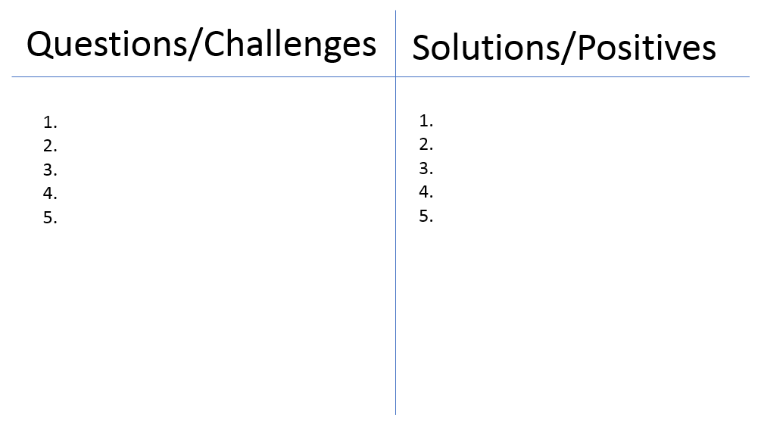
  - Think of this as balancing an equation – our goal is that for every negative/question they are listing, your goal (and hopefully theirs) is to put at least 1 solution or positive point on the other side.
- Large circle drawing and ask if there is a specific manufacturer or make/model they are loyal to and why?
  - Ask them to name some other manufacturers or make/model that they do NOT prefer and put those names inside the big circle.

  - The point is that “fuel additives” are the “big circle” and there are additive packages in the fuel they purchase, so clearly those work and are authorized by the manufacturer. There are many additives and many are petroleum based or alcohol based which both have their challenges.
  - Point is to keep and open mind and on the big picture (this is especially helpful for companies who say they have tested additives and they don’t work – other than the additives in the fuel they buy at the pump which they believe are working ok.
Another drawing is the word “goal” on the right side of a page. On the left draw an “x” which will represent the company which is not currently reaching that goal. Then every objection, excuse, and BS “arbitrary requirement” they give you simply draw a line on either side (left, right, top, bottom) until they either get the point or “box themselves in and completely stop themselves from solutions to ultimately their goals”.



Used Oil Analysis Info:
Review the following PDF’s
- Used Oil Analysis Handbook by Certified Labs
  - http://www.certifiedlabs.com/certified/vContent/4/documents/general/Oil_Analysis_Handbook.pdf
- Used oil analysis by Xp Lab
TAN – Total Acid Number – adding this would increase the cost of each analysis by $10
- http://camblab.info/wp/index.php/what-is-tan-total-acid-number/
  - “The TAN value itself can not be used to predict the corrosive nature of an oil, as the test only measures the amount of acid in a sample, not the specific quantities of different acidic compounds in the sample. Two samples might have the same TAN value, but one have high levels of corrosive acids while the other much lower levels of the same corrosive acids. An increase in viscosity, which can cause physical damage to metallic parts, and the formation of gums and resins, which can attach and cause parts to not wear correctly, are two other negative effects which can be attributed to an increased TAN value.”
TBN - Total Base Number – adding this would also increase the cost of each analysis by $10
- Note: If we purchase 50 kits up front, it includes TAN, TBN, Soot, and free shipping for $37/per kit. This is a substantial discount.

Knowing this number is another measure of how we can compare the readings/analysis done by the lab with a specific number. For some people it provides reassurance to have this info.
- https://www.blackstone-labs.com/do-i-need-a-tbn.php

Additional Sales Resources:
10 recommended sales books (or audiobooks)
- https://blog.hubspot.com/sales/best-audiobooks
Marketing Resources:
Article with tips on how to use LinkedIn website demographics –
- https://blog.hubspot.com/marketing/linkedin-website-demographics

